
Wonderful Tonight (Eric Clapton, 1976) (G)
Wonderful Tonight by Eric Clapton

Intro G | D | C | D  G D  It's late in the evening  C D  She's wondering what clothes to wear  G D  She puts on her makeup  C D  And brushes her long blonde hair  C D  And then she asks me  G D Em  Do I look al-right?  C D G  And I say yes, you look wonderful to-night  Interlude G | D | C | D |  G D  We go to a party  C D  And everyone turns to see  G D  This beautiful lady  C D  That's walking around with me  C D  And then she asks me  G D Em  Do you feel al-right?  C D G  And I say yes, I feel wonderful to-night |  |  |  | Bridge  C  I feel wonderful  D G D Em  Be-cause I see the love light in your eyes  C D  And the wonder of it all  C D  Is that you just don't rea-lize  TACET G  How much I love you  Interlude G | D | C | D |  G D  It's time to go home now  C D  And I've got an aching head  G D  So I give her the car keys  C D  She helps me to bed  C D  And then I tell her  G D Em  As I turn out the light  C D G  I say my darling, you were wonderful to-night  Bm | Em | D  C D G  Oh my darling, you were wonderful to-night  Outro G | D | C | D | G | D | C | D | G
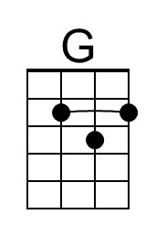 | 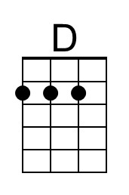 | 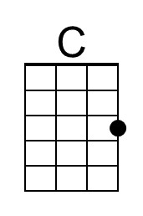 | 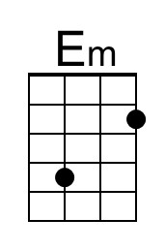 | 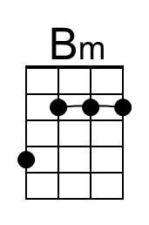
 |  | Bari | 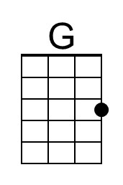 | 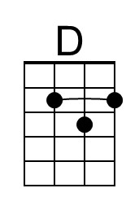 | 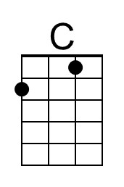 | 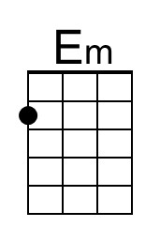 | 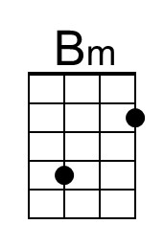

Wonderful Tonight (Eric Clapton, 1976) (C)
Wonderful Tonight by Eric Clapton

Intro C | G | F | G  C G  It's late in the evening  F G  She's wondering what clothes to wear  C G  She puts on her makeup  F G  And brushes her long blonde hair  F G  And then she asks me  C G Am  Do I look al-right?  F G C  And I say yes, you look wonderful to-night  Interlude: C | G | F | G |  C G  We go to a party  F G  And everyone turns to see  C G  This beautiful lady  F G  That's walking around with me  F G  And then she asks me  C G Am  Do you feel al-right?  F G C  And I say yes, I feel wonderful to-night |  |  |  | Bridge  F  I feel wonderful  G C G Am  Be-cause I see the love light in your eyes  F G  And the wonder of it all  F G  Is that you just don't rea-lize  TACET C  How much I love you  Interlude: C | G | F | G |  C G  It's time to go home now  F G  And I've got an aching head  C G  So I give her the car keys  F G  She helps me to bed  F G  And then I tell her  C G Am  As I turn out the light  F G C  I say my darling, you were wonderful to-night  Em | Am | G  F G C  Oh my darling, you were wonderful to-night  Outro C | G | F | G | C | G | F | G | C
 |  | 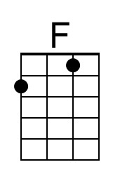 | 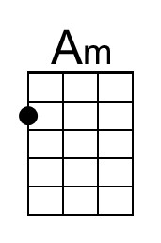
 |  | Bari |  |  | 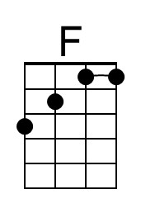 | 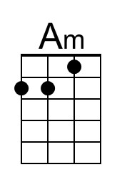
Wonderful Tonight (Eric Clapton, 1976) (D)
Wonderful Tonight by Eric Clapton

Intro D A G A  D A  It's late in the evening  G A  She's wondering what clothes to wear  D A  She puts on her makeup  G A  And brushes her long blonde hair  G A  And then she asks me  D A Bm  Do I look al-right?  G A D  And I say yes, you look wonderful to-night.  Interlude: D A G A  D A  We go to a party  G A  And everyone turns to see  D A  This beautiful lady  G A  That's walking around with me  G A  And then she asks me  D A Bm  Do you feel al-right?  G A D  And I say yes, I feel wonderful to-night. |  |  |  | Bridge  G  I feel wonderful  A D A Bm  Be-cause I see the love light in your eyes  G A  And the wonder of it all  G A  Is that you just don't rea-lize  TACET D  How much I love you  Interlude: D A G A  D A  It's time to go home now  G A  And I've got an aching head  D A  So I give her the car keys  G A  She helps me to bed  G A  And then I tell her  D A Bm  As I turn out the light  G A D  I say my darling, you were wonderful to-night  Interlude F#m Bm A  G A D  Oh my darling, you were wonderful to-night  Outro D A G A D A G A D
 | 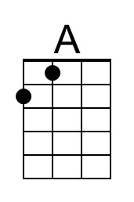 |  |  | 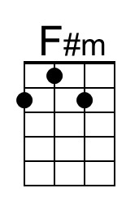
 |  | Bari |  | 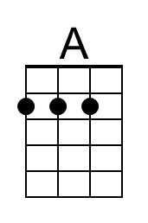 |  |  | 