
Wonderful Tonight (Eric Clapton, 1976) (G)
Wonderful Tonight by Eric Clapton – Tempo = 96 bpm

Intro G | D | C | D  G D  __It's late in the evening  C D  __She's wondering what clothes to wear  G D  __She puts on her makeup  C D  __And brushes her long blonde hair  C D  __And then she asks me  G D Em  __Do I look al-right?  C D G  And I say yes, you look wonderful to-night  Interlude G | D | C | D |  G D  __We go to a party  C D  __And everyone turns to see  G D  __This beautiful lady  C D  __That's walking a-round with me  C D  __And then she asks me  G D Em  __Do you feel al-right?  C D G  And I say yes, I feel wonderful to-night |  |  |  | Bridge  C  I feel wonderful  D G D Em  Be-cause I see the love light in your eyes  C D  And the wonder of it all  C D  Is that you just don't rea-lize  TACET G  How much I love you  Interlude G | D | C | D |  G D  __It's time to go home now  C D  __And I've got an aching head  G D  __So I give her the car keys  C D  __She helps me to bed  C D  __And then I tell her  G D Em  __As I turn out the light  C D G  I say my darling, you were wonderful to-night  Bm | Em | D  C D G  Oh my darling, you were wonderful to-night  Outro G | D | C | D | G | D | C | D | G
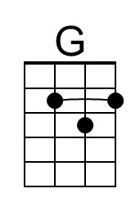 | 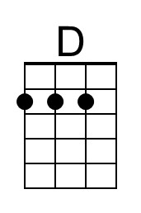 | 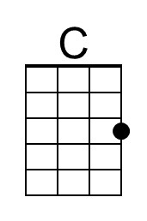 | 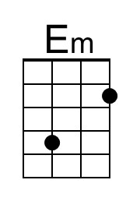 | 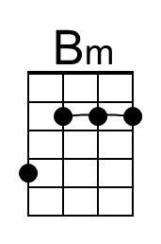
 |  | Bari | 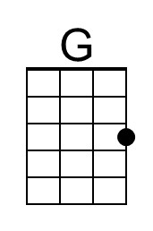 | 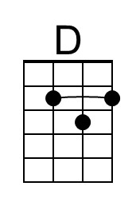 | 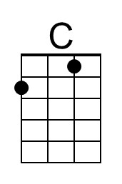 | 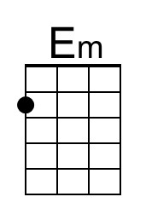 | 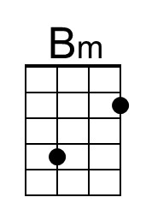

Wonderful Tonight (Eric Clapton, 1976) (C)
Wonderful Tonight by Eric Clapton – Tempo = 96 bpm

Intro C | G | F | G  C G  __It's late in the evening  F G  __She's wondering what clothes to wear  C G  __She puts on her makeup  F G  __And brushes her long blonde hair  F G  __And then she asks me  C G Am  __Do I look al-right?  F G C  And I say yes, you look wonderful to-night  Interlude: C | G | F | G |  C G  __We go to a party  F G  __And everyone turns to see  C G  __This beautiful lady  F G  __That's walking a-round with me  F G  __And then she asks me  C G Am  __Do you feel al-right?  F G C  And I say yes, I feel wonderful to-night |  |  |  | Bridge  F  I feel wonderful  G C G Am  Be-cause I see the love light in your eyes  F G  And the wonder of it all  F G  Is that you just don't rea-lize  TACET C  How much I love you  Interlude: C | G | F | G |  C G  __It's time to go home now  F G  __And I've got an aching head  C G  __So I give her the car keys  F G  __She helps me to bed  F G  __And then I tell her  C G Am  __As I turn out the light  F G C  I say my darling, you were wonderful to-night  Em | Am | G  F G C  Oh my darling, you were wonderful to-night  Outro C | G | F | G | C | G | F | G | C
 |  | 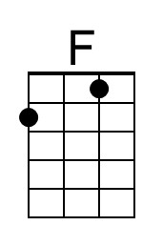 | 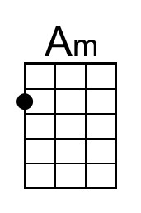
 |  | Bari |  |  | 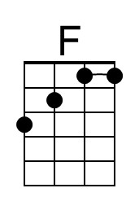 | 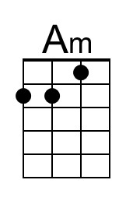
Wonderful Tonight (Eric Clapton, 1976) (D)
Wonderful Tonight by Eric Clapton – Tempo = 96 bpm

Intro D | A | G | A |  D A  __It's late in the evening  G A  __She's wondering what clothes to wear  D A  __She puts on her makeup  G A  __And brushes her long blonde hair  G A  __And then she asks me  D A Bm  __Do I look al-right?  G A D  And I say yes, you look wonderful to-night.  Interlude: D | A | G | A |  D A  __We go to a party  G A  __And everyone turns to see  D A  __This beautiful lady  G A  __That's walking a-round with me  G A  __And then she asks me  D A Bm  __Do you feel al-right?  G A D  And I say yes, I feel wonderful to-night. |  |  |  | Bridge  G  I feel wonderful  A D A Bm  Be-cause I see the love light in your eyes  G A  And the wonder of it all  G A  Is that you just don't rea-lize  TACET D  How much I love you  Interlude: D | A | G | A |  D A  __It's time to go home now  G A  __And I've got an aching head  D A  __So I give her the car keys  G A  __She helps me to bed  G A  __And then I tell her  D A Bm  __As I turn out the light  G A D  I say my darling, you were wonderful to-night  Interlude F#m Bm A  G A D  Oh my darling, you were wonderful to-night  Outro D | A | G | A |D | A | G | A | D
 | 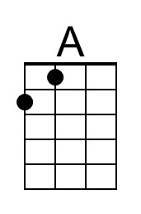 |  |  | 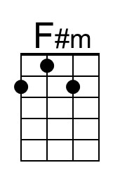
 |  | Bari |  | 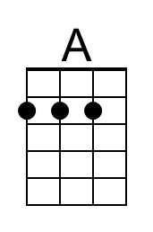 |  |  | 