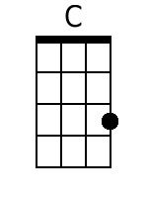
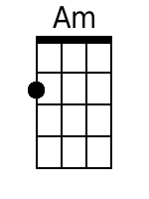
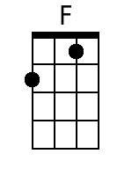
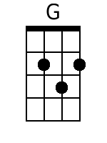
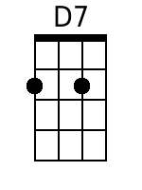
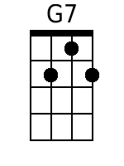
Wonderful World
Written by Herb Alpert & Lou Adler; Performed by Sam Cooke

Intro: C Am F G (First Two Lines of Verse) | Tempo=155 | Allegro

C Am
Don't know much about history,
F G
Don't know much bi-ology.
C Am
Don't know much about a science book,
F G
Don't know much about the French I took.
C F
But I do know that I love you,
C F
And I know that if you love me too;
G C
What a wonderful world this could be.

C Am
Don't know much about ge-ography,
F G
Don't know much trigo-nometry.
C Am
Don't know much about algebra,
F G
Don't know what a slide rule is for.
C F
But I do know one and one is two,
C F
And if this one could be with you;
G C
What a wonderful world this could be.

Bari
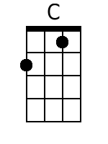 | 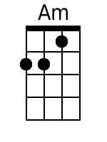 | 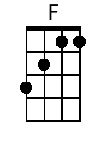 | 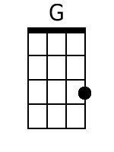 | 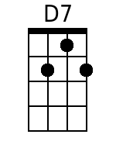 | 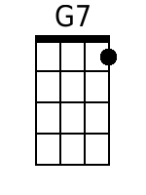

Bridge
G C
Now I don't claim to be an 'A' student,
G C
But I'm tryin' to be.
Am D7
That maybe by being an 'A' student, baby,
G G7
I could win your love for me.

C Am
Don't know much about history,
F G
Don't know much bi-ology.
C Am
Don't know much about a science book,
F G
Don't know much about the French I took.
C F
But I do know one and one is two,
C F
And if this one could be with you;
G C
What a wonderful world this could be.

C Am
La la, la la la la... (history),
F G
Mmm... (bi-ology).
C Am
La la la la la la la la la, (science book),
F G
Mmm... (French I took).
C F
But I do know that I love you,
C F
And I know that if you love me too;
G C | Am | F | G |
What a wonderful world this could be. C-Ring

Note. Form appears to be a nine-part rondo with three verses (A1 2 3), two choruses (B1 2) and a bridge (C):
A1 B1 A2 B2 C A1 B2 A3 B1

