I've Been Working On My Costume
At YouTube:
I've Been Working on My Costume (in key of F)

C C7 F C  I’ve been working on my costume all the live long day  C D7 G  I’ve been working on my costume, watch out, I’m on my way  G7 C F E7  When you see me at your doorbell, you’ll know what I mean  F C G C  I’ve been working on my costume, be-cause it’s Hallo-ween.  1st Chorus  C F  Little bit of this, little bit of that  G7 C  Itty bitty pillow to make me fat  C F  Wig upon my head, sheet from off my bed  G7 C  All because it’s Hallo-ween  Repeat First Verse.  2nd Chorus  C F  Funny kind of nose, funny kind of beard  G7 C  Don’t know what I am but I look weird  C F  Makeup on my face, powder every place  G7 C  All because it’s Hallo-ween  Repeat Chorus  Spoken: Trick- or - Treat ! ! !  Bari |  |  |  |  | 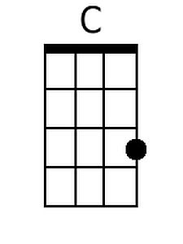  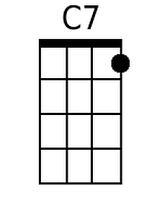  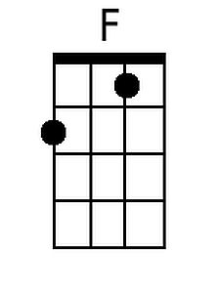  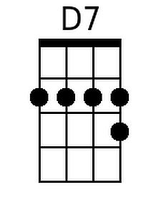  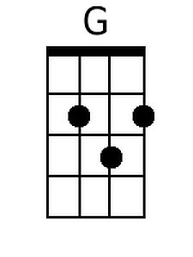  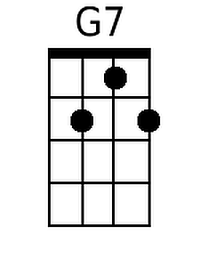  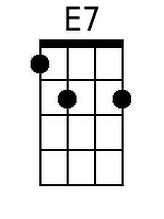
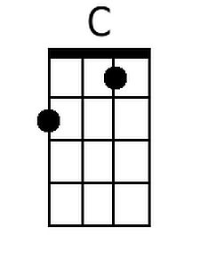 | 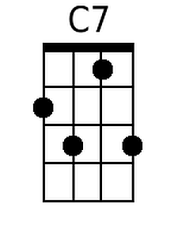 | 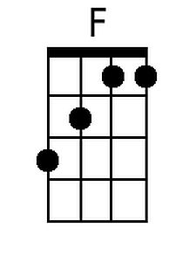 | 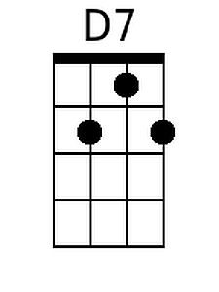
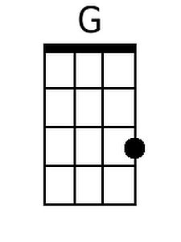 | 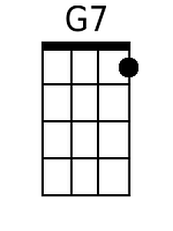 | 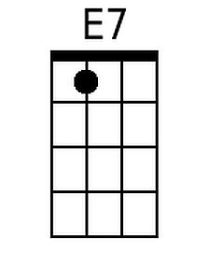

I've Been Working On My Costume
At YouTube:
I've Been Working on My Costume (in key of F)

F F7 Bb F  I’ve been working on my costume all the live long day  F G7 C  I’ve been working on my costume, watch out, I’m on my way  C7 F Bb A7  When you see me at your doorbell, you’ll know what I mean  Bb F C F  I’ve been working on my costume, be-cause it’s Hallo-ween.  1st Chorus  F Bb  Little bit of this, little bit of that  C7 F  Itty bitty pillow to make me fat  F Bb  Wig upon my head, sheet from off my bed  C7 F  All because it’s Hallo-ween  Repeat First Verse.  2nd Chorus  F Bb  Funny kind of nose, funny kind of beard  C7 F  Don’t know what I am but I look weird  F Bb  Makeup on my face, powder every place  C7 F  All because it’s Hallo-ween  Repeat Chorus  Spoken: Trick- or - Treat ! ! !  Bari: |  |  |  |  | 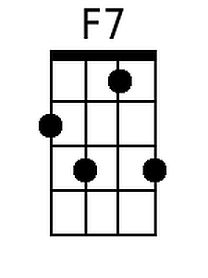  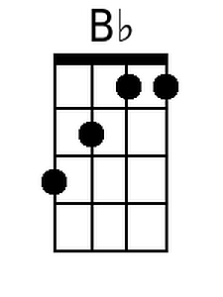  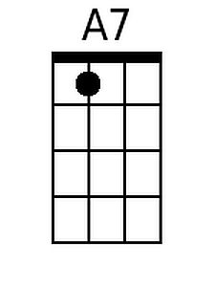
 | 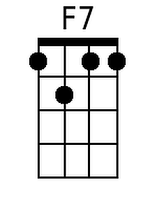 | 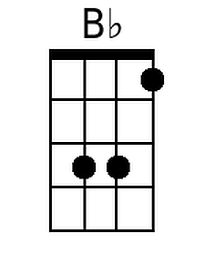
 |  | 