**Wouldn’t It Be Loverly (Alan Jay Lerner / Frederick Loewe)**

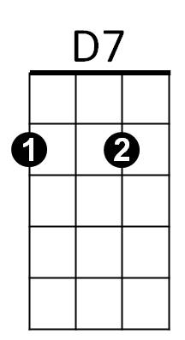

F



Bb

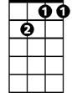

Gm7

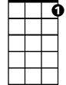

C7

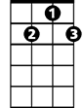

G7

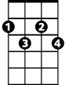

Cdim

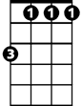

Bbm

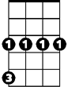

Cm



G

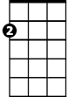

Am

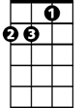

Dm

E7

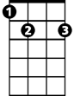

**F Bb Gm7 C7**

All I want is a room somewhere

**F G7 C7**

Far away from the cold night air

**F C7 Cm D7**

With one enormous chair

**Bbm F Cdim Gm7 C7**

Oh, wouldn't it be loverly?

**F Bb Gm7 C7**

Lots of chocolate for me to eat

**F G7 C7**

Lots of coal making lots of heat

**F C7 Cm D7**

Warm face warm hands warm feet

**Bbm F C7 F**

Oh, wouldn't it be loverly?

**C G7 C E7 Am E C7**

Oh so loverly sitting absobloomin’ lute - ly still

**Dm E7 Am E7 Am D7 G Gm7 C7**

I would nev - er budge til spring crept over the windowsill

**F Bb G**  **m7 C7**

**BARITONE**

Someone's head resting on my knee

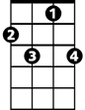

C7



G7



F

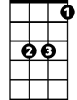

Bb

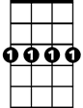

Gm7

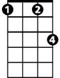

Cm

**F G7 C7**

Warm and tender as he can be

**F C7 Cm D7**

Who takes good care of me

**Bbm F Dm Gm7 C7 F C7 Bb**

Oh, wouldn't it - be loverly? Loverly, loverly?

**(Repeat song)**

**Bbm F Dm Gm7 C7 F**

Loverly Oh, wouldn't it - be loverly?

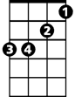

Bbm



G



Am

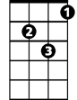

Dm

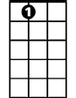

E7

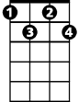

Cdim



D7