YMCA (Jacques Morali, Victor Willis) (C)
YMCA by Village People (In F#)

Intro (1st 4 lines) C Am Dm G  C  Young man, there's no need to feel down, I said  Am  Young man, pick yourself off the ground, I said  Dm  Young man, cause you're in a new town  G  There's no need to be unhappy.  C  Young man, there's a place you can go, I said  Am  Young man, when you're short on your dough, you can  Dm  Stay there, and I'm sure you will find  G  Many ways to have a good time. (STOP for 5 beats)  Chorus  C Am  It's fun to stay at the YMCA. It's fun to stay at the YMCA,  Dm  They have everything for you men to enjoy  G  You can hang out with all the boys.  C Am  It's fun to stay at the YMCA. It's fun to stay at the YMCA,  Dm  You can get yourself cleaned, you can have a good meal  G  You can do whatever you feel.  C  Young man, are you listening to me, I said  Am  Young man, what do you want to be, I said  Dm  Young man, you can make real your dreams, |  |  |  | G  But you've got to know this one thing  C  No man does it all by himself, I said  Am  Young man, put your pride on the shelf and just  Dm  Go there, to the YMCA  G  I'm sure they can help you today. (STOP for 5 beats) (Chorus)  C  Young man, I was once in your shoes, I said  Am  I was down and out with the blues, I felt  Dm  No man cared if I were alive  G  I felt the whole world was so tight.  C  That's when someone came up to me and said,  Am  "Young man, take a walk up the street, there's a  Dm  Place there called the YMCA  G  They can start you back on your way. (STOP for 5 beats) (Chorus)  Outro  C Am  It's fun to stay at the YMCA. It's fun to stay at the YMCA,  Dm  They have everything for you men to enjoy  G - C  (Slowing Down) You can hang out with all the boys.
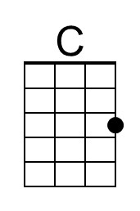 | 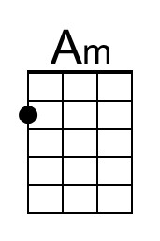 | 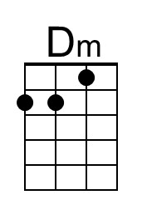 | 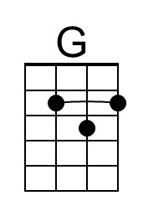 | 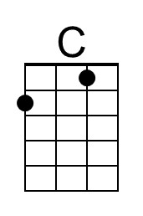 | 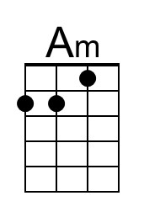 | 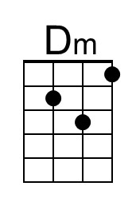 | 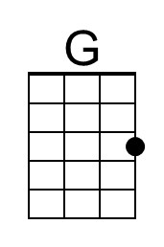

YMCA (Jacques Morali, Victor Willis) (G)
YMCA by Village People (In F#)

Intro (1st 4 lines) G Em Am D  G  Young man, there's no need to feel down, I said  Em  Young man, pick yourself off the ground, I said  Am  Young man, cause you're in a new town  D  There's no need to be unhappy.  G  Young man, there's a place you can go, I said  Em  Young man, when you're short on your dough, you can  Am  Stay there, and I'm sure you will find  D  Many ways to have a good time. (STOP for 5 beats)  Chorus  G Em  It's fun to stay at the YMCA. It's fun to stay at the YMCA,  Am  They have everything for you men to enjoy  D  You can hang out with all the boys.  G Em  It's fun to stay at the YMCA. It's fun to stay at the YMCA,  Am  You can get yourself cleaned, you can have a good meal  D  You can do whatever you feel.  G  Young man, are you listening to me, I said  Em  Young man, what do you want to be, I said  Am  Young man, you can make real your dreams, |  |  |  | D  But you've got to know this one thing  G  No man does it all by himself, I said  Em  Young man, put your pride on the shelf and just  Am  Go there, to the YMCA  D  I'm sure they can help you today.  (STOP for 5 beats) (Chorus)  G  Young man, I was once in your shoes, I said  Em  I was down and out with the blues, I felt  Am  No man cared if I were alive  D  I felt the whole world was so tight.  G  That's when someone came up to me and said,  Em  "Young man, take a walk up the street, there's a  Am  Place there called the YMCA  D  They can start you back on your way.  (STOP for 5 beats) (Chorus)  Outro  G Em  It's fun to stay at the YMCA. It's fun to stay at the YMCA,  Am  They have everything for you men to enjoy  D - G  (Slowing Down) You can hang out with all the boys.
 | 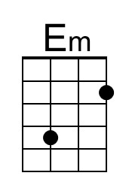 |  | 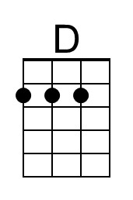 |  | 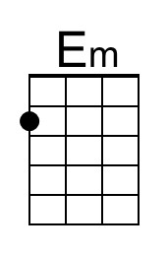 |  | 