**Yankee Doodle Boy ("Yankee Doodle Dandy") Key C**

**(George M. Cohan / Kenneth Elkinson)**

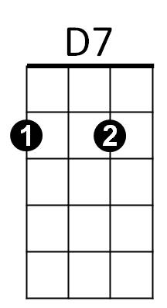**C** **D7**

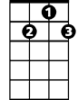

G7



C

I'm a Yankee Doodle Dandy

**G7** **C**

A Yankee Doodle, do or die

**A7** **Dm**

A real live ne phew of my Uncle Sam

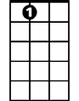

A7

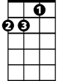

Dm

**D7** **G** **G7**

Bor n on the Fourth of July

**C** **D7**

I've got a Yankee Doodle sweetheart

**G7** **C**

She's my Yankee Doodle joy

**C** **G7** **C** **G7**

Yankee Doodle came to London

**C** **G7** **C** **G7**

Just to ride the po-nies

**D7** **G7** **C**

I am the Yankee Doodle boy

**REPEAT SONG**

**BARITONE**

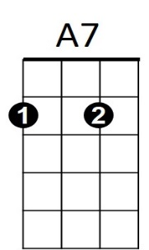

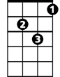

Dm

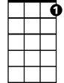

G7



D7

C



**Yankee Doodle Boy ("Yankee Doodle Dandy") Key G**

**(George M. Cohan / Kenneth Elkinson)**

**G** **A7**

****I'm a Yankee Doodle Dandy



A7



G

**D7** **G**

A Yankee Doodle, do or die

**E7** **Am**

A real live nephew of my Uncle Sam

**A7** **D** **D7**

E7

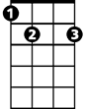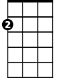

Am

Born on the Fourth of July

**G** **A7**

I've got a Yankee Doodle sweetheart

**D7** **G**

She's my Yankee Doodle joy

**G** **D7** **G** **D7**

Yankee Doodle came to London

**G** **D7** **G** **D7**

Just to ride the po-nies

**A7** **D7** **G**

I am the Yankee Doodle boy

**REPEAT SONG**





E7



Am



D7



G

**BARITONE**