**Yankee Doodle (Dr. Richard Shuckburgh, 1755) Key C**

**C**

Yankee Doodle went to town riding on a pony

**F G7 C**

Stuck a feather in his hat and called it macaroni

**Chorus**

F



**F**



C

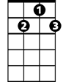

G7

Yankee Doodle keep it up

**C**

Yankee Doodle dandy

**F**

Mind the music and the step

**C G7 C**

And with the girls be handy

**C**

Father and I went down to camp along with Captain Gooding

**F G7 C**

And there we saw the men and boys as thick as hasty pudding

**(Chorus)**

**BARITONE**

**C**

C



There was Captain Washington upon a slapping stallion

**F G7 C**

Giving orders to his men I guess there was a million

**(Chorus)**

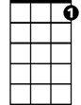

G7



F

**C**

And there we saw a thousand men as rich as Squire David

**F G7 C**

And what they wasted every day I wish it could be sa-ved

**(Chorus)**

**C**

And there I saw a pumpkin shell as big as mother's basin

**F G7 C**

And every time they touched it off they scamper'd like the nation

**(Chorus)**

**Yankee Doodle (Dr. Richard Shuckburgh, 1755) Key G**

**G**

Yankee Doodle went to town riding on a pony

**C D7 G**

Stuck a feather in his hat and called it macaroni

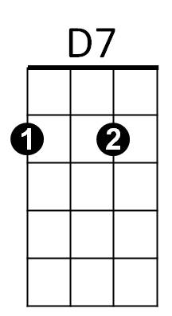



G



C

**Chorus**

**C**

Yankee Doodle keep it up

**G**

Yankee Doodle dandy

**C**

Mind the music and the step

**G D7 G**

And with the girls be handy

**G**

Father and I went down to camp along with Captain Gooding

**C D7 G**

And there we saw the men and boys as thick as hasty pudding

**BARITONE**



G

**(Chorus)**

**G**

There was Captain Washington upon a slapping stallion

**C D7 G**

C



Giving orders to his men I guess there was a million

**(Chorus)**

**G**

And there we saw a thousand men as rich as Squire David



D7

**C D7 G**

And what they wasted every day I wish it could be sa-ved

**(Chorus)**

**G**

And there I saw a pumpkin shell as big as mother's basin

**C D7 G**

And every time they touched it off they scamper'd like the nation

**(Chorus)**