**Yesterday’s Gone (Chad and Jeremy)**

**Intro: C F C F (2X)**

**C F C**



C

F



I loved you all the summer through,

**Am G**

I thought I'd found my dream in you

**F C G**

For me you were the one;

**C G7 C**

But that was yesterday, and yesterday's gone

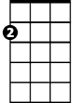

Am



G

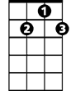

G7

**C F C**

We walked together hand in hand;

**Am G**

'cross miles and miles of golden sand

**F C G**

But now it's over and done;

**C G7 C**

'cause that was yesterday, and yesterday's gone

**BARITONE**

**Refrain:**



G



F

C

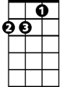

Am

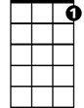

G7

**Am G Am**

We had such happiness together,

**G Am G7**

I can't believe it's gone for-ev er

**C F C**

Wait 'til summer comes again;

**Am G**

I hope that you'll remember when

**F C G**

Our love had just begun;

**C G7 C**

I loved you yesterday, and yesterday's gone

**C F C / C Am G / F C G / C G7 C (chords for verse)**

**(Refrain)**

**C F C**

Wait 'til summer comes again;

**Am G**

I hope that you'll remember when

**F C G**

Our love had just begun;

**C G7 C G7**

I loved you yesterday, and yesterday's gone

**C G7 C G7 C F C F C F C**

Yesterday's gone, Yesterday's gone, Yesterday's g - o - n - e