Yo Ho, Yo Ho! A Pirate's Life For Me
Disney' s “Pirates of the Caribbean”
C F C G7 C  1. Yo ho, yo ho, a pirate's life for me  Am E7  We pillage and plunder, we rifle and loot!  F G  Drink up me 'earties, yo ho  F Am  We kidnap and ravage and don't give a hoot.  D7 G  Drink up me ‘earties, yo ho!  C F C G7 C  2. Yo ho, yo ho, a pirate's life for me  Am E7  We extort and pilfer, we filch and sack.  F G  Drink up me 'earties, yo ho  F Am  Maraud and embezzle and even highjack.  D7 G  Drink up me 'earties, yo ho.  Bari |  |  |  | 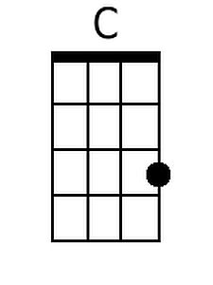  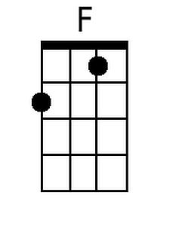  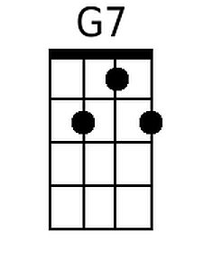  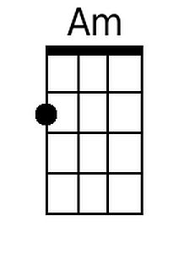  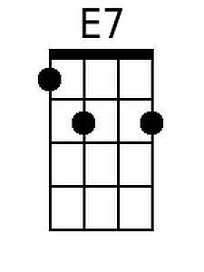  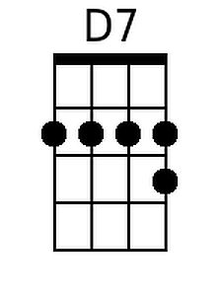  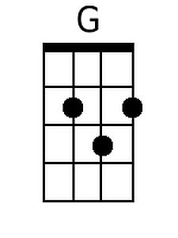
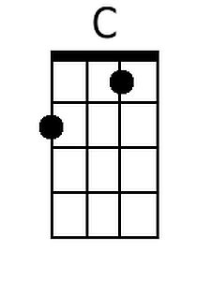 | 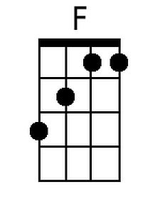 | 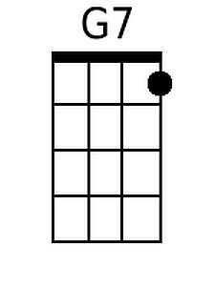 | 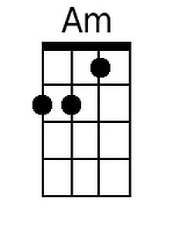
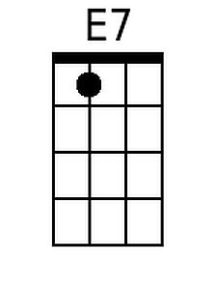 | 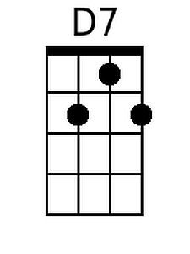 | 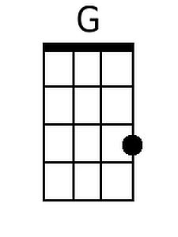

Yo Ho, Yo Ho! A Pirate's Life For Me – Page 2

C F C G7 C
3. Yo ho, yo ho, a pirate's life for me
Am E7
We kindle and char and in-flame and ignite.
F G
Drink up me 'earties, yo ho
F Am
We burn up the city, we're really a fright.
D7 G
Drink up me 'earties, yo ho.

C F C G7 C
4. Yo ho, yo ho, a pirate's life for me
Am E7
We’re rascals and scoundrels, we’re villains and knaves.
F G
Drink up me ‘hearties, yo ho!
F Am
We’re devils and black sheep, we’re really bad eggs!
D7 G
Drink up me ‘earties, yo ho!

C F C G7 C
5. Yo ho, yo ho, a pirate's life for me
Am E7
We’re beggars and blighters and ne’er- do- well cads!
F G
Drink up me 'earties, yo ho
F Am
Aye, but we’re loved by our mummies and dads,
D7 G
Drink up me ‘earties, yo ho!

C F C G7 C
Yo ho, yo ho, a pirate's life for me.
C F C G7 C
Yo ho, yo ho, a pirate's life for me.

