**You Are the Sunshine of My Life (Stevie Wonder)**

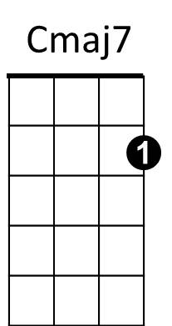**Intro: Cm** **aj7 G7 x2**

Em7

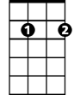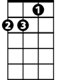

Dm



C

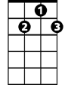

G7

**C Dm G Em7 Bbdim**

You are the sunshine of my life

**Dm G7 C Dm G7**

That's why I'll always be around

**C Dm G Em7 Bbdim**

F

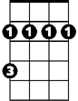

Bm

E7

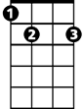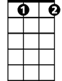

Bbdim



G

You are the apple of my eye

**Dm G7 C Dm G7**



F#m

B7



Fdim

Forever you'll stay in my heart

**C F Cmaj7 F G7**

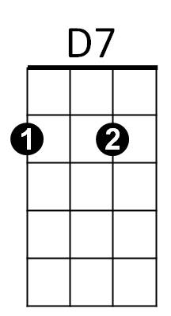I feel like this is the beginning

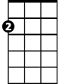

Am

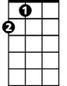

A

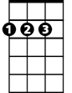

D

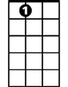

A7

**Cmaj7 F Bm E7**

Though I've loved you for a million years

**A D Em7**

And if I thought our love was ending

**A7 D7**

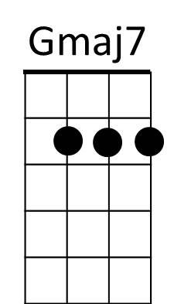I'd find myself drowning in my own tears

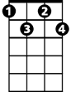

Fdim

Em

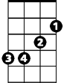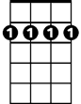

Bm7

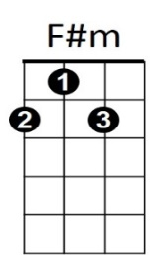

**G Am D Bm7 Fdim**

You are the sunshine of my life

**Am D7 G Am D7**

That's why I'll always be around

**G Am D Bm7 Fdim**

You are the apple of my eye

**Am D7 G Am D7**

**BARITONE**

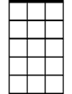

Em7

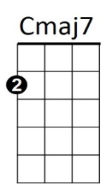Forever you'll stay in my heart

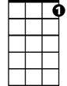

G7

C

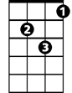

Dm

**G C Gmaj7 C D7**

You must have known that I was lonely

**Gmaj7 C F#m B7**

Because you came to my res - cue

**Em A Bm7**

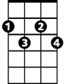

Bbdim



G



F

Bm



E7

And I know that this must be heaven

**E7 A7 D7**

How could so much love be inside of you?

**(Repeat to fade)**

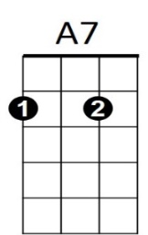



Am



D7



D



A

**G Am D Bm7 Fdim**

You are the sunshine of my life

**Am D7 G Am D7**

That's why I'll always be around

**G Am D Bm7 Fdim**

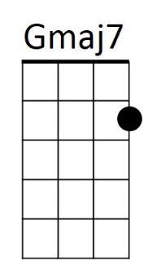You are the apple of my eye

Bm7



Em

**Am D7 G Am D7**

Forever you'll stay in my soul