
You Become Someone Else for the Holidays
C95 C
“Meet Your Holiday Selves,” Nexium Commercial (2015)
Tune: “There’s No Place Like Home for The Holidays” (About 90 BPM)

Intro (Chords for 2 last lines)  C F C  You become someone else for the holidays  C A7 D7 – G7  Eating, drinking, toasting every day.  C F C  You lose all inhibitions for the Holidays  G7 Dm G7 C – C7  Everybody celebrates in their own way.  F  I’ll take a bit of this, a touch of that,  C  and a smidge of this thing too.  G7 C – C7  And a tiny sliver of this pumpkin pie.  F  Well, I’ve had five Grande’ latte’s  C  and sixteen expressos, too!  G Am  I licked the batter off this beater,  G G7  gee, this frosting can’t get sweeter.  C F C  Oh I love everything about the Holidays  A7 D7 – G7  I’d like to raise a glass or two, or ten.  Spoken  Enough with the toasts!  C F C  Oh I HATE every-thing about the Holidays  G7 Dm G7 C – C7  When will all this stress and chaos ever end?  F  I’ll put some tinsel here, a bauble there,  C  a wreath around the dog  G7  Well the neighbors will be jealous,  C – C7  that’s for sure |  |  |  |  | F  My plate is filled with cookies, ice cream,  C  toffee, tarts and fudge  G D7  Man, that turkey looks horrific,  G G7  but this broccoli tastes terrific  C F C  I drink plenty of nog for the Holidays,  A7  And since no one likes it here,  D7 G7  there’s more for me.  C F  I’ve got breakfast and lunch  C  in my purse right here.  G7 Dm G7 C  And I’m eating like a king all week for free.  C F C  You become someone else for the holidays  A7 D7 G7  Eating, drinking, toasting every day.  C F C  So take care of yourself through the Holidays,  G7 Dm G7 C  And make sure that you’re protected all the way,  G7 Dm G7 C  And make sure that you’re protected all the way!
 |  |  |  |  | 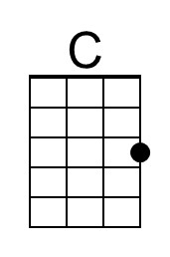 |  | 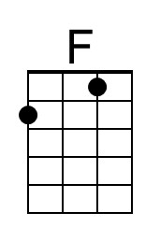 |  | 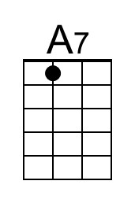 |  | 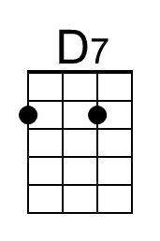
 |  |  |  |  | 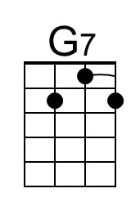 |  | 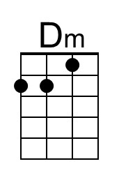 |  | 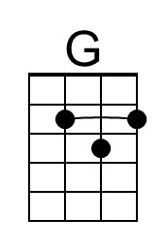 |  | 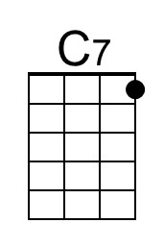
Baritone | 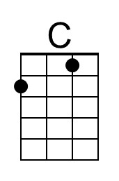 | 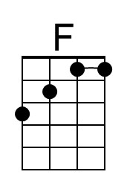 | 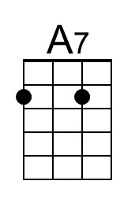 | 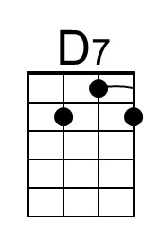 |  | 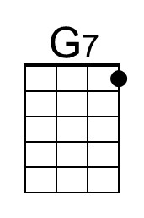 |  | 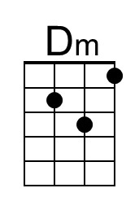 |  | 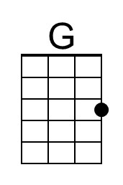 |  | 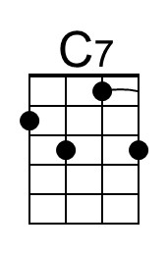

You Become Someone Else for the Holidays
C95 G
“Meet Your Holiday Selves,” Nexium Commercial (2015)
Tune: “There’s No Place Like Home for The Holidays” (About 90 BPM)

Intro (Chords for 2 last lines)  G C G  You become someone else for the holidays  E7 A7 D7  Eating, drinking, toasting every day  G C G  You lose all inhibitions for the Holidays  D7 Am D7 G – G7  Everybody celebrates in their own way  C  I’ll take a bit of this, a touch of that  G  and a smidge of this thing too  D7 G – G7  And a tiny sliver of this pumpkin pie  C  Well, I’ve had five Grande’ latte’s  G  and sixteen expressos, too  D Em  I licked the batter off this beater,  D D7  gee, this frosting can’t get sweeter  G C G  Oh I love everything about the Holidays  E7 A7 – D7  I’d like to raise a glass or two, or ten  Spoken  Enough with the toasts!  G C G  Oh I HATE every-thing about the Holidays  D7 Am D7 G – G7  When will all this stress and chaos ever end?  C  I’ll put some tinsel here, a bauble there,  G  a wreath around the dog  D7  Well the neighbors will be jealous,  G – G7  that’s for sure |  |  |  |  | C  My plate is filled with cookies, ice cream,  G  toffee, tarts and fudge  D A7  Man, that turkey looks horrific,  D D7  but this broccoli tastes terrific  G C G  I drink plenty of nog for the Holidays  E7  And since no one likes it here,  D7 – G7  there’s more for me.  G C  I’ve got breakfast and lunch  G  in my purse right here  D7 Am D7 G  And I’m eating like a king all week for free.  G C G  You become someone else for the holidays  E7 A7 – D7  Eating, drinking, toasting every day  G C G  So take care of yourself through the Holidays  D7 Am D7 G  And make sure that you’re protected all the way,  D7 Am D7 G  And make sure that you’re protected all the way!
 |  |  |  |  |  |  |  |  | 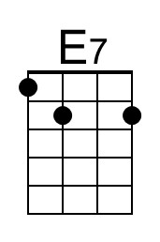
 |  |  |  |  |  |  | 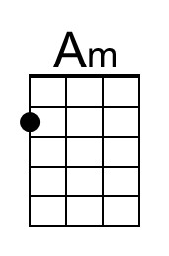 |  | 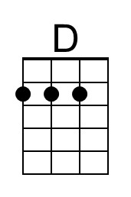
Baritone |  |  | 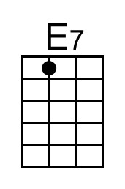 |  |  |  |  | 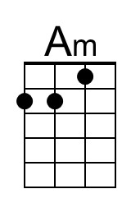 |  | 