**You Become Someone Else for the Holidays (Nexium Commercial)**

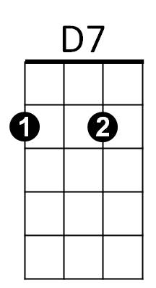



G

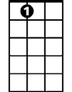

A7

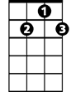

G7

F

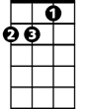

Dm



C

**C F C**

You become someone else for the holidays

**A7 D7 G7**

Eating, drinking, toasting every day

**C F C**

You lose all inhibitions for the Holidays

**G7 Dm G7 C**

Everybody celebrates in their own way

**F C**

I’ll take a bit of this, a touch of that and a smidge of this thing too

**G7 C**

And a tiny sliver of this pumpkin pie

**F C**

Well, I’ve had five Grande’ latte’s and sixteen expressos, too

**G Am G G7**

I licked the batter off this beater, gee, this frosting can’t get sweeter

**C F C**

Oh I love everything about the Holidays

**A7 D7 G7**

I’d like to raise a glass or two, or ten

**C F C**

(Enough with the toasts) Oh I HATE everything about the Holidays

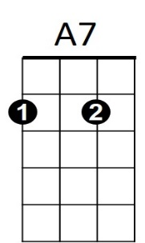**G7 Dm G7 C**



G

**BARITONE**

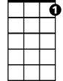

G7

C



D7

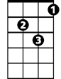

Dm



F

When will all this stress and chaos ever end?

**F C**

I’ll put some tinsel here, a bauble there, a wreath around the dog

**G7 C**

Well the neighbors will be jealous, that’s for sure

**F C**

My plate is filled with cookies, ice cream, toffee, tarts and fudge

**G D7 G G7**

Man, that turkey looks horrific, but this broccoli tastes terrific

**C F C**

I drink plenty of nog for the Holidays

**A7 D7 G7**

And since no one likes it here, there’s more for me

**C F C**

I’ve got breakfast and lunch in my purse right here

**G7 Dm G7 C**

And I’m eating like a king all week for free

**C F C**

You become someone else for the holidays

**A7 D7 G7**

Eating, drinking, toasting every day

**C F C**

So take care of yourself through the Holidays

**G7 Dm G7 C G7 Dm G7 C**

And make sure that you’re protected all the way, and make sure that you’re protected all the way!