**You Can Close Your Eyes (James Taylor)**

Em

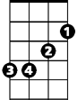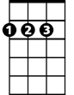

D



G

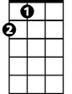

A

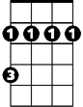

Bm

**D G D A**

Well the Sun is surely sin - kin' down,

**Em D A G Em A**

And the Moon is slowly ri - sing.

**D G D A**

So this old world must still be spinnin' 'round,



Bm



C

**Em D A D G D A D**

And I still love you.

**G D A C G Bm**

So close your eyes, you can close your eyes, it’s alright.

**Em A C G Bm**

I don't know no love songs, and I can’t sing the blues anymore.

**Em A G Em A G A Bm G A**

But I can sing this song; and you can sing this song, when I'm gone.

**BARITONE**



D

C

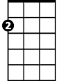

Em

Bm



G



A

**D G D A**

It won't be long before another day.

**Em D A G Em A**

We gonna have a good time,

**D G D A**

And no one’s gonna take that time away.

**Em A D G D A D**

You can stay as long as you like.

**G D A C G Bm**

So close your eyes, you can close your eyes, it’s alright.

**Em A C G Bm**

I don't know no love songs, and I can’t sing the blues anymore.

**Em A G Em A G A Bm G D A D**

But I can sing this song; and you can sing this song, when I'm gone.