You Can't Rollerskate In A Buffalo Herd (Roger Miller) (C)
You Can't Rollerskate In A Buffalo Herd by Roger Miller (In Ab)

Intro (4 Measures) C  C  You can't rollerskate in a buffalo herd  G  You can't rollerskate in a buffalo herd  C  You can't rollerskate in a buffalo herd  G C  But you can be happy if you've a mind to.  C  You can't take a shower in a parakeet cage.  G  You can't take a shower in a parakeet cage  C  You can't take a shower in a parakeet cage  G C  But you can be happy if you've a mind to.  Chorus  F C  All you have to do is put your mind to it  D7 G  Knuckle down, buckle down, do it, do it, do it !  C  You can't go swimming in a baseball pool  G  You can't go swimming in a baseball pool  C  You can't go swimming in a baseball pool  G C  But you can be happy if you've a mind to. |  |  |  | Instrumental Verse  C  You can't change film with a kid on your back  G  You can't change film with a kid on your back  C  You can't change film with a kid on your back  G C  But you can be happy if you've a mind to.  C  You can't drive around with a tiger in your car  G  You can't drive around with a tiger in your car  C  You can't drive around with a tiger in your car  G C  But you can be happy if you've a mind to. Chorus  Repeat First Verse  C  You can't go fishin' in a watermelon patch  G  You can't go fishin' in a watermelon patch  C  You can't go fishin' in a watermelon patch  G C  But you can be happy if you've a mind to.  Repeat First Verse (2x)
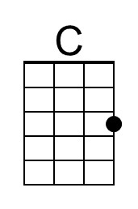 | 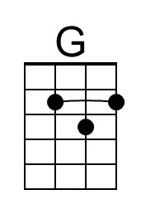 | 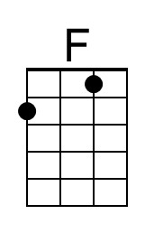 | 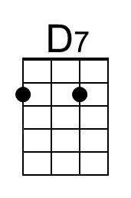 | 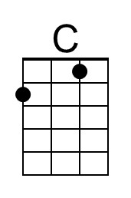 | 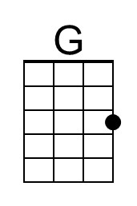 | 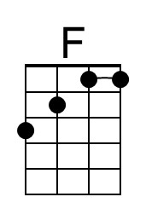 | 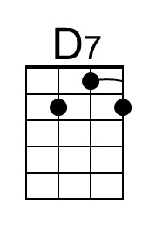

You Can't Rollerskate In A Buffalo Herd (Roger Miller) (G)
You Can't Rollerskate In A Buffalo Herd by Roger Miller (In Ab)

Intro (4 Measures) G  G  You can't rollerskate in a buffalo herd  D  You can't rollerskate in a buffalo herd  G  You can't rollerskate in a buffalo herd  D G  But you can be happy if you've a mind to.  G  You can't take a shower in a parakeet cage.  D  You can't take a shower in a parakeet cage  G  You can't take a shower in a parakeet cage  D G  But you can be happy if you've a mind to.  Chorus  C G  All you have to do is put your mind to it  A7 D  Knuckle down, buckle down, do it, do it, do it !  G  You can't go swimming in a baseball pool  D  You can't go swimming in a baseball pool  G  You can't go swimming in a baseball pool  D G  But you can be happy if you've a mind to. |  |  |  | Instrumental Verse  G  You can't change film with a kid on your back  D  You can't change film with a kid on your back  G  You can't change film with a kid on your back  D G  But you can be happy if you've a mind to.  G  You can't drive around with a tiger in your car  D  You can't drive around with a tiger in your car  G  You can't drive around with a tiger in your car  D G  But you can be happy if you've a mind to. Chorus  Repeat First Verse  G  You can't go fishin' in a watermelon patch  D  You can't go fishin' in a watermelon patch  G  You can't go fishin' in a watermelon patch  D G  But you can be happy if you've a mind to.  Repeat First Verse (2x)
 | 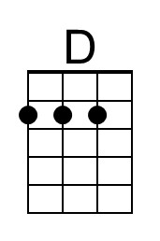 |  | 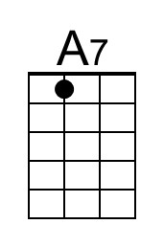 |  | 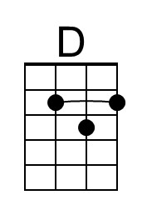 |  | 