You Don't Own Me (John Madara & David White, 1963) (C)
You Don't Own Me by Lesley Gore (D – 95 BPM)

Intro Cm Cm  Fm  You don't own me,  G7 Fm G Cm  I'm not just one of your many toys  Fm  You don't own me,  G7 Fm G Cm  Don't say I can't go with other boys  C  And don't tell me what to do  Am  And don't tell me what to say  F  And please, when I go out with you,  G G7 Cm  Don't put me on display, ' cause  Fm  You don't own me,  G7 Fm G Cm  Don't try to change me in any way  Fm  You don't own me,  G7 Fm G Cm  Don't tie me down 'cause I'd never stay  C  Oh, I don't tell you what to say  Am  I don't tell you what to do  F  So just let me be myself,  G G7  That's all I ask of you. |  |  |  | C  I'm young and I love to be young  Am  I'm free and I love to be free  F  To live my life the way I want  G G7  To say and do what-ever I please  Cm Fm G7 Fm G C (2x)  C  Aaah don't tell me what to do  Am  And don't tell me what to say  F  And please, when I go out with you,  G G7  Don't put me on display  C  I don't tell you what to say  Am  Oh-h-h-h don't tell you what to do  F  So just let me be myself  G G7  That's all I ask of you  C  I'm young and I love to be young  Am  I'm free and I love to be free  F  To live my life the way I want  G G7  To say and do what-ever I please  Cm Fm C  You don't own me… |  |  | 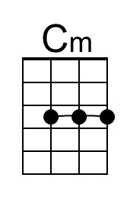
 |  |  |  |  |  |  | 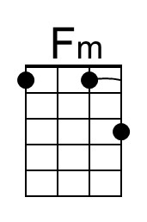
 |  |  |  |  |  |  | 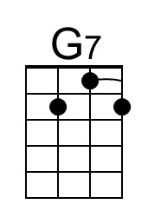
 |  |  |  |  |  |  | 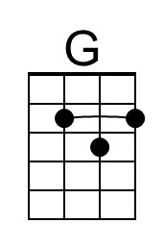
 |  |  |  |  |  |  | 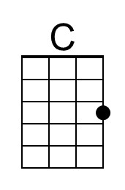
 |  |  |  |  |  |  | 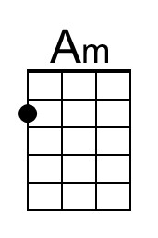
 |  |  |  |  |  |  | 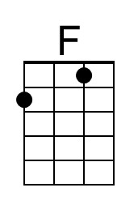
Bari | 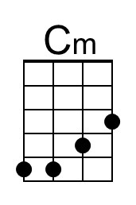 | 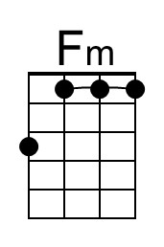 | 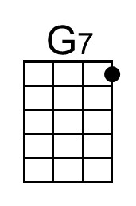 | 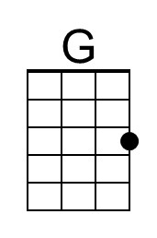 | 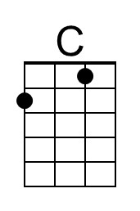 | 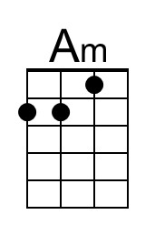 | 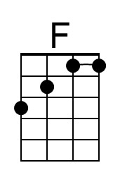

You Don't Own Me (John Madara & David White, 1963) (D)
You Don't Own Me by Lesley Gore (D – 95 BPM)

Intro Dm Dm  Gm  You don't own me,  A7 Gm A Dm  I'm not just one of your many toys  Gm  You don't own me,  A7 Gm A Dm  Don't say I can't go with other boys  D  And don't tell me what to do  Bm  And don't tell me what to say  G  And please, when I go out with you,  A A7 Dm  Don't put me on display, ' cause  Gm  You don't own me,  A7 Gm A Dm  Don't try to change me in any way  Gm  You don't own me,  A7 Gm A Dm  Don't tie me down 'cause I'd never stay  D  Oh, I don't tell you what to say  Bm  I don't tell you what to do  G  So just let me be myself,  A A7  That's all I ask of you. |  |  |  | D  I'm young and I love to be young  Bm  I'm free and I love to be free  G  To live my life the way I want  A A7  To say and do what-ever I please  Instrumental (2x)  Dm Gm A7 Gm A D  D  Aaah don't tell me what to do  Bm  And don't tell me what to say  G  And please, when I go out with you,  A A7  Don't put me on display  D  I don't tell you what to say  Bm  Oh-h-h-h don't tell you what to do  G  So just let me be myself  A A7  That's all I ask of you  D  I'm young and I love to be young  Bm  I'm free and I love to be free  G  To live my life the way I want  A A7  To say and do what-ever I please  Dm Gm D  You don't own me… |  |  | 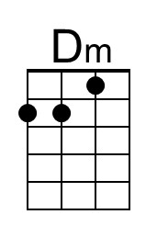
 |  |  |  |  |  |  | 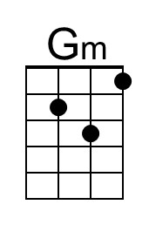
 |  |  |  |  |  |  | 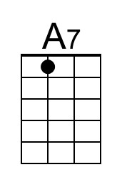
 |  |  |  |  |  |  | 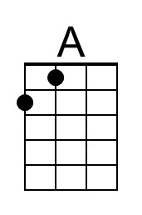
 |  |  |  |  |  |  | 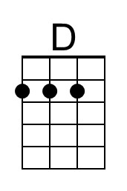
 |  |  |  |  |  |  | 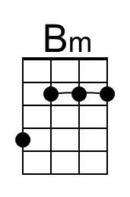
Bari | 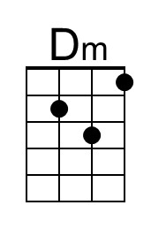 | 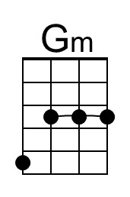 | 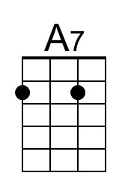 | 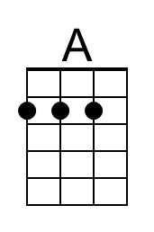 | 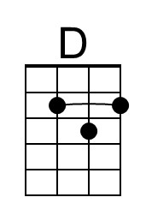 | 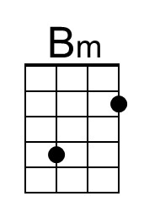

You Don't Own Me (John Madara & David White, 1963) (G)
You Don't Own Me by Lesley Gore (D – 95 BPM)

Intro Gm Gm  Cm  You don't own me,  D7 Cm D Gm  I'm not just one of your many toys  Cm  You don't own me,  D7 Cm D Gm  Don't say I can't go with other boys  G  And don't tell me what to do  Em  And don't tell me what to say  C  And please, when I go out with you,  D D7 Gm  Don't put me on display, ' cause  Cm  You don't own me,  D7 Cm D Gm  Don't try to change me in any way  Cm  You don't own me,  D7 Cm D Gm  Don't tie me down 'cause I'd never stay  G  Oh, I don't tell you what to say  Em  I don't tell you what to do  C  So just let me be myself,  D D7  That's all I ask of you |  |  |  | G  I'm young and I love to be young  Em  I'm free and I love to be free  C  To live my life the way I want  D D7  To say and do what-ever I please  Gm Cm D7 Cm D G (2x)  G  Aaah don't tell me what to do  Em  And don't tell me what to say  C  And please, when I go out with you,  D D7  Don't put me on display  G  I don't tell you what to say  Em  Oh-h-h-h don't tell you what to do  C  So just let me be myself  D D7  That's all I ask of you  G  I'm young and I love to be young  Em  I'm free and I love to be free  C  To live my life the way I want  D D7  To say and do what-ever I please  Gm Cm G  You don't own me
 |  |  |  |  |  |  | 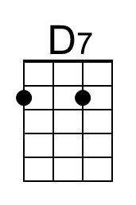
 |  |  |  |  |  |  | 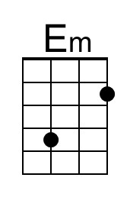
Bari |  | 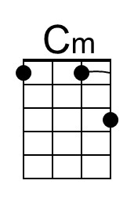 | 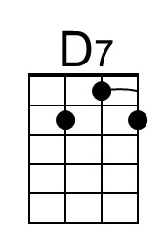 |  |  | 