You Make Me Feel Brand New (Thom Bell & Linda Creed, 1974)
Keys of A to C - GCEA

Intro: DΔ7 | Bm7 | C#m7 | F#m7 . Bm7 Em7 (2x) DΔ7 . . C#m7 | Bm7 Bm7 . . | A | A . .

A Dm A  My love, I'll never find the words, my love  Dm A  To tell you how I feel, my love,  C#m7 B7 Bm7 E7  mere words . . . could not . . . ex-plain  Dm7 G7 C Fm C  Pre - cious love, You held my life within your hands  Fm C Fm C  Cre-ated everything I am, Taught me how to live a-gain  Em Am Em  Only you, cared when I needed a friend  Am Dm7  Be-lieved in me through thick and thin  FΔ7 Em7 Dm7 Em7 FΔ7 Dm7 G  This song is for you, filled with grati-tude and love.  Dm7 G7 FΔ7 Dm7 Em7  God bless you, You make me feel brand new  Em7 Em Dm7 G7 FΔj7 Dm7 Em7  For God blessed me with you You make me feel brand new  Em7 Em Dm7 G7 FΔ7 Em7 Dm7  I sing this song 'cause you  Dm7 C Fm A A  Make me feel brand new  A Dm A  My love, when-ever I was inse-cure,  Dm A  you built me up and made me sure  C#m7 B7 Bm7 E7  You gave . . . my pride . . . back to me  Dm7 G7 C Fm C  Pre - cious friend, with you, I'll always have a friend  Fm C  You're someone who I can de-pend,  Fm C  to walk a path that sometimes bends  Em Am Em  Without you, Life has no meaning or rhyme,  Am Dm7  like notes to a song out of time  FΔ7 Em Dm7 Em7 FΔ7 Dm7 G  How can I re-pay you for having faith in me?  God bless you… | GCEA
 | 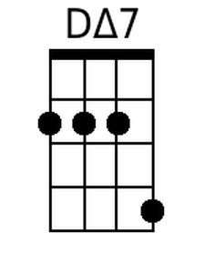 | 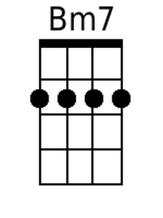 | 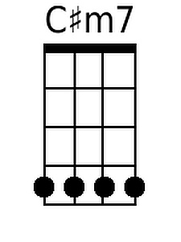
 | 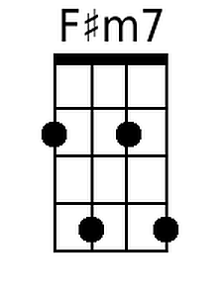 | 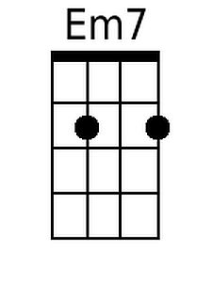 | 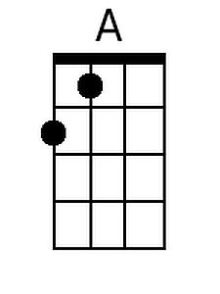
 | 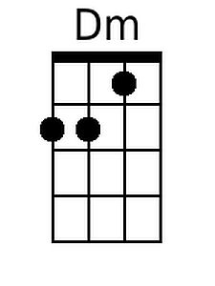 | 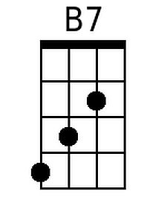 | 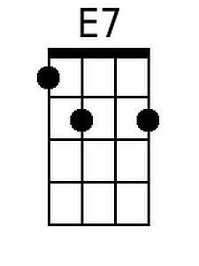
 | 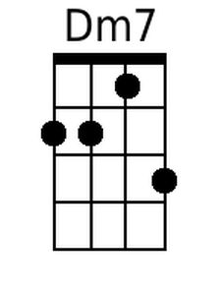 | 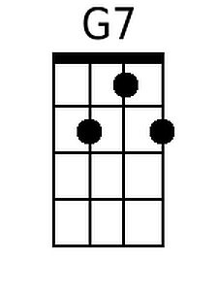 | 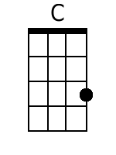
 | 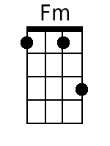 | 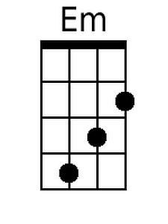 | 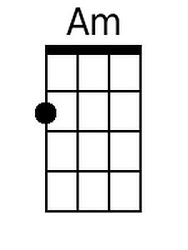
 | 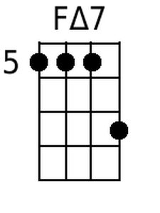 | 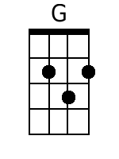

You Make Me Feel Brand New (Thom Bell & Linda Creed, 1974)
Keys of A to C - DGBE

Intro: DΔ7 | Bm7 | C#m7 | F#m7 . Bm7 Em7 (2x) DΔ7 . . C#m7 | Bm7 Bm7 . . | A | A . .

A Dm A  My love, I'll never find the words, my love  Dm A  To tell you how I feel, my love,  C#m7 B7 Bm7 E7  mere words . . . could not . . . ex-plain  Dm7 G7 C Fm C  Pre - cious love, You held my life within your hands  Fm C Fm C  Cre-ated everything I am, Taught me how to live a-gain  Em Am Em  Only you, cared when I needed a friend  Am Dm7  Be-lieved in me through thick and thin  FΔ7 Em7 Dm7 Em7 FΔ7 Dm7 G  This song is for you, filled with grati-tude and love.  Dm7 G7 FΔ7 Dm7 Em7  God bless you, You make me feel brand new  Em7 Em Dm7 G7 FΔ7 Dm7 Em7  For God blessed me with you You make me feel brand new  Em7 Em Dm7 G7 FΔ7 Em7 Dm7  I sing this song 'cause you  Dm7 C Fm A A  Make me feel brand new  A Dm A  My love, when-ever I was inse-cure,  Dm A  you built me up and made me sure  C#m7 B7 Bm7 E7  You gave . . . my pride . . . back to me  Dm7 G7 C Fm C  Pre - cious friend, with you, I'll always have a friend  Fm C  You're someone who I can de-pend,  Fm C  to walk a path that sometimes bends  Em Am Em  Without you, Life has no meaning or rhyme,  Am Dm7  like notes to a song out of time  FΔ7 Em Dm7 Em7 FΔ7 Dm7 G  How can I re-pay you for having faith in me?  God bless you… | DGBE
 | 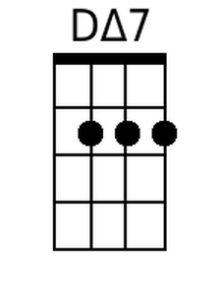 | 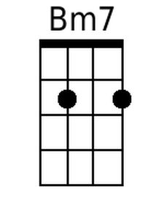 | 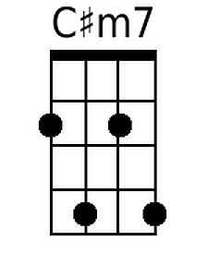
 | 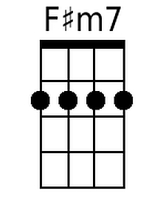 | 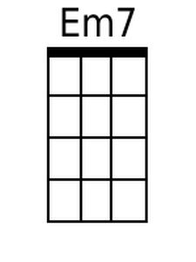 | 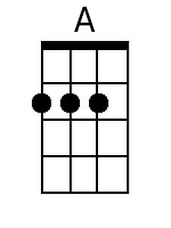
 | 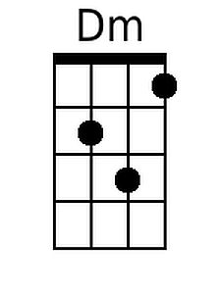 | 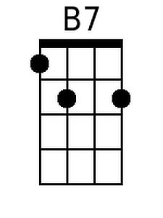 | 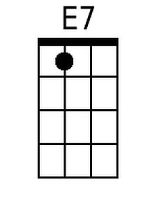
 | 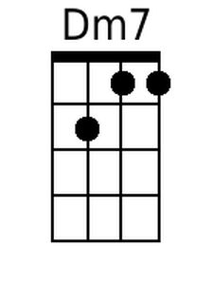 | 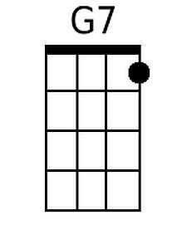 | 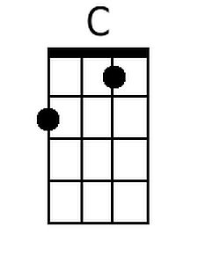
 | 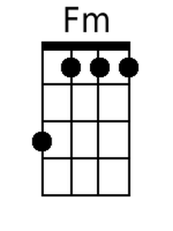 | 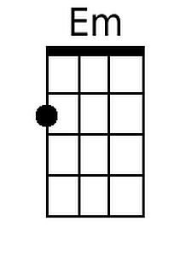 | 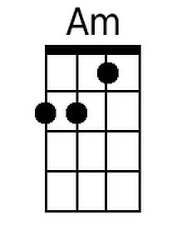
 | 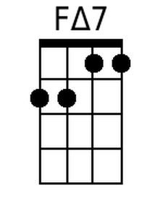 | 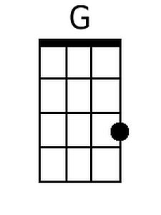

You Make Me Feel Brand New (Thom Bell & Linda Creed, 1974)
Keys of D to F – GCEA

Intro: GΔ7 | Em7 | F#m7 | Bm7 . Em7 Am7 (2x) GΔ7 . . F#m7 | Em7 Em7 . . | D | D . .

D Gm D  My love, I'll never find the words, my love  Gm D  To tell you how I feel, my love,  F#m7 E7 Em7 A7  mere words . . . could not . . . explain  Gm7 C7 F Bbm F  Pre - cious love, you held my life within your hands  Bbm F Bbm F  Cre-ated everything I am, Taught me how to live a-gain  Am Dm Am  Only you, cared when I needed a friend  Dm Gm7  Be-lieved in me through thick and thin  BbΔ7 Am7  This song is for you,  Gm7 Am7 BbΔ7 Gm7 C  filled with grati-tude and love.  Gm7 C7 BbΔ7 Gm7 Am7  God bless you, You make me feel brand new  Am7 Am Gm7 C7 BbΔ7  For God blessed me with you  Gm7 Am7  You make me feel brand new  Am7 Am Gm7 C7 BbΔ7 Am7 Gm7  I sing this song 'cause you  Gm7 F Bbm D D  Make me feel brand new  D Gm D  My love, when-ever I was inse-cure,  Gm D  you built me up and made me sure  F#m7 E7 Em7 A7  You gave . . . my pride . . . back to me  Gm7 C7 F Bbm F  Pre - cious friend, with you, I'll always have a friend  Bbm F  You're someone who I can de-pend,  Bbm F  to walk a path that sometimes bends  Am Dm Am  Without you, Life has no meaning or rhyme,  Dm Gm7  like notes to a song out of time  BbΔ7 Am Gm7 Am7 BbΔ7 Gm7 C  How can I re-pay you for having faith in me?  God bless you... | GCEA
 | 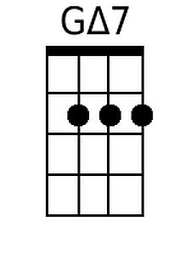
 |  | 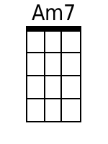 | 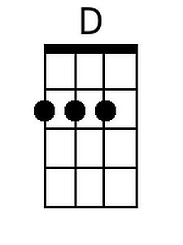
 | 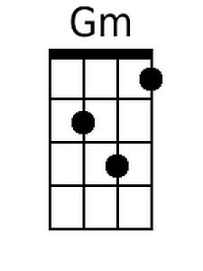 |  | 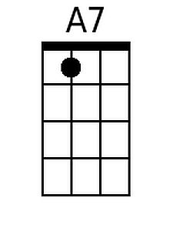
 | 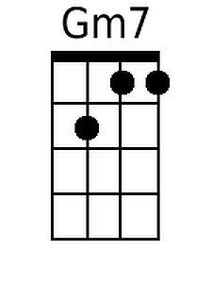 | 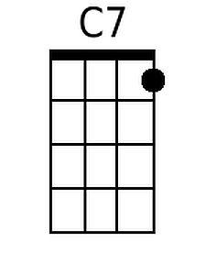 | 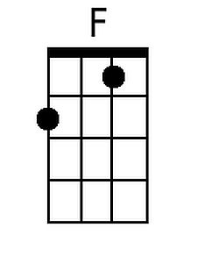
 | 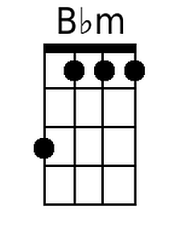
 | 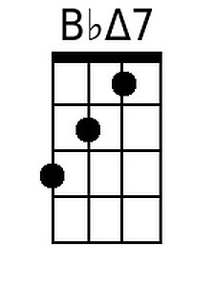

You Make Me Feel Brand New (Thom Bell & Linda Creed, 1974)
Keys of D to F – DGBE

Intro: GΔ7 | Em7 | F#m7 | Bm7 . Em7 Am7 (2x) GΔ7 . . F#m7 | Em7 Em7 . . | D | D . .

D Gm D  My love, I'll never find the words, my love  Gm D  To tell you how I feel, my love,  F#m7 E7 Em7 A7  mere words . . . could not . . . explain  Gm7 C7 F Bbm F  Pre - cious love, you held my life within your hands  Bbm F Bbm F  Cre-ated everything I am, Taught me how to live a-gain  Am Dm Am  Only you, cared when I needed a friend  Dm Gm7  Be-lieved in me through thick and thin  BbΔ7 Am7  This song is for you,  Gm7 Am7 BbΔ7 Gm7 C  filled with grati-tude and love.  Gm7 C7 BbΔ7 Gm7 Am7  God bless you, You make me feel brand new  Am7 Am Gm7 C7 BbΔ7  For God blessed me with you  Gm7 Am7  You make me feel brand new  Am7 Am Gm7 C7 BbΔ7 Am7 Gm7  I sing this song 'cause you  Gm7 F Bbm D D  Make me feel brand new  D Gm D  My love, when-ever I was inse-cure,  Gm D  you built me up and made me sure  F#m7 E7 Em7 A7  You gave . . . my pride . . . back to me  Gm7 C7 F Bbm F  Pre - cious friend, with you, I'll always have a friend  Bbm F  You're someone who I can de-pend,  Bbm F  to walk a path that sometimes bends  Am Dm Am  Without you, Life has no meaning or rhyme,  Dm Gm7  like notes to a song out of time  BbΔ7 Am Gm7 Am7 BbΔ7 Gm7 C  How can I re-pay you for having faith in me?  God bless you... | DGBE
 | 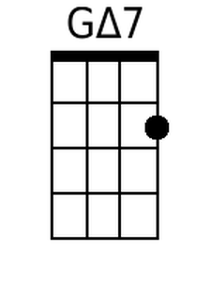
 |  | 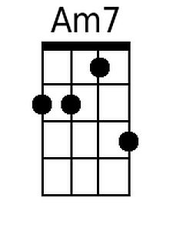 | 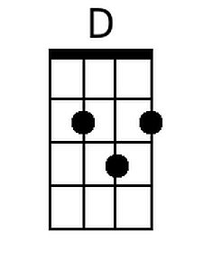
 | 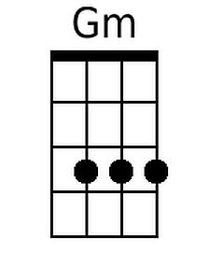 |  | 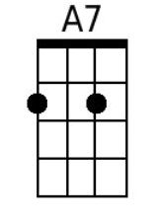
 | 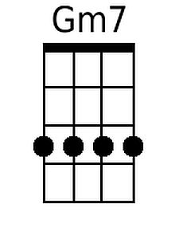 | 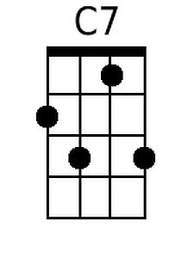 | 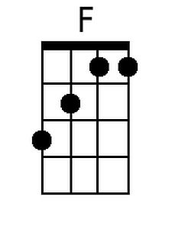
 | 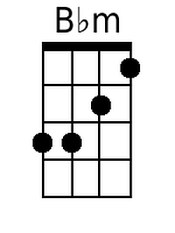
 | 