**You Send Me (Sam Cooke)**

**Intro: C Am Dm G7**

**C Am Dm G7 C Am Dm G7**

Darling you ~ send me, I know you ~ send m e

**C Am Dm G7 C**

Darling you - send me, honest you do,

**Am Dm G7**

Honest you do, honest you do, whoa

**C Am Dm G7 C Am Dm G7**

You ~ thrill me, I know you, you, you thrill me

**C Am Dm G7**

Darling, you, you, you, you thrill me

**C F C**

Honest you do

**Dm G7 C**

At first I thought it was infatuation,

**Dm G7 C**

But, wooh, it's lasted so long

**Dm G7 C Bb A7**

Now I find myself wa - nt -ing –

**D7 Dm G7**

To marry you and take you home, whoa

**C Am Dm G7 C Am Dm G7**

You, you, you, you send me, I know you ~ send me

**C Am Dm G7 C F C**

I know you ~ send me ~ Honest you do

**C Am Dm G7**

You ~ send me ~

Whoa-oh-oh, whenever I'm with you

**C Am Dm G7**

You ~ send me

I know, I know, I know when I'm near you

**C Am Dm G7**

You ~ send me

Mm hmm, mmm hmm,

**C Am**

Honest you do, honest you do

**Dm G7**

Whoa-oh-oh, I know-oh-oh-oh

**C Am Dm G7**

You ~ send me

I know, I know, I know, when you hold me

**C Am Dm G7**

You ~ send me

Whoa, whenever you kiss me

**C Am Dm G7**

You ~ send me

Mm hmm, mm hmm,

**C F C**

Honest you do, honest you do

**Dm G7 C**

At first I thought it was infatuation,

**Dm G7 C**

But, wooh, it's lasted so long

**Dm G7 C Bb A7**

Now I find myself wa - nt -ing –

**D7 Dm**

To marry you and take you home

**G7**

I know, I know, I know

**C Am Dm G7 C Am Dm G7**

You ~ send me - I know you - send me

**C Am Dm G7**

Whoa, you, you, you, you send me

**C D G**

Honest you do

**D Bm7 Em7 A7 D Bm7 Em7 A7**

You ~ send me, I know you ~ send me,

**D Bm7 Em7 A7**

I know you ~ send me,

**D G D Db6 Bm7**

Honest you do, honest you do, honest you do

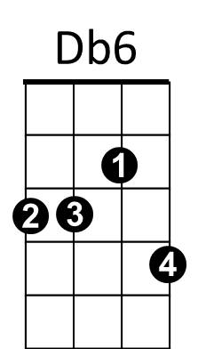

**BARITONE**

**Em7**

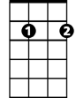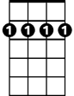

**Bm7**

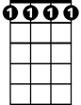

**Db6**

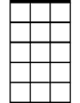

**Em7**

**Bm7**

