You Were On My Mind (Sylvia Fricker, 1961) (C)
You Were On My Mind by The We Five (1965) (E)

Intro N.C.  C F | C F | C F | C  C F G7 C F | G7  When I woke up this morning _ you were on my mind,  F Em Dm - G7  And _ you were on my mind.  C F C F  I got troubles, woe, oh woe, I got worries, woe, oh woe,  C Am F - G7  I got wounds __ to bind.  C F G7 C - F G7  So I went to the corner, just to ease my pain.  F Em Dm - G7  Yeah, just to ease my pain.  C F C F  I got troubles, woe, oh woe, I got worries, woe, oh woe,  C Am F - G7  I came home __ a-gain.  C F G7 C C+ F G7  But I woke up this morning _ You were on my mi-i-i-i-nd then  F Em Dm G7  _ You were on my mind.  C F C F  I got troubles, woe, oh woe, I got worries, woe, oh woe  C Am D7?  I got wounds __ to bind.  G7 A D G7 A D D+ G7 A  Hey and I got a feelin' __ down in my sho-o-o-o-es, said,  G7 F#m Em A7?  __ Way down in my sho-o-es.  D G7 D G7  Yeah, I got to ramble, woe, oh woe, I got to move on, woe, oh woe  D Bm Em7 - A  I got to walk a-way my blues.  D G7 A D G7 A  When I woke up this morning, __ you were on my mi-i-i-nd, and  G7 F#m Em - Asus4  __ You were on my mind.  D G7 D G7  Hey! I got troubles, woe, oh woe, I got worries, woe, oh woe  D Em C A7sus4 A7 - D Dsus4 D  I got wounds to bind. | 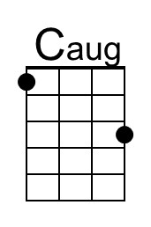 | 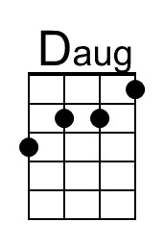
 | 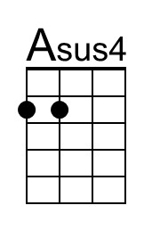 | 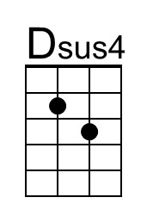
 | Baritone
 | 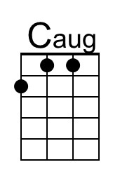 | 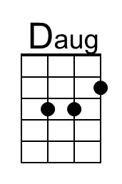
 | 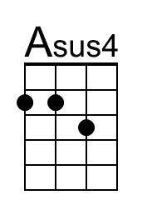 | 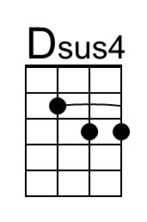

You Were On My Mind (Sylvia Fricker, 1961) (D)
You Were On My Mind by The We Five (1965) (E)

 | Caug | Daug
 | Asus4 | Dsus4
 | Baritone
 | Caug | Daug
 | Asus4 | Dsus4

You Were On My Mind (Sylvia Fricker, 1961) (G)
You Were On My Mind by The We Five (1965) (E)

 | Caug | Daug
 | Asus4 | Dsus4
 | Baritone
 | Caug | Daug
 | Asus4 | Dsus4

