**You Were On My Mind (Ian and Sylvia)**

**TACET C F G C F G**

When I woke up this morning, you were on my mind..

**F Em Dm G**

And, you were on my mind.

**C F C F**

I got troubles, whoa-oh..I got worries, whoa-oh..

**Am Dm G**

I got wounds to bi - nd.

**G C F C F G**

So, I went to the corner, just to ease my pain..

**F Em Dm G7**

Yeah, just to ease my pain.

**C F C F**

I got troubles, whoa-oh..I got worries, whoa-oh..

**Am G**

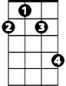

F#m

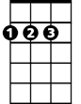

D

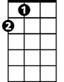

A

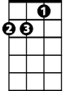

Dm

I came home again.

**G C F G C E7 Am G**

When I woke up this morning, you were on my mi – i – i - ind..

**F Em Dm G**

And you were on my mind.

**G C F C F**

**BARITONE**

I got troubles, whoa-oh..I got worries, whoa-oh..

**C Am D G**

I got wounds to bind.

**G A D G A D G A**

And I got a feelin'..down in my sho-oo-oo-oes, said..

**G F#m Em7 A**

Way down in my sho-oo-oes.

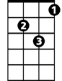

Dm

**D G**

Yeah, I got to ramble, whoa-oh..

**D G**

I got to move on, whoa-oh..

**D Bm Em7 A**

I got to walk away my blu-ues.

**TACET D G A D G A**

When I woke up this morning..you were on my mind..

**G F#m Em7 A7**

You were on my mind.

**D G D G**

I got troubles, whoa-oh..I got worries, whoa-oh..

**D Em7 C A7 D G A D**

I got wounds to bi – i - nd.

Em7

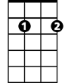

F



G

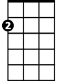

Am

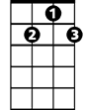

G7



C

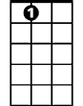

A7

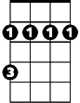

Bm

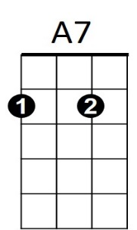



F

C

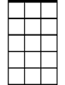

Em7

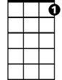

G7



Am



G

Bm

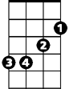

D



F#m



A