You’re a Mean One, Mr. Grinch
C83 Am
Theodor "Dr. Seuss" Geisel & Albert Hague (1966) – You're A Mean One, Mr. Grinch by Thurl Ravenscroft

Intro Am Dm / Am Dm / Am Dm E  Am Dm G Am B7 E  You’re a mean one, Mr. Grinch. You really are a heel.  Am Dm  You’re as cuddly as a cactus  G C F E  You’re as charming as an eel - Mister Gri – i - nch  Tacet Am Dm  You’re a bad banana with a - greasy black peel  Instrumental Am Dm / Am Dm E  Am Dm G  You’re a Monster, Mr. Grinch.  Am B7 E Am Dm  Your heart’s an empty hole. Your brain is full of spiders  G C F E  You’ve got garlic in your soul - Mister Gri – i - nch  Tacet  I wouldn’t touch you with a  E Am Dm  Thirty-nine and a half foot pole  Instrumental Am Dm / Am Dm E  Am Dm G  You’re a vile one, Mr. Grinch  Am B7 E  You’ve got termites in your smile  Am Dm  You have all the tender sweetness  G C F E  Of a seasick crocodile - Mister Gri – i - nch  Tacet  Given the choice between the two of you -  E Am Dm  I’d take the - seasick crocodile  Instrumental Am Dm / Am Dm E  Am Dm G  You’re a foul one, Mr. Grinch.  Am B7 E  You’re a nasty – wasty skunk.  Am Dm  Your heart is full of unwashed socks  G C F E  Your soul is full of gunk - Mister Gri – i - nch  Tacet  The three words that best describe you are as follows:  Dm E Am Dm  And I quote: Stink, Stank, Stunk!  Instrumental Am Dm / Am Dm E | Am Dm G  You’re a rotter, Mr. Grinch  Am B7 E  You’re the king of sinful sots  Am Dm  Your heart’s a dead tomato splotched  G C F E  With moldy purple spots - Mister Gri – i - nch  Tacet  Your soul is an appalling dump-heap overflowing with the most disgraceful assortment of deplorable rubbish imaginable mangled up in  E Am Dm  Tangled up knots  Instrumental Am Dm / Am Dm E  Am Dm G  You nauseate me, Mr. Grinch  Am B7 E  With a nauseous super “naus”  Am Dm  You’re a crooked jerky jockey  G C F E  And you drive a crooked horse - Mister Gri – i - nch  Tacet  You’re a three decker sauerkraut and toadstool sandwich  E Am Dm  With arsenic sauce  Outro Am Dm / Am Dm / Am Dm A
 | 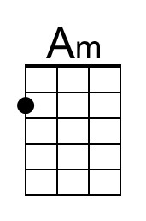 | 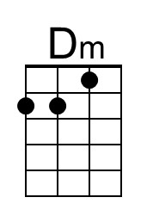 | 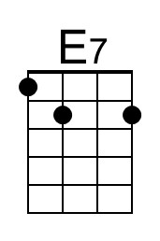 | 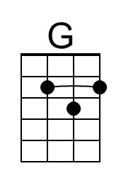
 | 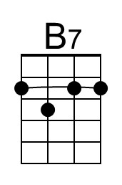 | 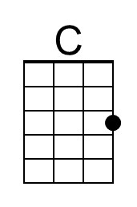 | 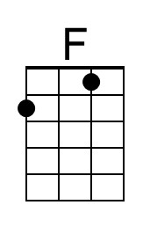
 | 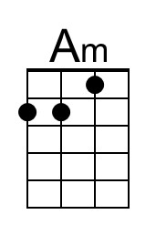 | 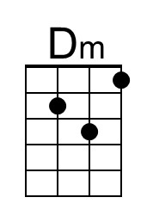 | 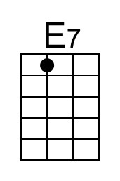 | 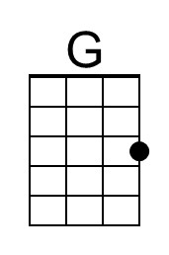
 | 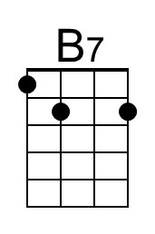 | 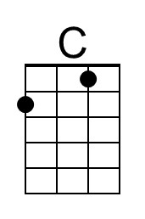 | 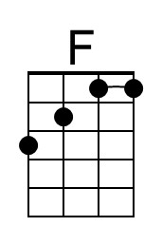


You’re a Mean One, Mr. Grinch
C83 Dm
Theodor "Dr. Seuss" Geisel & Albert Hague, 1966 – You're A Mean One, Mr. Grinch by Thurl Ravenscroft

Intro Dm Gm / Dm Gm / Dm Gm A  Dm Gm C Dm E7 A  You’re a mean one, Mr. Grinch. You really are a heel  Dm Gm  You’re as cuddly as a cactus  C F Bb A  You’re as charming as an eel - Mister Gri – i - nch  Tacet Dm Gm  You’re a bad banana with a - greasy black peel  Instrumental Dm Gm / Dm Gm A  Dm Gm C  You’re a Monster, Mr. Grinch  Dm E7 A  Your heart’s an empty hole  Dm Gm  Your brain is full of spiders  C F Bb A  You’ve got garlic in your soul - Mister Gri – i - nch  Tacet  I wouldn’t touch you with a  A Dm Gm  Thirty-nine and a half foot pole  Instrumental Dm Gm / Dm Gm A  Dm Gm C  You’re a vile one, Mr. Grinch  Dm E7 A  You’ve got termites in your smile  Dm Gm  You have all the tender sweetness  C F Bb A  Of a seasick crocodile - Mister Gri – i - nch  Tacet  Given the choice between the two of you -  A Dm Gm  I’d take the - seasick crocodile  Instrumental Dm Gm / Dm Gm A  Dm Gm C  You’re a foul one, Mr. Grinch  Dm E7 A  You’re a nasty – wasty skunk  Dm Gm  Your heart is full of unwashed socks  C F Bb A  Your soul is full of gunk - Mister Gri – i - nch  Tacet  The three words that best describe you are as follows:  Gm A Dm Gm  And I quote: Stink, Stank, Stunk!  Instrumental Dm Gm / Dm Gm A | Dm Gm C  You’re a rotter, Mr. Grinch  Dm E7 A  You’re the king of sinful sots  Dm Gm  Your heart’s a dead tomato splotched  C F Bb A  With moldy purple spots - Mister Gri – i - nch  Tacet (Spoken)  Your soul is an appalling dump-heap overflowing with the most disgraceful assortment of deplorable rubbish imaginable mangled up in  A Dm Gm  Tangled up knots.  Instrumental Dm Gm / Dm Gm A  Dm Gm C  You nauseate me, Mr. Grinch  Dm E7 A  With a nauseous super “naus”  Dm Gm  You’re a crooked jerky jockey  C F Bb A  And you drive a crooked horse - Mister Gri – i - nch  Tacet  You’re a three decker sauerkraut and toadstool sandwich  A Dm Gm  With arsenic sauce  Outro Dm Gm / Dm Gm / Dm Gm D
 |  | 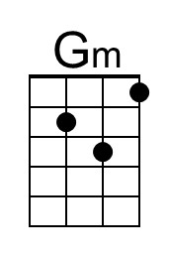 | 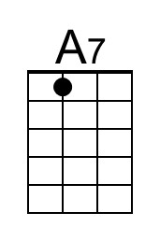
 |  |  | 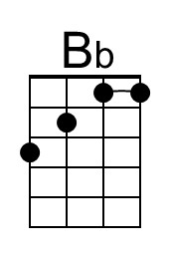
 |  | 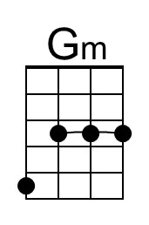 | 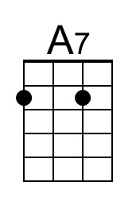
 |  |  | 