**You'll Never Walk Alone**

**(Oscar Hammerstein II / Richard Rodgers)**

**C G**

When you walk through a storm hold your head up high

**F C G Gm**

and don't be afraid of the dark



C



G

F

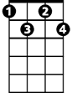

Fdim

E7

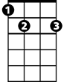

**Dm Bb F Dm**

At the end of a storm is a golden sky

**Bb F Gm F E7 C7**

and the sweet silver song of a lark

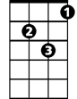

Gm

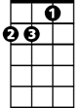

Dm



Bb

**F Fdim**

Walk on through the wind

**C Fm**

walk on through the rain

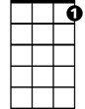

C7

**C Em F G7**

though your dreams be tossed and blown

**C Eaug F D7**

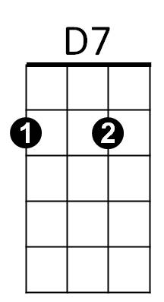Walk on walk on with hope in your heart

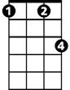

Fm

Em

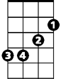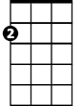

Am

**BARITONE**

**C Eaug Em**

and you'll never walk alone

**G7 C Am F G7 C**

you'll ne-ver walk a – lone

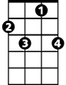

C7

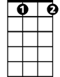

Fdim

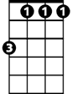

Fm



Am

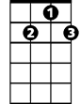

D7



Em



G



F

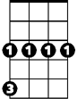

Gm



Dm

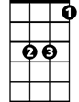

Bb



E7

C



**(Repeat Song, extend last line)**