**You're a Grand Old Flag**

**(Paul J. Frederick / Valerie Peterson / George M Cohan)**

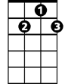

G7



G

F



C

**C**

You're a grand old flag,

**F C**

You're a high flying flag

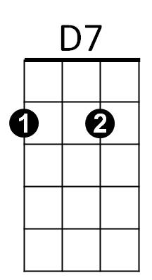 **G**

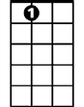

A7

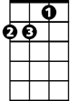

Dm

And forever in peace may you wave

**G7 C**

You're the emblem of the land I love

**D7 G G7**

The home of the free and the brave

**C**

Every heart beats true

**F C**

For the red white and blue

**BARITONE**

**A7 Dm G7**



G



F

C



Where there's never a boast or brag

**C G**

Should old acquaintance be forgot

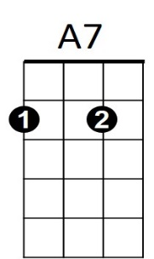 **D7 G7 C**

Keep your eye on the grand old flag



D7

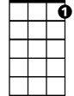

G7

**(Repeat song)**

**D7 G C**

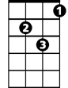

Dm

Keep your eye on the grand old flag

**D7 G C**

Keep your eye on the grand old flag