Chordius Chord Types - Version 2.1.0.0.
Chordius by Jon Thysell

Description | Abbreviation | Construction

Augmented | aug | 0,4,8
Augmented 7th | aug7 | 0,4,8,10
Augmented Dominant 9th | aug9 | 0,4,8,10,14
Augmented Dominant 11th | aug11 | 0,4,8,10,14, 17
Augmented Dominant 13th | aug13 | 0,4,8,10,14, 17, 21
Augmented Major 7th | M7(#5) | 0,4,8,11
Augmented Major 9th | aug/M9 | 0,4,8,11,14
Augmented Major 11th | aug/M11 | 0,4,8,11,14,17
Augmented Major 13th | aug/M13 | 0,4,8,11,14,17,21
Diminished | dim | 0,3,6
Diminished 7th | dim7 | 0,3,6,9
Diminished 9th | dim9 | 0,3,6,9,14
Diminished 11th | dim11 | 0,3,6,9,13,16
Diminished Minor 9th | dim(b9) | 0,3,6,9,13
Dominant 7th | 7 | 0,4,7,10
Dominant 7th Flat 5 | 7(b5) | 0,4,6,10
Dominant 7th Suspended 2nd | 7sus2 | 0,2,7,10
Dominant 7th Suspended 4th | 7sus4 | 0,5,7,10
Dominant 9th | 9 | 0,4,7,10,14
Dominant 11th | 11 | 0,4,7,10,14,17
Dominant 13th | 13 | 0,4,7,10,14,17,21
Half- Diminished 7th | m7(b5) | 0,3,6,10
Half- Diminished 9th | Ø9 | 0,3,6,10,14
Half- Diminished 11th | Ø11 | 0,3,6,10,13,17
Half- Diminished 13th | Ø13 | 0,3,6,10,14,17,21
Half-Diminished Minor 9th | Øb9 | 0,3,6,10,13
Major |  | 0,4,7
Major 6th | 6 | 0,4,7,9
Major 6th 9th | 6/9 | 0,4,7,9,14
Major 7th | maj7 | 0,4,7,11
Major 7th Suspended 2nd | M7sus2 | 0,2,7,11
Major 7th Suspended 4th | M7sus4 | 0,5,7,11
Major 9th | M9 | 0,4,7,11,14
Major 11th | maj11 | 0,4,7,11,14,17
Major 13th | maj13 | 0,4,7,11,14,17,21
Major Added 2nd | add2 | 0,2,4,7
Major Added 4th | add4 | 0,4,5,7
Major Added 9th | add9 | 0,4,7,14
Major Added 11th | add11 | 0,4,7,17
Minor | m | 0,3,7
Minor 6th | m6 | 0,3,7,9
Minor 6th 9th | m6/9 | 0,3,7,9,14
Minor 7th | m7 | 0,3,7,10
Minor 9th | m9 | 0,3,7,10,14
Minor 11th | m11 | 0,3,7,10,14,17
Minor 13th | m13 | 0,3,7,10,14,17,21
Minor Added 2nd | madd2 | 0,2,3,7
Minor Added 4th | madd4 | 0,3,5,7
Minor Added 9th | madd9 | 0,3,7,14
Minor Added 11th | madd11 | 0,3,7,17
Minor/Major 7th | m/M7 | 0,3,7,11
Minor/Major 9th | m/M9 | 0,3,7,11,14
Minor/Major 11th | m/M11 | 0,3,7,11,14,17
Minor/Major 13th | m/M13 | 0,3,7,11,14,17,21
Suspended 2nd | sus2 | 0,2,7
Suspended 4th | sus4 | 0,5,7

Total = 56 Chord Forms

Chord Namer, UkeBuddy – Allows entry of notes on a ukulele neck and the website will tell you the name of the chord.
https://ukebuddy.com/chord-namer
Screenshots
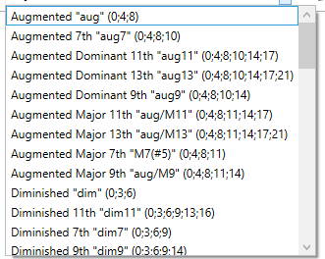 | 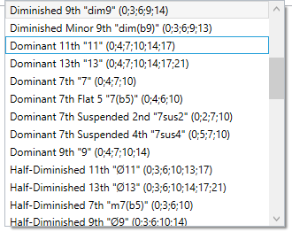
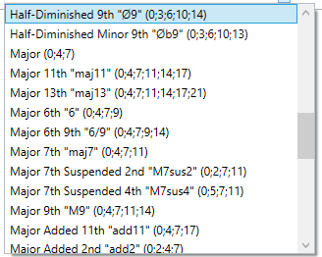 | 