It Keeps You Running (Michael McDonald, 1976) (G)
It Keeps You Running by Doobie Brothers from the album Takin' It to the Streets (G @ 133)
It Keeps You Running by Doobie Brothers (Live On Soundstage In Chicago from The Livin' On The Fault Line Tour, 1977) (G @ 133)
It Keeps You Running by Carly Simon from Another Passenger (1976) (G @ 145)
4/4 Time
Intro (4x)
| G7 | _ _ C _ | G7 | _ _ C _ |

Bm7 Bb7 Am7 | Ab7 G7 | _ _ C _ | G7 | _ _ C _ |
___ Say, where you gonna go? Girl, where you gonna hide?
Bm7 Bb7 Am7 Ab7 G7 | _ _ C _ | G7
___ You go on leavin' out your heart, and all it's sayin' down deep in-side.
B9 | _ Am _ B9
From here I can feel your heartbeat.
C7 G7 | _ _ C _ | G7
Oh, you got me all wrong,
B9 | _ Am | C B9
You ain't got no worry,
Am G7 | _ _ C _ | G7 | _ _ C _ |
You just been lone – ly too long.

Chorus
Em7 A9 D7sus4 | D7
___ I know what it means to hide your heart
B7 A7 B7 Em7 D7
___ From a long time a - go. _ Oh, darlin'
D Cmaj7 D Cmaj7
_ It keeps you run - nin', yeah, it keeps you run - nin'
D Em D Em
_ It keeps you run - nin', yeah, it keeps you run - nin'
D Cmaj7 D Cmaj7
_ It keeps you run - nin', yeah, it keeps you run - nin'
D Em D Em
_ It keeps you run - nin', yeah, it keeps you run - nin'

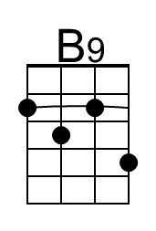 | 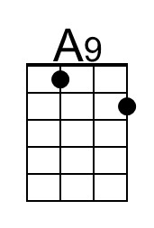 | 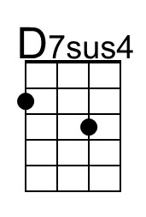 | 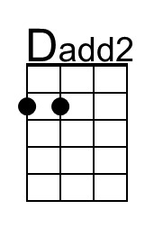 | Baritone | 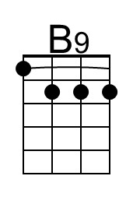 | 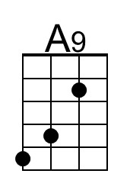 | 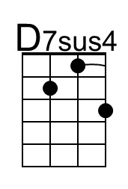 | 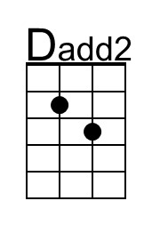

It Keeps You Running (G) – Page 2

Bm7 Bb7 Am7 | Ab7 G7 | _ _ C _ | G7 | _ _ C _ |
___ Oh, you know how I feel . Hey, you know I been there.
Bm7 Bb7 Am7 Ab7 G7 | _ _ C _ | G7
___ But what you're keepin' to your-self ___ Oh, you know it just ain't fair
B9 | _ Am _ B9
Are you gonna worry,
C7 G7 | _ _ C _ | G7
For the rest of your life?
B9 | _ Am | C B9
Why you in such a hurry,
Am G7 | _ _ C _ | G7 | _ _ C _ |
To be lonely one more night?

Chorus
Em7 A9 D7sus4 | D7
___ I know what it means to hide your heart
B7 A7 B7 Em7 D7
___ From a long time a - go. _ Oh, darlin'
D Cmaj7 D Cmaj7
_ It keeps you run - nin', yeah, it keeps you run - nin'
D Em D Em
_ It keeps you run - nin', yeah, it keeps you run - nin'
D Cmaj7 D Cmaj7
_ It keeps you run - nin', yeah, it keeps you run - nin'
D Em D Em
_ It keeps you run - nin', yeah, it keeps you run - nin'

Outro
D Cmaj7 D Cmaj7 | Bm7
_ It keeps you run - nin', yeah, it keeps you run – nin'.

