Minute By Minute (Michael McDonald & Lester Abrams, 1978) (C)
Minute By Minute by The Doobie Brothers (1979) (C @ 144)
Minute By Minute by The Doobie Brothers (Official Music Video)
12/8 Time

Intro (4 Measures)
Cmaj7

Interlude
Dm7 | Dm7 | Dm7 | Dm7 | Cmaj7 | Cmaj7 | Cmaj7 | F9

Cmaj7
_____ Hey, don't worry, I've been lied to. __ I've been here many times before.
F6 Am7 F
Girl, don't you worry, I know where I stand, I don't need this love, I don't need your hand.
Gb7 F6
I know I could turn, blink, and you'd be gone,
Am7 F
Then I must be pre-pared any time to carry on,
FM9
But.__ minute by minute by minute by minute.
Cmaj7 Bm7 Bb7 Am7
I keep holding on, I'll be holding on
FM9
Oh, minute by minute by minute by minute
Cmaj7 | Cmaj7 - F9
I keep holding on ah babe, now.

Cmaj7
_____ You will stay just to watch me, darlin', __ wilt away on lies from you.
F6 Am7 F
Can't stop the habit of livin' on the run. I take it all for granted like you're the only one.
F6
Livin' on my own, somehow that sounds nice.
Am7 F
You think I'm your fool, well, you may just be right.

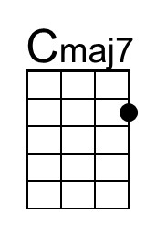 | 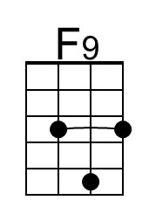 | 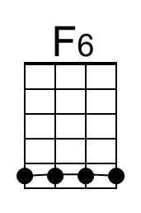 | 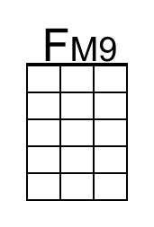 | 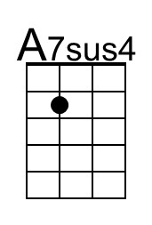 | 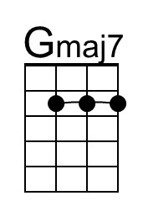
Bari | 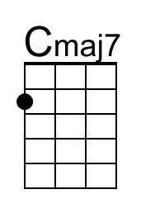 | 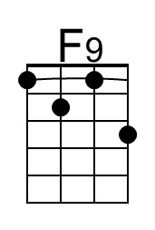 | 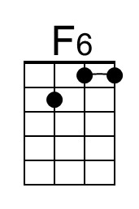 | 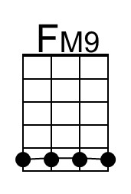 | 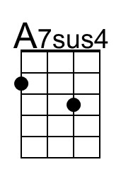 | 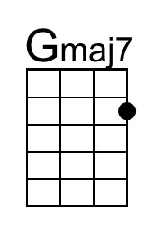

Minute by Minute (C) – Page 2

FM9
But... minute by minute by minute by minute,
Cmaj7 Bm7 Bb7 Am7
I keep holding on, now, I'll be holding on
FM9
Oh...minute by minute by minute by minute,
Cmaj7 | Cmaj7 | Bm7 Bb7 Am7
I keep holding on I keep holding on.

Interlude (4 Measures)
Dm7 C F F#dim7 C G#dim7 |
Am G Am C#dim7 Dm C |
F F#dim7 C G#dim7 Am G |
Am C#dim7

Bridge
Em7 Cmaj9
N.C. ___ Call my name and I'll be gone _____ You'll reach out and I won't be there
A7sus4 Am7 A7sus4 Am7
______ Just my luck you'll real – ize
Cmaj7 C9 Cmaj7
_____ You should spend your life with someone.
C9 Cmaj7
__ You could spend your life with someone.

Outro(Repeat and Fade)
Cmaj9 Gmaj7 | __ __ F#m7 F7 | Em7
Minute by minute by minute by minute, I'll be holding on.

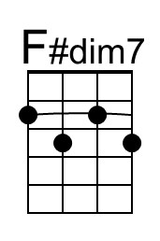 | 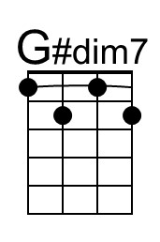 | 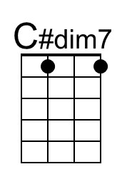 | 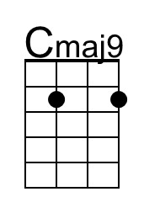 | 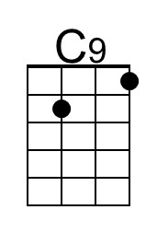
Bari | 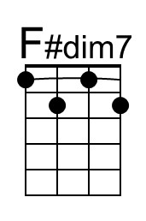 |  | 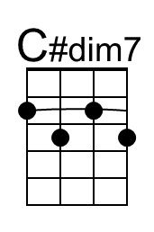 | 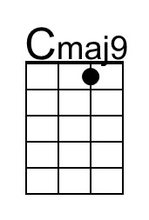 | 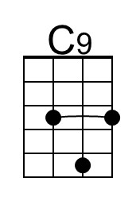

As originally written, most of "Minute by Minute" is in the key of C major,
but the bridge is in E minor and the last refrains are in G major.

