Another Park, Another Sunday (Tom Johnston, ca. 1973) (E)
Another Park, Another Sunday by The Doobie Brothers (Album Version, 1974) (E @ 113)
Another Park, Another Sunday by The Doobie Brothers (45 Version, 1974)
Another Park, Another Sunday by The Doobie Brothers (Live at Wolf Trap, 2004)

Intro  E | Emaj7 | E7sus4 | E | Emaj7 | E7sus4 |  E Emaj7  I’m sittin' in my room, I’m starin' out the window,  E7sus4 | E7sus4  And I wonder where you've gone.  E Emaj7 E7sus4 | E7sus4  Thinkin' back on the happy hours , just be – fore the dawn.  A Asus4 A F#m7 D E  Outside the wind is blow-in', ____ it seems to call your name … a-gain.  Badd4 Aadd2 B | E | Emaj7 | E7sus4 |  _____ Where _____ have you gone?  E Emaj7 E7sus4  __ City streets __ and lonely highways I've travelled down.  E Emaj7 E7sus4 | E7sus4  My car is empty and the radio just seems to bring me down.  A Asus4 A F#m7 D E  I'm just tryin' to find me ____ a pretty smile that I can get in-to.  Badd4 Aadd2 B  It's true. I'm lost without you.  Emaj7 Em7  An - other park, another Sunday, ____ why is it life turns out that way?  F#m7 Asus4 - A  ___ Just when you think you got a good thing,  G D E  It seems to slip a – way.  E7sus4 E  _______It's warm outside, no clouds are in the sky,  Bm7 E  But I need myself a place to go and hide  E7sus4 E D E  _______I keep it to myself, I don't want nobody else to see me cryin'  A Bsus4 | B  All those tears in my eyes. |  |  |  |  |  |  |  | 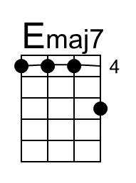
 |  |  |  |  |  |  |  | 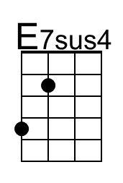
 |  |  |  |  |  |  |  | 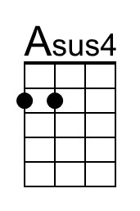
 |  |  |  |  |  |  |  | 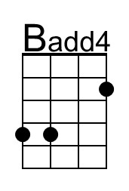
 |  |  |  |  |  |  |  | 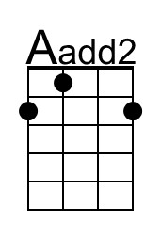
 |  |  |  |  |  |  |  | 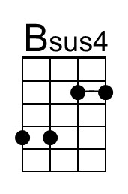
Baritone | 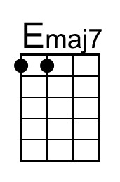 | 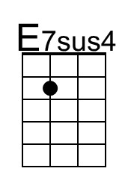 | 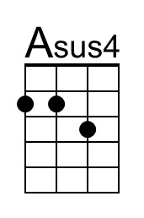 |  | 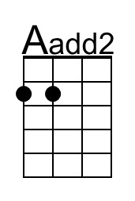 | 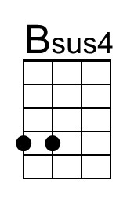

Another Park, Another Sunday (E) – Page 2

Emaj7 Em7
_____ Another park, another Sunday; ___ why is it life turns out that way?
F#m7 Asus4 - A G D E | G D E E |
_____ Just when you think you got a good thing, it seems to slip a – way.

Emaj7 Em7
_____ Another park, another Sunday; ___ its dark and empty, thanks to you
F#m7 Asus4 - A G D E | G D E E |
____ I got to get my-self to-gether, but it's hard to do.

Instrumental Verse
Emaj7 | Emaj7 | Em7 | Em7 |
F#m7 | Asus4 A | G D E E | G D E E |

Emaj7 Em7
_____ Another park, another Sunday; ___ why is it life turns out that way?
F#m7 Asus4 - A G D E | G D E E |
____ Just when you think you got a good thing, it seems to slip a – way.

Emaj7 Em7
_____ Another park, another Sunday; ___ its dark and empty, thanks to you
F#m7 Asus4 - A G D E | G D E E |
____ I've got to get myself to-gether, but it's hard to do.

Outro to Fade
E | Emaj7 | E7sus4 | E | Emaj7 | E7sus4 | E

“Another Park, Another Sunday” was the A-side release; it’s B-side was “Black Water” which eventually became the first #1 hit for The Doobie Brothers.

