China Grove (Tom Johnston, 1973) (A)
China Grove by The Doobie Brothers (1973) (E @ 120)
China Grove by The Doobie Brothers (Official Music Video)
4/4 Time

Intro (First line: 3x, then second line)
||: A ↓↓ _ _ | A ↓↓ _ _ | G ↓ _ F#m ↓ _ D ↓ _ | _ A ↓↓ _ :|| (3x)
| A ↓↓ _ _ | A ↓↓ _ _ | G ↓ _ F#m ↓ _ D ↓
(Hold)
A G D A
When the sun comes up on a sleepy little town, down around San An-tone.
G D - A
And the folks are risin' for another day 'round a-bout their homes.
F#m E - Esus4 E
The people of the town are strange,
D D#7 E7 F7
And they're proud of where they came.

Chorus
♪ ♪ ♪ ♪ ♩ ♪ ♪ ♩. ♩ ♪ ♩
A G D A
NC Well, you’re talkin' 'bout (talkin’ 'bout China Grove). Oh-oh-oh.
G D A | G D | A ↓ ↓ ↓ ↓ ↓ ↓
Oh-oh, China Grove.

A
Well, the preacher and the teacher, Lord, they're a caution,
G D - A
They are the talk of the town.
G D - A
When the gossip gets to flyin', and they ain't lyin', when the sun goes fallin' down.
F#m E - Esus4 E
They say that the father's in-sane,
D D#7 E7 F7 | F7
And dear Missus Per-kin's a game. Chorus

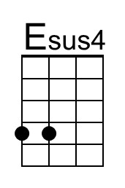 | 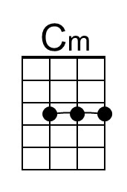 | 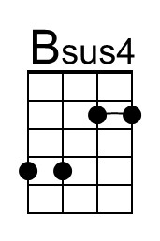 | 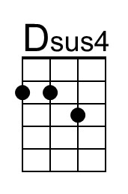 | Baritone | 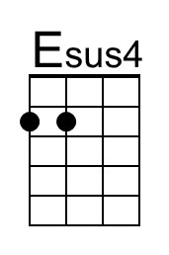 | 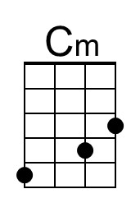 | 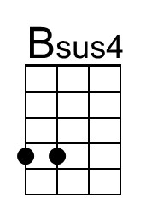 | 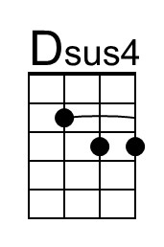

China Grove (A) – Page 2

Bridge
A A C#m E F#m7 Bm7 F#m7
_ _ ____ But ev'ry day there's a new thing comin', the ways of an oriental view.
F#m7
The sheriff and his buddies with their samurai swords.
B (Bsus4) B | Bsus4 ↓ ↓ ↓ ↓ ↓ ↓ B ↓ ↓ |
You can even hear the music at night.
B B C#m E F#m7
__ __ ____ __ And though it's a part of the Lone Star State,
Bm7 F#m7
The people don't seem to care,
D (Dsus4) D | F G A | A | F G A | A | A
They just keep on lookin' to the East. (Hold)

Optional Instrumental Solo
|| : A ↓↓ _ _ | A ↓↓ _ _ | G ↓ F#m ↓ D ↓ | _ A↓↓ _ :|| (6x)
A ↓↓ _ _ | A ↓↓ _ _ | G ↓ F#m ↓ D ↓ | _ A↓↓ _ |
F#m | E | D _ D↓ D#↓ E↓ F↓ | F7 | F7

Outro
♪ ♪ ♪ ♪ ♩ ♪ ♪ ♩. ♩ ♪ ♩
A G D A
NC Well, you’re talkin' 'bout (talkin’ 'bout China Grove). Oh-oh-oh.
G D A | G D | A ↓ ↓ ↓ ↓ ↓ ↓ | A ↓
Oh-oh, China Grove. (Hold)

Intro Chords (One of many possibilities)
C-Tuned Ukes G-Tuned Ukes
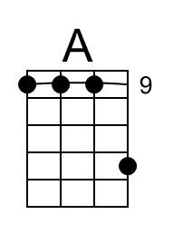 | 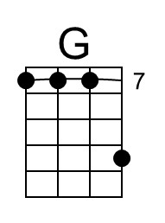 | 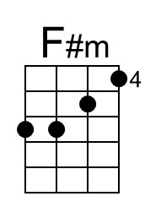 | 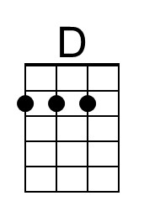 |  | 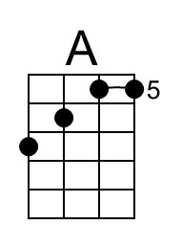 | 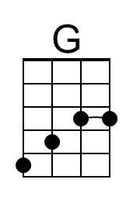 | 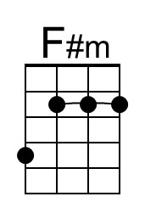 | 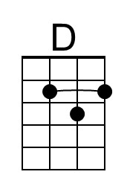

China Grove (Tom Johnston, 1973) (C)
China Grove by The Doobie Brothers (1973) (E @ 120)
China Grove by The Doobie Brothers (Official Music Video)
4/4 Time

Intro (First line: 3x, then second line)
||: C ↓↓ _ _ | C ↓↓ _ _ | Bb ↓ _ Am ↓ _ F ↓ _ | _ C ↓↓ _ :|| (3x)
| C ↓↓ _ _ | C ↓↓ _ _ | Bb ↓ _ Am ↓ _ F ↓
(Hold)
C Bb F C
When the sun comes up on a sleepy little town, down around San An-tone.
Bb F - C
And the folks are risin' for another day 'round a-bout their homes.
Am G - Gsus4 G
The people of the town are strange,
F F#7 G7 Ab7
And they're proud of where they came.

Chorus
♪ ♪ ♪ ♪ ♩ ♪ ♪ ♩. ♩ ♪ ♩
C Bb F C
NC Well, you’re talkin' 'bout (talkin’ 'bout China Grove). Oh-oh-oh.
Bb F C | Bb F | C ↓ ↓ ↓ ↓ ↓ ↓
Oh-oh, China Grove.

C
Well, the preacher and the teacher, Lord, they're a caution,
Bb F - C
They are the talk of the town.
Bb F - C
When the gossip gets to flyin', and they ain't lyin', when the sun goes fallin' down.
Am G - Gsus4 G
They say that the father's in-sane,
F F#7 G7 Ab7 | Ab7
And dear Missus Per-kin's a game. Chorus

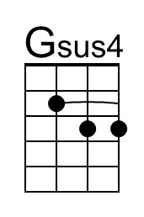 | 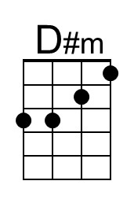 |  | 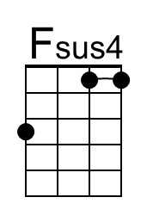 | Baritone | 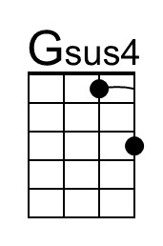 | 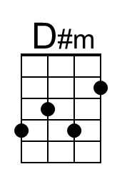 |  | 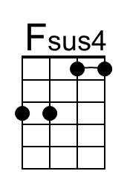

China Grove (C) – Page 2

Bridge
C C Em G Am7 Dm7 Am7
_ _ ____ But ev'ry day there's a new thing comin', the ways of an oriental view.
Am7
The sheriff and his buddies with their samurai swords.
D (Dsus4) D | Dsus4 ↓ ↓ ↓ ↓ ↓ ↓ D ↓ ↓ |
You can even hear the music at night.
D D Em G Am7
__ __ ____ __ And though it's a part of the Lone Star State,
Dm7 Am7
The people don't seem to care,
F (Fsus4) F | Ab Bb C | C | Ab Bb C | C | C
They just keep on lookin' to the East. (Hold)

Optional Instrumental Solo
|| : C ↓↓ _ _ | C ↓↓ _ _ | Bb ↓ Am ↓ F ↓ | _ C↓↓ _ :|| (6x)
C ↓↓ _ _ | C ↓↓ _ _ | Bb ↓ Am ↓ F ↓ | _ C↓↓ _ |
Am | G | F _ F↓ F#↓ G↓ Ab↓ | Ab7 | Ab7

Outro
♪ ♪ ♪ ♪ ♩ ♪ ♪ ♩. ♩ ♪ ♩
C Bb F C
NC Well, you’re talkin' 'bout (talkin’ 'bout China Grove). Oh-oh-oh.
Bb F C | Bb F | C ↓ ↓ ↓ ↓ ↓ ↓ | C ↓
Oh-oh, China Grove. (Hold)

Intro Chords (One of many possibilities)
C-Tuned Ukes G-Tuned Ukes
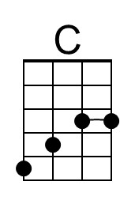 | 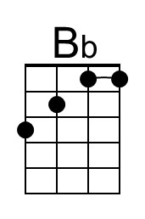 | 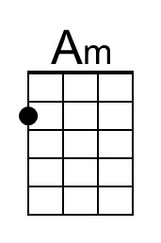 | 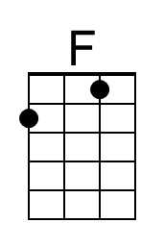 |  | 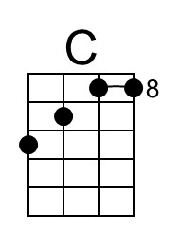 | 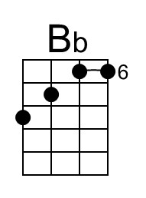 | 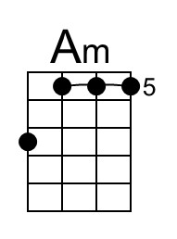 | 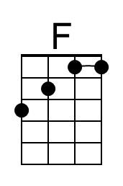

China Grove (Tom Johnston, 1973) (D)
China Grove by The Doobie Brothers (1973) (E @ 120)
China Grove by The Doobie Brothers (Official Music Video)
4/4 Time

Intro (First line: 3x, then second line)
||: D ↓↓ _ _ | D ↓↓ _ _ | C ↓ _ Bm ↓ _ G ↓ _ | _ D ↓↓ _ :|| (3x)
| D ↓↓ _ _ | D ↓↓ _ _ | C ↓ _ Bm ↓ _ G ↓
(Hold)
D C G D
When the sun comes up on a sleepy little town, down around San An-tone.
C G - D
And the folks are risin' for another day 'round a-bout their homes.
Bm A - Asus4 A
The people of the town are strange,
G Ab7 A7 Bb7
And they're proud of where they came.

Chorus
♪ ♪ ♪ ♪ ♩ ♪ ♪ ♩. ♩ ♪ ♩
D C - G D
NC Well, you’re talkin' 'bout (talkin’ 'bout China Grove). Oh-oh-oh.
C G D | C G | D ↓ ↓ ↓ ↓ ↓ ↓
Oh-oh, China Grove.

D
Well, the preacher and the teacher, Lord, they're a caution,
C G - D
They are the talk of the town.
C G - D
When the gossip gets to flyin', and they ain't lyin', when the sun goes fallin' down.
Bm A - Asus4 A
They say that the father's in-sane,
G Ab7 A7 Bb7 | Bb7
And dear Missus Per-kin's a game. Chorus

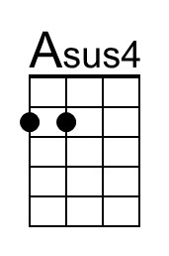 | 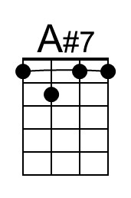 |  |  | Baritone | 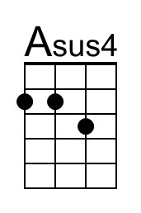 | 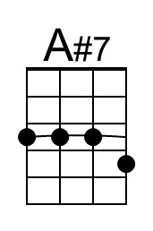

China Grove (D) – Page 2

Bridge
D D F#m A Bm7 Em7 Bm7
_ _ ____ But ev'ry day there's a new thing comin', the ways of an oriental view.
Bm7
The sheriff and his buddies with their samurai swords.
E (Esus4) E | Esus4 ↓ ↓ ↓ ↓ ↓ ↓ E ↓ ↓ |
You can even hear the music at night.
E E F#m A Bm7
_ _ ___ __ And though it's a part of the Lone Star State,
Em7 Bm7
The people don't seem to care,
G (Gsus4) G | Bb C D | D | Bb C D | D | D
They just keep on lookin' to the East. (Hold)

Optional Instrumental Solo
|| : D ↓↓ _ _ | D ↓↓ _ _ | C ↓ Bm ↓ G ↓ | _ D↓↓ _ :|| (6x)
D ↓↓ _ _ | D ↓↓ _ _ | C ↓ Bm ↓ G ↓ | _ D↓↓ _ |
Bm | A | G _ G↓ G#↓ A↓ Bb↓ | Bb7 | Bb7

Outro
♪ ♪ ♪ ♪ ♩ ♪ ♪ ♩. ♩ ♪ ♩
D C - G D
NC Well, you’re talkin' 'bout (talkin’ 'bout China Grove). Oh-oh-oh.
C G D | C G | D ↓ ↓ ↓ ↓ ↓ ↓ | D ↓
Oh-oh, China Grove. (Hold)

Intro Chords (One of many possibilities)
C-Tuned Ukes G-Tuned Ukes
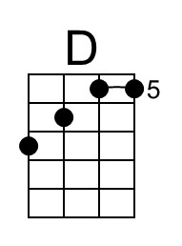 |  | 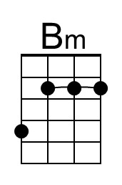 | 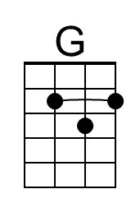 |  | 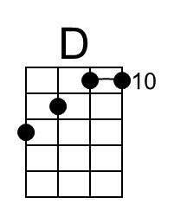 |  | 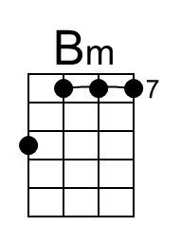

China Grove (Tom Johnston, 1973) (E)
China Grove by The Doobie Brothers (1973) (E @ 120)
China Grove by The Doobie Brothers (Official Music Video)
4/4 Time

Intro (First line: 3x, then second line)
||: E ↓↓ _ _ | E ↓↓ _ _ | D ↓ _ C#m ↓ _ A ↓ _ | _ E ↓↓ _ :|| (3x)
| E ↓↓ _ _ | E ↓↓ _ _ | D ↓ _ C#m ↓ _ A ↓
(Hold)
E D A E
When the sun comes up on a sleepy little town, down around San An-tone.
D A - E
And the folks are risin' for another day 'round a-bout their homes.
C#m B - Bsus4 B
The people of the town are strange,
A Bb7 B7 C7
And they're proud of where they came.

Chorus
♪ ♪ ♪ ♪ ♩ ♪ ♪ ♩. ♩ ♪ ♩
E D - A E
NC Well, you’re talkin' 'bout (talkin’ 'bout China Grove). Oh-oh-oh.
D A E | D A | E ↓ ↓ ↓ ↓ ↓ ↓
Oh-oh, China Grove.

E
Well, the preacher and the teacher, Lord, they're a caution,
D A - E
They are the talk of the town.
D A - E
When the gossip gets to flyin', and they ain't lyin', when the sun goes fallin' down.
C#m B - Bsus4 B
They say that the father's in-sane,
A Bb7 B7 C7 | C7
And dear Missus Per-kin's a game. Chorus

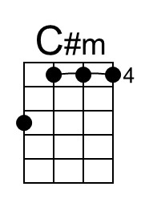 |  | 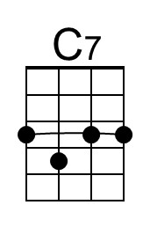 | 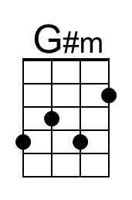 | 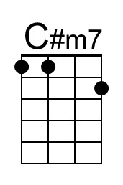 | 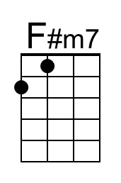 | 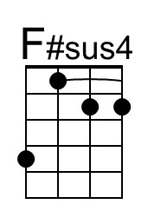
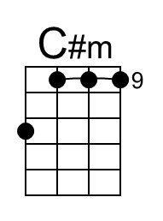 | 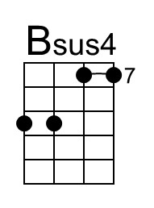 | 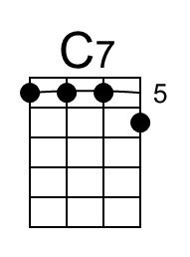 | 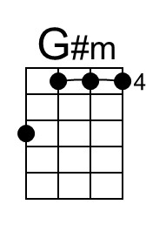 | 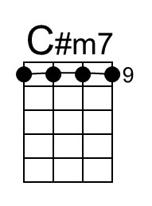 | 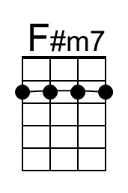 | 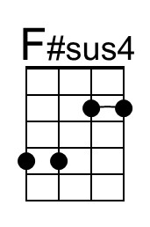

China Grove (E) – Page 2

Bridge
E E Abm B C#m7 F#m7 C#m7
_ _ ____ But ev'ry day there's a new thing comin', the ways of an oriental view.
C#m7
The sheriff and his buddies with their samurai swords.
F# (F#sus4) F# | F#sus4 ↓ ↓ ↓ ↓ ↓ ↓ F# ↓ ↓ |
You can even hear the music at night.
F# F# Abm B C#m7
__ __ ____ __ And though it's a part of the Lone Star State,
F#m7 C#m7
The people don't seem to care,
A (Asus4) A | C D E | E | C D E | E | E
They just keep on lookin' to the East. (Hold)

Optional Instrumental Solo
|| : E ↓↓ _ _ | E ↓↓ _ _ | D ↓ C#m ↓ A ↓ | _ E↓↓ _ :|| (6x)
E ↓↓ _ _ | E ↓↓ _ _ | D ↓ C#m ↓ A ↓ | _ E↓↓ _ |
C#m | B | A _ A↓ Bb↓ B↓ C↓ | C7 | C7

Outro
♪ ♪ ♪ ♪ ♩ ♪ ♪ ♩. ♩ ♪ ♩
E D - A E
NC Well, you’re talkin' 'bout (talkin’ 'bout China Grove). Oh-oh-oh.
D A E | D A | E ↓ ↓ ↓ ↓ ↓ ↓ | E ↓
Oh-oh, China Grove. (Hold)

Intro Chords (One of many possibilities)
C-Tuned Ukes G-Tuned Ukes
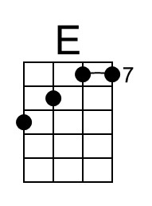 |  |  | 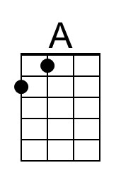 |  | 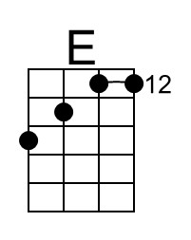

The Wikipedia article for China Grove, TX. They note:
“Despite its name and Johnston's lyrics, China Grove does not have a sizable Asian-American population; residents tracing their heritage to Asia number less than 0.1% of the population. Instead, the town got its name from a grove of chinaberry trees [Melia azedarach] once located near the town's train depot, no longer extant.”

According to GeoTarget.com, there are four other US towns named “China Grove”; they are located in Tennessee, South Carolina, Mississippi, and Alabama.
China Grove (Tom Johnston, 1973) (G)
China Grove by The Doobie Brothers (1973) (E @ 120)
China Grove by The Doobie Brothers (Official Music Video)
4/4 Time

Intro (First line: 3x, then second line)
||: G ↓↓ _ _ | G ↓↓ _ _ | F ↓ _ Em ↓ _ C ↓ _ | _ G ↓↓ _ :|| (3x)
| G ↓↓ _ _ | G ↓↓ _ _ | F ↓ _ Em ↓ _ C ↓
(Hold)
G F C G
When the sun comes up on a sleepy little town, down around San An-tone.
F C - G
And the folks are risin' for another day 'round a-bout their homes.
Em D - Dsus4 D
The people of the town are strange,
C C#7 D7 D#7
And they're proud of where they came.

Chorus
♪ ♪ ♪ ♪ ♩ ♪ ♪ ♩. ♩ ♪ ♩
G F C G
NC Well, you’re talkin' 'bout (talkin’ 'bout China Grove). Oh-oh-oh.
F C G | F C | G ↓ ↓ ↓ ↓ ↓ ↓
Oh-oh, China Grove.

G
Well, the preacher and the teacher, Lord, they're a caution,
F C - G
They are the talk of the town.
F C - G
When the gossip gets to flyin', and they ain't lyin', when the sun goes fallin' down.
Em D - Dsus4 D
They say that the father's in-sane,
C C#7 D7 D#7 | D#7
And dear Missus Per-kin's a game. Chorus

 | 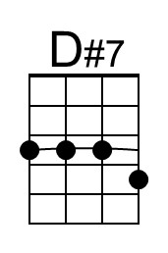 | 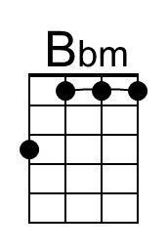 |  | 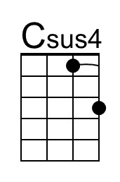
 | 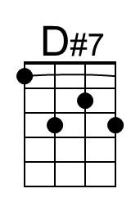 | 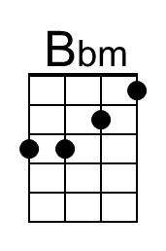 |  | 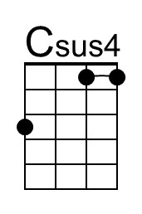

China Grove (G) – Page 2

Bridge
G G Bm D Em7 Am7 Em7
_ _ ____ But ev'ry day there's a new thing comin', the ways of an oriental view.
Em7
The sheriff and his buddies with their samurai swords.
A (Asus4) A | Asus4 ↓ ↓ ↓ ↓ ↓ ↓ A ↓ ↓ |
You can even hear the music at night.
A A Bm D Em7
__ __ ___ __ And though it's a part of the Lone Star State,
Am7 Em7
The people don't seem to care,
C (Csus4) C | D# F G | G | D# F G | G | G
They just keep on lookin' to the East. (Hold)

Optional Instrumental Solo
|| : G ↓↓ _ _ | G ↓↓ _ _ | F ↓ Em ↓ C ↓ | _ G↓↓ _ :|| (6x)
G ↓↓ _ _ | G ↓↓ _ _ | F ↓ Em ↓ C ↓ | _ G↓↓ _ |
Em | D | C _ C↓ C#↓ D↓ D#↓ | D#7 | D#7

Outro
♪ ♪ ♪ ♪ ♩ ♪ ♪ ♩. ♩ ♪ ♩
G F C G
NC Well, you’re talkin' 'bout (talkin’ 'bout China Grove). Oh-oh-oh.
F C G | F C | G ↓ ↓ ↓ ↓ ↓ ↓ | G ↓
Oh-oh, China Grove. (Hold)

Intro Chords (One of many possibilities)
C-Tuned Ukes G-Tuned Ukes
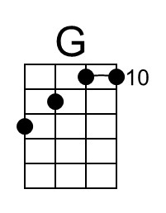 | 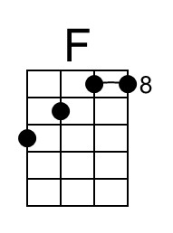 | 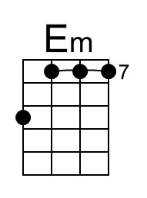 |  |  |  |  | 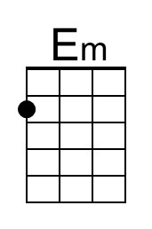 | 