China Grove (Tom Johnston, 1973) (E)
China Grove by The Doobie Brothers (1973) (E @ 120)
China Grove by The Doobie Brothers (Official Music Video)
4/4 Time

Intro (First line: 3x, then second line)
||: E ↓↓ _ _ | E ↓↓ _ _ | D ↓ _ C#m ↓ _ A ↓ _ | _ E ↓↓ _ :|| (3x)
| E ↓↓ _ _ | E ↓↓ _ _ | D ↓ _ C#m ↓ _ A ↓
(Hold)
E D A E
When the sun comes up on a sleepy little town, down around San An-tone.
D A - E
And the folks are risin' for another day 'round a-bout their homes.
C#m B - Bsus4 B
The people of the town are strange,
A A#7 B7 C7
And they're proud of where they came.

Chorus
♪ ♪ ♪ ♪ ♩ ♪ ♪ ♩. ♩ ♪ ♩
E D - A E
NC Well, you’re talkin' 'bout (talkin’ 'bout China Grove). Oh-oh-oh.
D A E | D A | E ↓ ↓ ↓ ↓ ↓ ↓
Oh-oh, China Grove.

E
Well, the preacher and the teacher, Lord, they're a caution,
D A - E
They are the talk of the town.
D A - E
When the gossip gets to flyin', and they ain't lyin', when the sun goes fallin' down.
C#m B - Bsus4 B
They say that the father's in-sane,
A A#7 B7 C7 | C7
And dear Missus Per-kin's a game. Chorus

 |  | 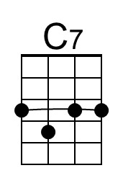 | 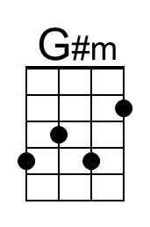 |  | 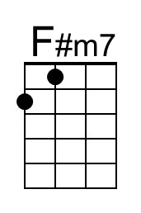 | 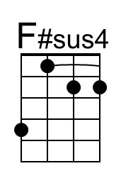 | 
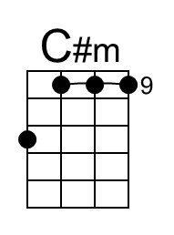 |  | 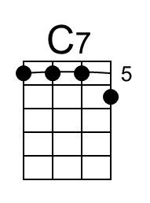 |  | 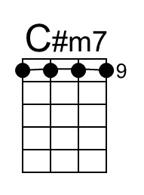 |  | 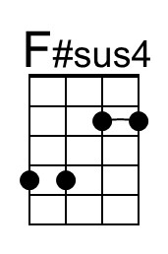 | 

China Grove (E) – Page 2

Bridge
E E G#m B C#m7 F#m7 C#m7
_ _ ____ But ev'ry day there's a new thing comin', the ways of an oriental view.
C#m7
The sheriff and his buddies with their samurai swords.
F# (F#sus4) F# | F#sus4 ↓ ↓ ↓ ↓ ↓ ↓ F# ↓ ↓ |
You can even hear the music at night.
F# F# G#m B C#m7
__ __ ____ __ And though it's a part of the Lone Star State,
F#m7 C#m7
The people don't seem to care,
A (Asus4) A | C D E | E | C D E | E | E
They just keep on lookin' to the East. (Hold)

Optional Instrumental Solo
|| : E ↓↓ _ _ | E ↓↓ _ _ | D ↓ C#m ↓ A ↓ | _ E↓↓ _ :|| (6x)
E ↓↓ _ _ | E ↓↓ _ _ | D ↓ C#m ↓ A ↓ | _ E↓↓ _ |
C#m | B | A _ A↓ A#↓ B↓ C↓ | C7 | C7

Outro
♪ ♪ ♪ ♪ ♩ ♪ ♪ ♩. ♩ ♪ ♩
E D - A E
NC Well, you’re talkin' 'bout (talkin’ 'bout China Grove). Oh-oh-oh.
D A E | D A | E ↓ ↓ ↓ ↓ ↓ ↓ | E ↓
Oh-oh, China Grove. (Hold)

Intro Chords (One of many possibilities)
C-Tuned Ukes G-Tuned Ukes
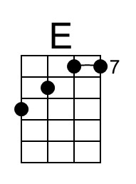 |  |  |  |  | 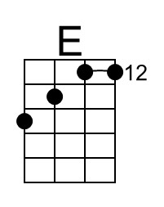 |  |  | 

The Wikipedia article for China Grove, TX. They note:
“Despite its name and Johnston's lyrics, China Grove does not have a sizable Asian-American population; residents tracing their heritage to Asia number less than 0.1% of the population. Instead, the town got its name from a grove of chinaberry trees [Melia azedarach] once located near the town's train depot, no longer extant.”

According to GeoTarget.com, there are four other US towns named “China Grove”; they are located in Tennessee, South Carolina, Mississippi, and Alabama.

