It Keeps You Running (Michael McDonald, 1976) (A)
It Keeps You Running by Doobie Brothers from the album Takin' It to the Streets (G @ 133)
It Keeps You Running by Doobie Brothers (Live On Soundstage In Chicago from The Livin' On The Fault Line Tour, 1977) (G @ 133)
It Keeps You Running by Carly Simon from Another Passenger (1976) (G @ 145)
4/4 Time
Intro (4x)
| A7 | _ _ D _ | A7 | _ _ D _ |

C#m7 C7 Bm7 | Bb7 A7 | _ _ D _ | A7 | _ _ D _ |
___ Say, where you gonna go? Girl, where you gonna hide?
C#m7 C7 Bm7 Bb7 A7 | _ _ D _ | A7
___ You go on leavin' out your heart, and all it's sayin' down deep in-side.
C#9 | _ Bm _ C#9
From here I can feel your heartbeat.
D7 A7 | _ _ D _ | A7
Oh, you got me all wrong,
C#9 | _ Bm | D C#9
You ain't got no worry,
Bm A7 | _ _ D _ | A7 | _ _ D _ |
You just been lone – ly too long.

Chorus
F#m7 B9 E7sus4 | E7
___ I know what it means to hide your heart
C#7 B7 C#7 F#m7 E7
___ From a long time a - go. __ Oh, darlin'
E Dmaj7 E Dmaj7
_ It keeps you run - nin', yeah, it keeps you run - nin'
E F#m E F#m
_ It keeps you run - nin', yeah, it keeps you run - nin'
E Dmaj7 E Dmaj7
_ It keeps you run - nin', yeah, it keeps you run - nin'
E F#m E F#m
_ It keeps you run - nin', yeah, it keeps you run - nin'

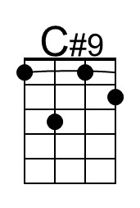 | 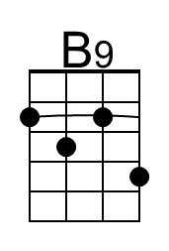 | 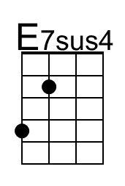 | 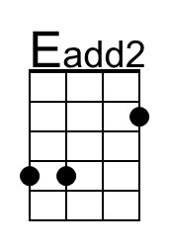 | Baritone | 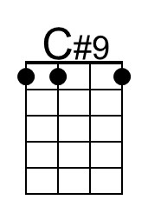 | 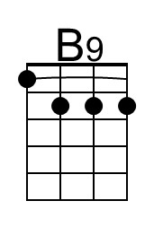 | 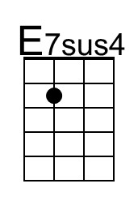 | 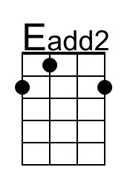

It Keeps You Running (A) – Page 2

C#m7 C7 Bm7 | Bb7 A7 | _ _ D _ | A7 | _ _ D _ |
____ Oh, you know how I feel . Hey, you know I been there.
C#m7 C7 Bm7 Bb7 A7 | _ _ D _ | A7
____ But what you're keepin' to your-self ___ Oh, you know it just ain't fair
C#9 | _ Bm _ C#9
Are you gonna worry,
D7 A7 | _ _ D _ | A7
For the rest of your life?
C#9 | _ Bm | D C#9
Why you in such a hurry,
Bm A7 | _ _ D _ | A7 | _ _ D _ |
To be lonely one more night?

Chorus
F#m7 B9 E7sus4 | E7
____ I know what it means to hide your heart
C#7 B7 C#7 F#m7 E7
___ From a long time a - go. __ Oh, darlin'
E Dmaj7 E Dmaj7
_ It keeps you run - nin', yeah, it keeps you run - nin'
E F#m E F#m
_ It keeps you run - nin', yeah, it keeps you run - nin'
E Dmaj7 E Dmaj7
_ It keeps you run - nin', yeah, it keeps you run - nin'
E F#m E F#m
_ It keeps you run - nin', yeah, it keeps you run - nin'

Outro
E Dmaj7 E Dmaj7 | C#m7
_ It keeps you run - nin', yeah, it keeps you run – nin'.

It Keeps You Running (Michael McDonald, 1976) (C)
It Keeps You Running by Doobie Brothers from the album Takin' It to the Streets (G @ 133)
It Keeps You Running by Doobie Brothers (Live On Soundstage In Chicago from The Livin' On The Fault Line Tour, 1977) (G @ 133)
It Keeps You Running by Carly Simon from Another Passenger (1976) (G @ 145)
4/4 Time
Intro (4x)
| C7 | _ _ F _ | C7 | _ _ F _ |

Em7 D#7 Dm7 | C#7 C7 | _ _ F _ | C7 | _ _ F _ |
___ Say, where you gonna go? Girl, where you gonna hide?
Em7 D#7 Dm7 C#7 C7 | _ _ F _ | C7
___ You go on leavin' out your heart, and all it's sayin' down deep in-side.
E9 | _ Dm _ E9
From here I can feel your heartbeat.
F7 C7 | _ _ F _ | C7
Oh, you got me all wrong,
E9 | _ Dm | F E9
You ain't got no worry,
Dm C7 | _ _ F _ | C7 | _ _ F _ |
You just been lone – ly too long.

Chorus
Am7 D9 G7sus4 | G7
___ I know what it means to hide your heart
E7 D7 E7 Am7 G7
___ From a long time a - go. __ Oh, darlin'
G Fmaj7 G Fmaj7
_ It keeps you run - nin', yeah, it keeps you run - nin'
G Am G Am
_ It keeps you run - nin', yeah, it keeps you run - nin'
G Fmaj7 G Fmaj7
_ It keeps you run - nin', yeah, it keeps you run - nin'
G Am G Am
_ It keeps you run - nin', yeah, it keeps you run - nin'

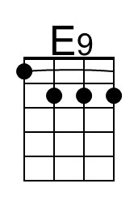 | 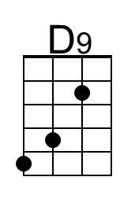 | 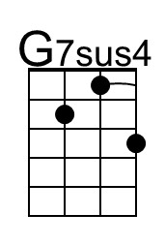 | 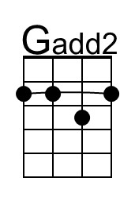 | Baritone | 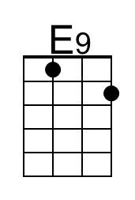 | 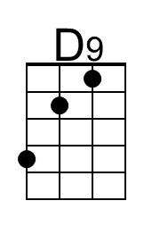 | 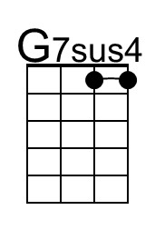 | 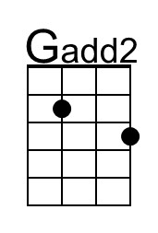

It Keeps You Running (C) – Page 2

Em7 D#7 Dm7 | C#7 C7 | _ _ F _ | C7 | _ _ F _ |
___ Oh, you know how I feel . Hey, you know I been there.
Em7 D#7 Dm7 C#7 C7 | _ _ F _ | C7
___ But what you're keepin' to your-self ___ Oh, you know it just ain't fair
E9 | _ Dm _ E9
Are you gonna worry,
F7 C7 | _ _ F _ | C7
For the rest of your life?
E9 | _ Dm | F E9
Why you in such a hurry,
Dm C7 | _ _ F _ | C7 | _ _ F _ |
To be lonely one more night?

Chorus
Am7 D9 G7sus4 | G7
___ I know what it means to hide your heart
E7 D7 E7 Am7 G7
__ From a long time a - go. __ Oh, darlin'
G Fmaj7 G Fmaj7
_ It keeps you run - nin', yeah, it keeps you run - nin'
G Am G Am
_ It keeps you run - nin', yeah, it keeps you run - nin'
G Fmaj7 G Fmaj7
_ It keeps you run - nin', yeah, it keeps you run - nin'
G Am G Am
_ It keeps you run - nin', yeah, it keeps you run - nin'

Outro
G Fmaj7 G Fmaj7 | Em7
_ It keeps you run - nin', yeah, it keeps you run – nin'.

It Keeps You Running (Michael McDonald, 1976) (D)
It Keeps You Running by Doobie Brothers from the album Takin' It to the Streets (G @ 133)
It Keeps You Running by Doobie Brothers (Live On Soundstage In Chicago from The Livin' On The Fault Line Tour, 1977) (G @ 133)
It Keeps You Running by Carly Simon from Another Passenger (1976) (G @ 145)
4/4 Time
Intro (4x)
| D7 | _ _ G _ | D7 | _ _ G _ |

F#m7 F7 Em7 | D#7 D7 | _ _ G _ | D7 | _ _ G _ |
___ Say, where you gonna go? Girl, where you gonna hide?
F#m7 F7 Em7 D#7 D7 | _ _ G _ | D7
___ You go on leavin' out your heart, and all it's sayin' down deep in-side.
F#9 | _ Em _ F#9
From here I can feel your heartbeat.
G7 D7 | _ _ G _ | D7
Oh, you got me all wrong,
F#9 | _ Em | G F#9
You ain't got no worry,
Em D7 | _ _ G _ | D7 | _ _ G _ |
You just been lone – ly too long.

Chorus
Bm7 E9 A7sus4 | A7
___ I know what it means to hide your heart
F#7 E7 F#7 Bm7 A7
___ From a long time a - go. __ Oh, darlin'
A Gmaj7 A Gmaj7
_ It keeps you run - nin', yeah, it keeps you run - nin'
A Bm A Bm
_ It keeps you run - nin', yeah, it keeps you run - nin'
A Gmaj7 A Gmaj7
_ It keeps you run - nin', yeah, it keeps you run - nin'
A Bm A Bm
_ It keeps you run - nin', yeah, it keeps you run - nin'

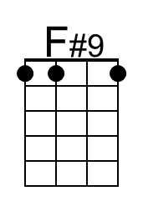 |  | 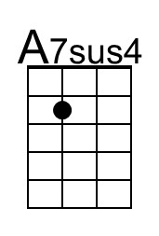 | 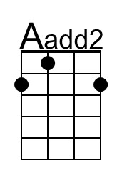 | Baritone | 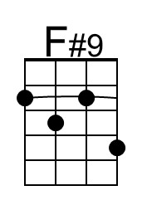 |  | 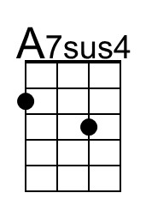 | 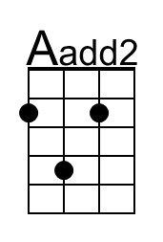

It Keeps You Running (D) – Page 2

F#m7 F7 Em7 | D#7 D7 | _ _ G _ | D7 | _ _ G _ |
___ Oh, you know how I feel . Hey, you know I been there.
F#m7 F7 Em7 D#7 D7 | _ _ G _ | D7
___ But what you're keepin' to your-self ___ Oh, you know it just ain't fair
F#9 | _ Em _ F#9
Are you gonna worry,
G7 D7 | _ _ G _ | D7
For the rest of your life?
F#9 | _ Em | G F#9
Why you in such a hurry,
Em D7 | _ _ G _ | D7 | _ _ G _ |
To be lonely one more night?

Chorus
Bm7 E9 A7sus4 | A7
___ I know what it means to hide your heart
F#7 E7 F#7 Bm7 A7
___ From a long time a - go. __ Oh, darlin'
A Gmaj7 A Gmaj7
_ It keeps you run - nin', yeah, it keeps you run - nin'
A Bm A Bm
_ It keeps you run - nin', yeah, it keeps you run - nin'
A Gmaj7 A Gmaj7
_ It keeps you run - nin', yeah, it keeps you run - nin'
A Bm A Bm
_ It keeps you run - nin', yeah, it keeps you run - nin'

Outro
A Gmaj7 A Gmaj7 | F#m7
_ It keeps you run - nin', yeah, it keeps you run – nin'.

It Keeps You Running (Michael McDonald, 1976) (G)
It Keeps You Running by Doobie Brothers from the album Takin' It to the Streets (G @ 133)
It Keeps You Running by Doobie Brothers (Live On Soundstage In Chicago from The Livin' On The Fault Line Tour, 1977) (G @ 133)
It Keeps You Running by Carly Simon from Another Passenger (1976) (G @ 145)
4/4 Time
Intro (4x)
| G7 | _ _ C _ | G7 | _ _ C _ |

Bm7 Bb7 Am7 | Ab7 G7 | _ _ C _ | G7 | _ _ C _ |
___ Say, where you gonna go? Girl, where you gonna hide?
Bm7 Bb7 Am7 Ab7 G7 | _ _ C _ | G7
___ You go on leavin' out your heart, and all it's sayin' down deep in-side.
B9 | _ Am _ B9
From here I can feel your heartbeat.
C7 G7 | _ _ C _ | G7
Oh, you got me all wrong,
B9 | _ Am | C B9
You ain't got no worry,
Am G7 | _ _ C _ | G7 | _ _ C _ |
You just been lone – ly too long.

Chorus
Em7 A9 D7sus4 | D7
___ I know what it means to hide your heart
B7 A7 B7 Em7 D7
___ From a long time a - go. _ Oh, darlin'
D Cmaj7 D Cmaj7
_ It keeps you run - nin', yeah, it keeps you run - nin'
D Em D Em
_ It keeps you run - nin', yeah, it keeps you run - nin'
D Cmaj7 D Cmaj7
_ It keeps you run - nin', yeah, it keeps you run - nin'
D Em D Em
_ It keeps you run - nin', yeah, it keeps you run - nin'

 | 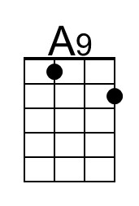 | 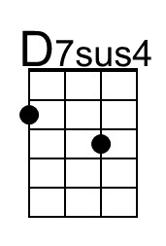 | 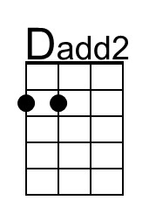 | Baritone |  | 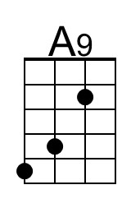 | 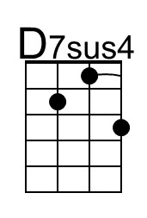 | 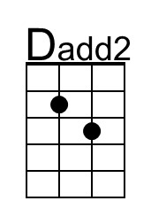

It Keeps You Running (G) – Page 2

Bm7 Bb7 Am7 | Ab7 G7 | _ _ C _ | G7 | _ _ C _ |
___ Oh, you know how I feel . Hey, you know I been there.
Bm7 Bb7 Am7 Ab7 G7 | _ _ C _ | G7
___ But what you're keepin' to your-self ___ Oh, you know it just ain't fair
B9 | _ Am _ B9
Are you gonna worry,
C7 G7 | _ _ C _ | G7
For the rest of your life?
B9 | _ Am | C B9
Why you in such a hurry,
Am G7 | _ _ C _ | G7 | _ _ C _ |
To be lonely one more night?

Chorus
Em7 A9 D7sus4 | D7
___ I know what it means to hide your heart
B7 A7 B7 Em7 D7
___ From a long time a - go. _ Oh, darlin'
D Cmaj7 D Cmaj7
_ It keeps you run - nin', yeah, it keeps you run - nin'
D Em D Em
_ It keeps you run - nin', yeah, it keeps you run - nin'
D Cmaj7 D Cmaj7
_ It keeps you run - nin', yeah, it keeps you run - nin'
D Em D Em
_ It keeps you run - nin', yeah, it keeps you run - nin'

Outro
D Cmaj7 D Cmaj7 | Bm7
_ It keeps you run - nin', yeah, it keeps you run – nin'.

