Long Train Runnin’ (Tom Johnston, 1973) (Am)
Long Train Runnin’ by The Doobie Brothers (Gm @ 117)
Long Train Runnin’ by The Doobie Brothers (Gm) (Official Music Video)
Long Train Runnin’ by The Doobie Brothers (Gm) (Live at the Beacon, 2018)
4/4 Time
Note: “%” = Repeat the previous chord

Intro
Em7 Am7 % Em7 ||: Am7 % % Em7 :|| Em7 |
^----------- [6x] -----------^

Em7 Am7 - Em7 Am7 - Em7
Down a-round the corner, a half a mile from here,
Am7 Em7 Am7
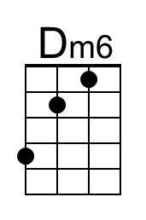
You see them long trains runnin', and you watch 'em disappear.

Chorus
Em7 Dm7 | Dm6 Em7 Am7 % Em7 |
Without love ___ Where would you be now? (now, now, now)
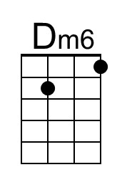
Am7 Bbm7 F | Am7 Bb7 | Em7 Am7 % Em7 | Am7
___ Without love.

Am7 Em7 Am7 - Em7 Am7 - Em7
3. ___ You know I saw Miss Lucy, down along the tracks,
Am7 Em7 Am7
She lost her home and her family, and she won't be coming back. Chorus

Am7 Em7 Am7 G#m7 Am7
___ Well, the Illinois Central and the Southern Central Freight
G#m7 Am7 G#m7 Am7
Gotta keep on pushin', mama, 'Cause you know they're runnin' late. Chorus

Optional Solo
Em7 Am7 % Em7 ||: Am7 % % Em7 :|| Em7 |
^----------- [6x] -----------^

Repeat Verse 3. Chorus

Am7 Em7 Am7 G#m7 Am7
___ Well, pistons keep on churnin' and the wheels go 'round and 'round
G#m7 Am7 G#m7 Am7
And the steel rails lie cold and hard for the miles that they go down. Chorus

B7 Am7
Ooh, where would you be now?

Long Train Runnin’ (Am) – Page 2

Em7 Am7 % Em7 ||: Am7 % % Em7 :||
Opt. Instrumental ^------------ [3x] -------------^

Outro
Am7 % Am7 Em7 | Am7 % % Em7 |
Mmm, got to get you, baby baby, won't you move it down?
Am7 % % Em7 |
Won't you move it down? Baby, baby, baby, baby
Am7 % % Em7 | Am7 % % Em7 |
Won't you move it down?
Am7 % % Em7 | Am7 % % Em7 |
When the big train run
Am7 % % Em7 | Am7 % % Em7 |
When the train is movin' on, keep on movin'
Am7 % % Em7 |
Won't you keep on movin'?
Am7 % % Em7 |
Gonna keep on movin'

Em7 Am7 % Em7 ||: Am7 % % Em7 :|| Em7 |
^------------ [6x] ------------^

Long Train Runnin’ (Tom Johnston, 1973) (Dm)
Long Train Runnin’ by The Doobie Brothers (Gm @ 117)
Long Train Runnin’ by The Doobie Brothers (Gm) (Official Music Video)
Long Train Runnin’ by The Doobie Brothers (Gm) (Live at the Beacon, 2018)
4/4 Time
Note: “%” = Repeat the previous chord

Intro
Am7 Dm7 % Am7 ||: Dm7 % % Am7 :|| Am7 |
^----------- [6x] -----------^

Am7 Dm7 - Am7 Dm7 - Am7
Down a-round the corner, a half a mile from here,
Dm7 Am7 Dm7
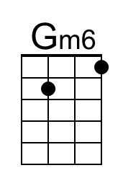
You see them long trains runnin', and you watch 'em disappear.

Chorus
Am7 Gm7 | Gm6 Am7 Dm7 % Am7 |
Without love ___ Where would you be now? (now, now, now)
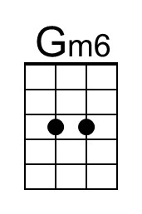
Dm7 Ebm7 Bb | Dm7 Eb7 | Am7 Dm7 % Am7 | Dm7
___ Without love.

Dm7 Am7 Dm7 - Am7 Dm7 - Am7
3. ___ You know I saw Miss Lucy, down along the tracks,
Dm7 Am7 Dm7
She lost her home and her family, and she won't be coming back. Chorus

Dm7 Am7 Dm7 Dbm7 Dm7
___ Well, the Illinois Central and the Southern Central Freight
Dbm7 Dm7 Dbm7 Dm7
Gotta keep on pushin', mama, 'Cause you know they're runnin' late. Chorus

Optional Solo
Am7 Dm7 % Am7 ||: Dm7 % % Am7 :|| Am7 |
^----------- [6x] -----------^

Repeat Verse 3. Chorus

Dm7 Am7 Dm7 Dbm7 Dm7
___ Well, pistons keep on churnin' and the wheels go 'round and 'round
Dbm7 Dm7 Dbm7 Dm7
And the steel rails lie cold and hard for the miles that they go down. Chorus

E7 Dm7
Ooh, where would you be now?

Long Train Runnin’ (Dm) – Page 2

Am7 Dm7 % Am7 ||: Dm7 % % Am7 :||
Opt. Instrumental ^------------ [3x] -------------^

Outro
Dm7 % Dm7 Am7 | Dm7 % % Am7 |
Mmm, got to get you, baby baby, won't you move it down?
Dm7 % % Am7 |
Won't you move it down? Baby, baby, baby, baby
Dm7 % % Am7 | Dm7 % % Am7 |
Won't you move it down?
Dm7 % % Am7 | Dm7 % % Am7 |
When the big train run
Dm7 % % Am7 | Dm7 % % Am7 |
When the train is movin' on, keep on movin'
Dm7 % % Am7 |
Won't you keep on movin'?
Dm7 % % Am7 |
Gonna keep on movin'

Am7 Dm7 % Am7 ||: Dm7 % % Am7 :|| Am7 |
^------------ [6x] ------------^

Long Train Runnin’ (Tom Johnston, 1973) (Em)
Long Train Runnin’ by The Doobie Brothers (Gm @ 117)
Long Train Runnin’ by The Doobie Brothers (Gm) (Official Music Video)
Long Train Runnin’ by The Doobie Brothers (Gm) (Live at the Beacon, 2018)
4/4 Time
Note: “%” = Repeat the previous chord

Intro
Bm7 Em7 % Bm7 ||: Em7 % % Bm7 :|| Bm7 |
^----------- [6x] -----------^

Bm7 Em7 - Bm7 Em7 - Bm7
Down a-round the corner, a half a mile from here,
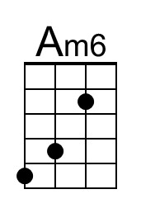
Em7 Bm7 Em7
You see them long trains runnin', and you watch 'em disappear.

Chorus
Bm7 Am7 | Am6 Bm7 Em7 % Bm7 |
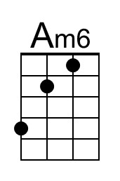
Without love ___ Where would you be now? (now, now, now)
Em7 Fm7 C | Em7 F7 | Bm7 Em7 % Bm7 | Em7
___ Without love.

Em7 Bm7 Em7 - Bm7 Em7 - Bm7
3. ___ You know I saw Miss Lucy, down along the tracks,
Em7 Bm7 Em7
She lost her home and her family, and she won't be coming back. Chorus

Em7 Bm7 Em7 D#m7 Em7
___ Well, the Illinois Central and the Southern Central Freight
D#m7 Em7 D#m7 Em7
Gotta keep on pushin', mama, 'Cause you know they're runnin' late. Chorus

Optional Solo
Bm7 Em7 % Bm7 ||: Em7 % % Bm7 :|| Bm7 |
^----------- [6x] -----------^

Repeat Verse 3. Chorus

Em7 Bm7 Em7 D#m7 Em7
___ Well, pistons keep on churnin' and the wheels go 'round and 'round
D#m7 Em7 D#m7 Em7
And the steel rails lie cold and hard for the miles that they go down. Chorus

F#7 Em7
Ooh, where would you be now?

Long Train Runnin’ (Em) – Page 2

Bm7 Em7 % Bm7 ||: Em7 % % Bm7 :||
Opt. Instrumental ^------------ [3x] -------------^

Outro
Em7 % Em7 Bm7 | Em7 % % Bm7 |
Mmm, got to get you, baby baby, won't you move it down?
Em7 % % Bm7 |
Won't you move it down? Baby, baby, baby, baby
Em7 % % Bm7 | Em7 % % Bm7 |
Won't you move it down?
Em7 % % Bm7 | Em7 % % Bm7 |
When the big train run
Em7 % % Bm7 | Em7 % % Bm7 |
When the train is movin' on, keep on movin'
Em7 % % Bm7 |
Won't you keep on movin'?
Em7 % % Bm7 |
Gonna keep on movin'

Bm7 Em7 % Bm7 ||: Em7 % % Bm7 :|| Bm7 |
^------------ [6x] ------------^

Long Train Runnin’ (Tom Johnston, 1973) (Gm)
Long Train Runnin’ by The Doobie Brothers (Gm @ 117)
Long Train Runnin’ by The Doobie Brothers (Gm) (Official Music Video)
Long Train Runnin’ by The Doobie Brothers (Gm) (Live at the Beacon, 2018)
4/4 Time
Note: “%” = Repeat the previous chord

Intro
Dm7 Gm7 % Dm7 ||: Gm7 % % Dm7 :|| Dm7 |
^----------- [6x] -----------^

Dm7 Gm7 - Dm7 Gm7 - Dm7
Down a-round the corner, a half a mile from here,
Gm7 Dm7 Gm7
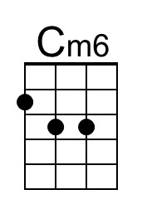
You see them long trains runnin', and you watch 'em disappear.

Chorus
Dm7 Cm7 | Cm6 Dm7 Gm7 % Dm7 |
Without love ___ Where would you be now? (now, now, now)
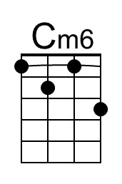
Gm7 Abm7 Eb | Gm7 Ab7 | Dm7 Gm7 % Dm7 | Gm7
___ Without love.

Gm7 Dm7 Gm7 - Dm7 Gm7 - Dm7
3. ___ You know I saw Miss Lucy, down along the tracks,
Gm7 Dm7 Gm7
She lost her home and her family, and she won't be coming back. Chorus

Gm7 Dm7 Gm7 F#m7 Gm7
___ Well, the Illinois Central and the Southern Central Freight
F#m7 Gm7 F#m7 Gm7
Gotta keep on pushin', mama, 'Cause you know they're runnin' late. Chorus

Optional Solo
Dm7 Gm7 % Dm7 ||: Gm7 % % Dm7 :|| Dm7 |
^----------- [6x] -----------^

Repeat Verse 3. Chorus

Gm7 Dm7 Gm7 F#m7 Gm7
___ Well, pistons keep on churnin' and the wheels go 'round and 'round
F#m7 Gm7 F#m7 Gm7
And the steel rails lie cold and hard for the miles that they go down. Chorus

A7 Gm7
Ooh, where would you be now?

Long Train Runnin’ (Gm) – Page 2

Dm7 Gm7 % Dm7 ||: Gm7 % % Dm7 :||
Opt. Instrumental ^------------ [3x] -------------^

Outro
Gm7 % Gm7 Dm7 | Gm7 % % Dm7 |
Mmm, got to get you, baby baby, won't you move it down?
Gm7 % % Dm7 |
Won't you move it down? Baby, baby, baby, baby
Gm7 % % Dm7 | Gm7 % % Dm7 |
Won't you move it down?
Gm7 % % Dm7 | Gm7 % % Dm7 |
When the big train run
Gm7 % % Dm7 | Gm7 % % Dm7 |
When the train is movin' on, keep on movin'
Gm7 % % Dm7 |
Won't you keep on movin'?
Gm7 % % Dm7 |
Gonna keep on movin'

Dm7 Gm7 % Dm7 ||: Gm7 % % Dm7 :|| Dm7 |
^------------ [6x] ------------^

~ ~ ~ ~ ~ ~ ~ ~ ~ ~
This is a great song to use the barre chord for the minor 7th type of chords. To get you started, here is Dm7 & Gm7 for C-Tuned and G-Tuned ukuleles (used in the Intro).
C-Tuned: | 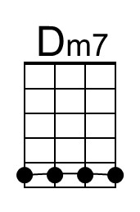 | 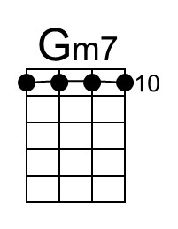 |  | G-Tuned: | 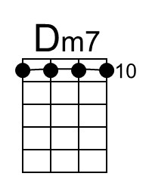 | 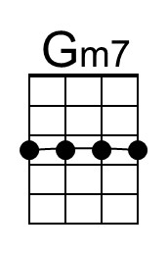
As always, you may choose any form that appeals to you.

Below there is an approximation of the distinctive strum pattern in this song.
Play along with an MP3 to get the timing.

♪. ♪♪ .. ♪♪ ♪. | ♪. ♪♪ . . ♪♪ ♪. | ♪. ♪♪ .. ♪♪ ♪ |
Dm7 Gm7 Gm7 Dm7 Dm7 Gm7 Gm7 Dm7 Dm7 Gm7 Gm7 Dm7

