Long Train Runnin’ (Tom Johnston, 1973) (Gm)
Long Train Runnin’ by The Doobie Brothers (Gm @ 117)
Long Train Runnin’ by The Doobie Brothers (Gm) (Official Music Video)
Long Train Runnin’ by The Doobie Brothers (Gm) (Live at the Beacon, 2018)
4/4 Time
Note: “%” = Repeat the previous chord

Intro
Dm7 Gm7 % Dm7 ||: Gm7 % % Dm7 :|| Dm7 |
^----------- [6x] -----------^

Dm7 Gm7 - Dm7 Gm7 - Dm7
Down a-round the corner, a half a mile from here,
Gm7 Dm7 Gm7
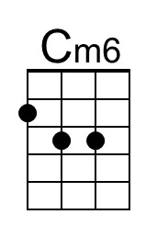
You see them long trains runnin', and you watch 'em disappear.

Chorus
Dm7 Cm7 | Cm6 Dm7 Gm7 % Dm7 |
Without love ___ Where would you be now? (now, now, now)
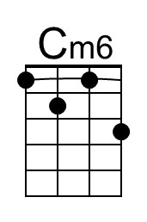
Gm7 Abm7 Eb | Gm7 Ab7 | Dm7 Gm7 % Dm7 | Gm7
___ Without love.

Gm7 Dm7 Gm7 - Dm7 Gm7 - Dm7
3. ___ You know I saw Miss Lucy, down along the tracks,
Gm7 Dm7 Gm7
She lost her home and her family, and she won't be coming back. Chorus

Gm7 Dm7 Gm7 F#m7 Gm7
___ Well, the Illinois Central and the Southern Central Freight
F#m7 Gm7 F#m7 Gm7
Gotta keep on pushin', mama, 'Cause you know they're runnin' late. Chorus

Optional Solo
Dm7 Gm7 % Dm7 ||: Gm7 % % Dm7 :|| Dm7 |
^----------- [6x] -----------^

Repeat Verse 3. Chorus

Gm7 Dm7 Gm7 F#m7 Gm7
___ Well, pistons keep on churnin' and the wheels go 'round and 'round
F#m7 Gm7 F#m7 Gm7
And the steel rails lie cold and hard for the miles that they go down. Chorus

A7 Gm7
Ooh, where would you be now?

Long Train Runnin’ (Dm) – Page 2

Dm7 Gm7 % Dm7 ||: Gm7 % % Dm7 :||
Opt. Instrumental ^------------ [3x] -------------^

Outro
Gm7 % Gm7 Dm7 | Gm7 % % Dm7 |
Mmm, got to get you, baby baby, won't you move it down?
Gm7 % % Dm7 |
Won't you move it down? Baby, baby, baby, baby
Gm7 % % Dm7 | Gm7 % % Dm7 |
Won't you move it down?
Gm7 % % Dm7 | Gm7 % % Dm7 |
When the big train run
Gm7 % % Dm7 | Gm7 % % Dm7 |
When the train is movin' on, keep on movin'
Gm7 % % Dm7 |
Won't you keep on movin'?
Gm7 % % Dm7 |
Gonna keep on movin'

Dm7 Gm7 % Dm7 ||: Gm7 % % Dm7 :|| Dm7 |
^------------ [6x] ------------^

~ ~ ~ ~ ~ ~ ~ ~ ~ ~
This is a great song to use the barre chord for the minor 7th type of chords. To get you started, here is Dm7 & Gm7 for C-Tuned and G-Tuned ukuleles (used in the Intro).
C-Tuned: | 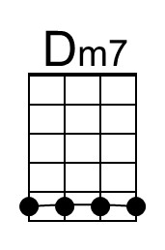 | 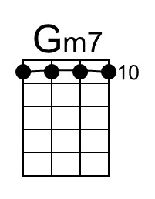 |  | G-Tuned: | 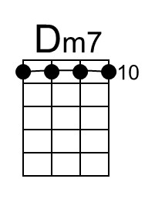 | 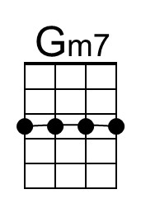
As always, you may choose any form that appeals to you.

Below there is an approximation of the distinctive strum pattern in this song.
Play along with an MP3 to get the timing.

♪. ♪♪ .. ♪♪ ♪. | ♪. ♪♪ . . ♪♪ ♪. | ♪. ♪♪ .. ♪♪ ♪ |
Dm7 Gm7 Gm7 Dm7 Dm7 Gm7 Gm7 Dm7 Dm7 Gm7 Gm7 Dm7

