Minute By Minute (Michael McDonald & Lester Abrams, 1978) (A)
Minute By Minute by The Doobie Brothers (1979) (C @ 144)
Minute By Minute by The Doobie Brothers (Official Music Video)
12/8 Time

Intro (4 Measures)
Amaj7

Optional Interlude
Bm7 | Bm7 | Bm7 | Bm7 | Amaj7 | Amaj7 | Amaj7 | D9

Amaj7
_____ Hey, don't worry, I've been lied to. __ I've been here many times before.
D6 F#m7 D
Girl, don't you worry, I know where I stand, I don't need this love, I don't need your hand.
D#7 D6
I know I could turn, blink, and you'd be gone,
F#m7 D
Then I must be pre-pared any time to carry on,
Dmaj9
But.__ minute by minute by minute by minute.
Amaj7 G#m7 Bb7 F#m7
I keep holding on, I'll be holding on
Dmaj9
Oh, minute by minute by minute by minute
Amaj7 | Amaj7 - D9
I keep holding on ah babe, now.

Amaj7
_____ You will stay just to watch me, darlin', __ wilt away on lies from you.
D6 F#m7 D
Can't stop the habit of livin' on the run. I take it all for granted like you're the only one.
D6
Livin' on my own, somehow that sounds nice.
F#m7 D
You think I'm your fool, well, you may just be right.

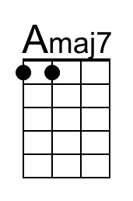 | 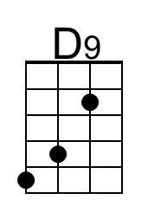 | 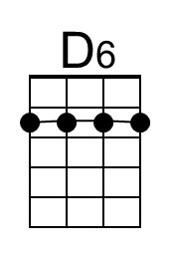 | 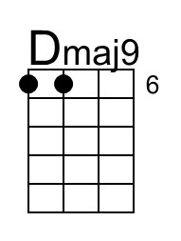 | 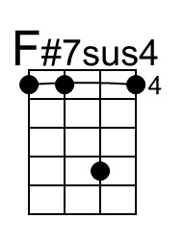 | 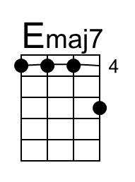
Bari | 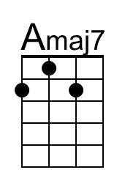 | 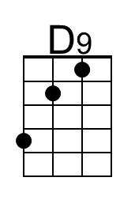 |  | 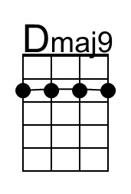 | 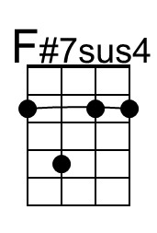 | 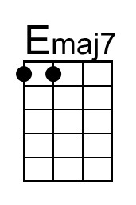

Minute by Minute (A) – Page 2

Dmaj9
But... minute by minute by minute by minute,
Amaj7 G#m7 Bb7 F#m7
I keep holding on, now, I'll be holding on
Dmaj9
Oh...minute by minute by minute by minute,
Amaj7 | Amaj7 | G#m7 Bb7 F#m7
I keep holding on I keep holding on.

Optional Interlude (4 Measures)
Bm7 A D D#dim7 A Fdim7 |
F#m E F#m A#dim7 Bm A |
D D#dim7 A Fdim7 F#m E |
F#m A#dim7

Bridge
C#m7 Amaj9
N.C. ___ Call my name and I'll be gone _____ You'll reach out and I won't be there
F#7sus4 F#m7 F#7sus4 F#m7
_______ Just my luck you'll real – ize
Amaj7 A9 Amaj7
_____ You should spend your life with someone.
A9 Amaj7
__ You could spend your life with someone.

Outro(Repeat and Fade)
Amaj9 Emaj7 | __ __ D#m7 D7 | C#m7
Minute by minute by minute by minute, I'll be holding on.

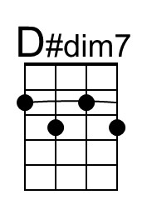 | 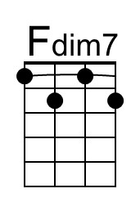 | 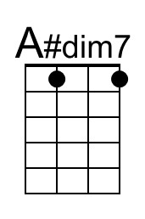 | 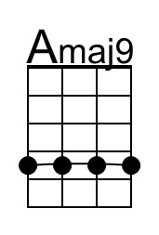 | 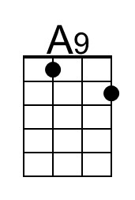
Bari | 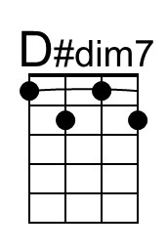 | 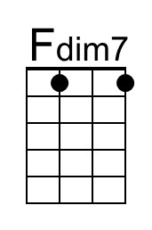 | 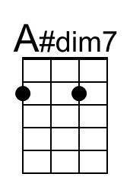 | 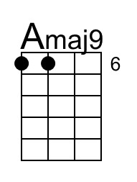 | 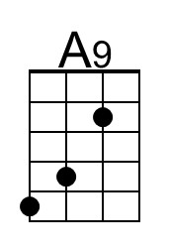

Minute By Minute (Michael McDonald & Lester Abrams, 1978) (C)
Minute By Minute by The Doobie Brothers (1979) (C @ 144)
Minute By Minute by The Doobie Brothers (Official Music Video)
12/8 Time

Intro (4 Measures)
Cmaj7

Optional Interlude
Dm7 | Dm7 | Dm7 | Dm7 | Cmaj7 | Cmaj7 | Cmaj7 | F9

Cmaj7
_____ Hey, don't worry, I've been lied to. __ I've been here many times before.
F6 Am7 F
Girl, don't you worry, I know where I stand, I don't need this love, I don't need your hand.
Gb7 F6
I know I could turn, blink, and you'd be gone,
Am7 F
Then I must be pre-pared any time to carry on,
Fmaj9
But.__ minute by minute by minute by minute.
Cmaj7 Bm7 Bb7 Am7
I keep holding on, I'll be holding on
Fmaj9
Oh, minute by minute by minute by minute
Cmaj7 | Cmaj7 - F9
I keep holding on ah babe, now.

Cmaj7
_____ You will stay just to watch me, darlin', __ wilt away on lies from you.
F6 Am7 F
Can't stop the habit of livin' on the run. I take it all for granted like you're the only one.
F6
Livin' on my own, somehow that sounds nice.
Am7 F
You think I'm your fool, well, you may just be right.

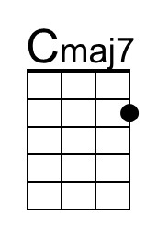 | 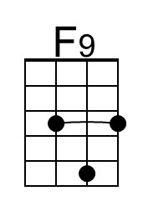 | 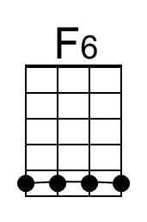 | 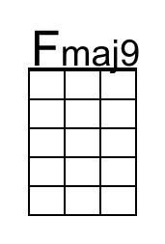 | 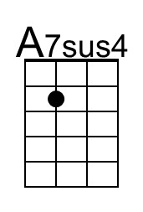 | 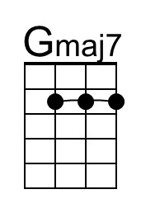
Bari | 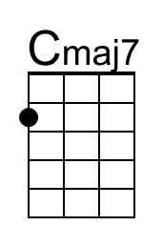 | 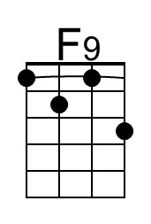 | 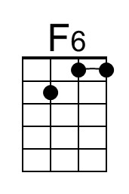 | 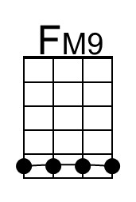 | 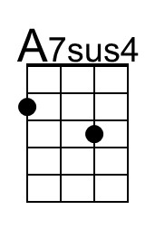 | 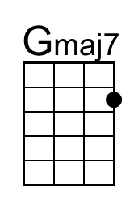

Minute by Minute (C) – Page 2

Fmaj9
But... minute by minute by minute by minute,
Cmaj7 Bm7 Bb7 Am7
I keep holding on, now, I'll be holding on
Fmaj9
Oh...minute by minute by minute by minute,
Cmaj7 | Cmaj7 | Bm7 Bb7 Am7
I keep holding on I keep holding on.

Optional Interlude (4 Measures)
Dm7 C F F#dim7 C G#dim7 |
Am G Am C#dim7 Dm C |
F F#dim7 C G#dim7 Am G |
Am C#dim7

Bridge
Em7 Cmaj9
N.C. ___ Call my name and I'll be gone _____ You'll reach out and I won't be there
A7sus4 Am7 A7sus4 Am7
______ Just my luck you'll real – ize
Cmaj7 C9 Cmaj7
_____ You should spend your life with someone.
C9 Cmaj7
__ You could spend your life with someone.

Outro(Repeat and Fade)
Cmaj9 Gmaj7 | __ __ F#m7 F7 | Em7
Minute by minute by minute by minute, I'll be holding on.

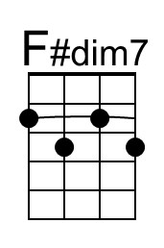 | 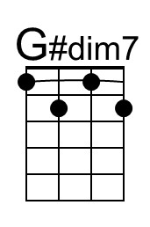 | 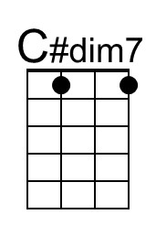 | 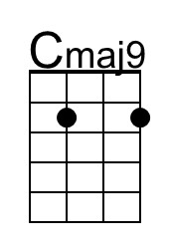 | 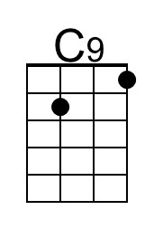
Bari | 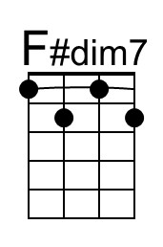 |  | 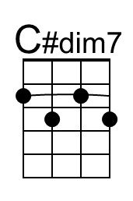 | 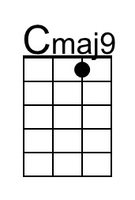 | 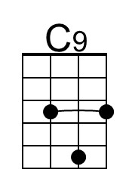

As originally written, most of "Minute by Minute" is in the key of C major,
but the bridge is in E minor and the last refrains are in G major.

Minute By Minute (Michael McDonald & Lester Abrams, 1978) (D)
Minute By Minute by The Doobie Brothers (1979) (C @ 144)
Minute By Minute by The Doobie Brothers (Official Music Video)
12/8 Time

Intro (4 Measures)
Dmaj7

Optional Interlude
Em7 | Em7 | Em7 | Em7 | Dmaj7 | Dmaj7 | Dmaj7 | G9

Dmaj7
_____ Hey, don't worry, I've been lied to. __ I've been here many times before.
G6 Bm7 G
Girl, don't you worry, I know where I stand, I don't need this love, I don't need your hand.
G#7 G6
I know I could turn, blink, and you'd be gone,
Bm7 G
Then I must be pre-pared any time to carry on,
Gmaj9
But.__ minute by minute by minute by minute.
Dmaj7 C#m7 Bb7 Bm7
I keep holding on, I'll be holding on
Gmaj9
Oh, minute by minute by minute by minute
Dmaj7 | Dmaj7 - G9
I keep holding on ah babe, now.

Dmaj7
_____ You will stay just to watch me, darlin', __ wilt away on lies from you.
G6 Bm7 G
Can't stop the habit of livin' on the run. I take it all for granted like you're the only one.
G6
Livin' on my own, somehow that sounds nice.
Bm7 G
You think I'm your fool, well, you may just be right.

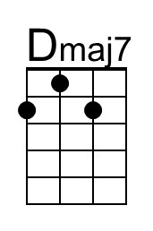 | 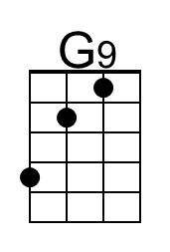 | 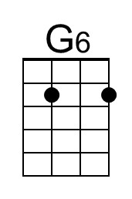 | 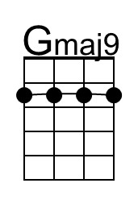 | 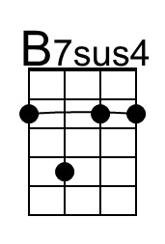
Bari | 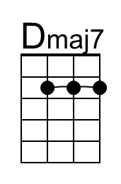 | 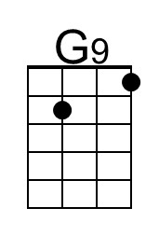 | 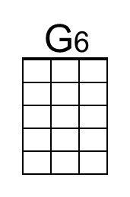 | 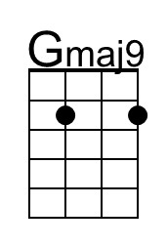 | 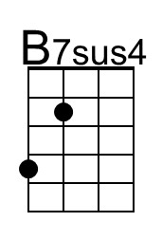

Minute by Minute (D) – Page 2

Gmaj9
But... minute by minute by minute by minute,
Dmaj7 C#m7 Bb7 Bm7
I keep holding on, now, I'll be holding on
Gmaj9
Oh...minute by minute by minute by minute,
Dmaj7 | Dmaj7 | C#m7 Bb7 Bm7
I keep holding on I keep holding on.

Optional Interlude (4 Measures)
Em7 D G G#dim7 D A#dim7 |
Bm A Bm D#dim7 Em D |
G G#dim7 D A#dim7 Bm A |
Bm D#dim7

Bridge
F#m7 Dmaj9
N.C. ___ Call my name and I'll be gone _____ You'll reach out and I won't be there
B7sus4 Bm7 B7sus4 Bm7
______ Just my luck you'll real – ize
Dmaj7 D9 Dmaj7
_____ You should spend your life with someone.
D9 Dmaj7
__ You could spend your life with someone.

Outro(Repeat and Fade)
Dmaj9 Amaj7 | __ __ G#m7 G7 | F#m7
Minute by minute by minute by minute, I'll be holding on.

Bari

Minute By Minute (Michael McDonald & Lester Abrams, 1978) (E)
Minute By Minute by The Doobie Brothers (1979) (C @ 144)
Minute By Minute by The Doobie Brothers (Official Music Video)
12/8 Time

Intro (4 Measures)
Emaj7

Optional Interlude
F#m7 | F#m7 | F#m7 | F#m7 | Emaj7 | Emaj7 | Emaj7 | A9

Emaj7
_____ Hey, don't worry, I've been lied to. __ I've been here many times before.
A6 C#m7 A
Girl, don't you worry, I know where I stand, I don't need this love, I don't need your hand.
A#7 A6
I know I could turn, blink, and you'd be gone,
C#m7 A
Then I must be pre-pared any time to carry on,
Amaj9
But.__ minute by minute by minute by minute.
Emaj7 D#m7 Bb7 C#m7
I keep holding on, I'll be holding on
Amaj9
Oh, minute by minute by minute by minute
Emaj7 | Emaj7 - A9
I keep holding on ah babe, now.

Emaj7
_____ You will stay just to watch me, darlin', __ wilt away on lies from you.
A6 C#m7 A
Can't stop the habit of livin' on the run. I take it all for granted like you're the only one.
A6
Livin' on my own, somehow that sounds nice.
C#m7 A
You think I'm your fool, well, you may just be right.

 |  | 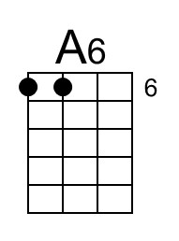 |  | 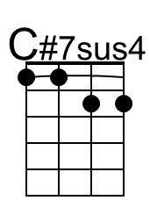 | 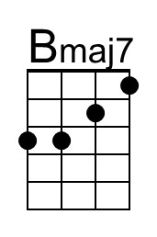
Bari |  |  | 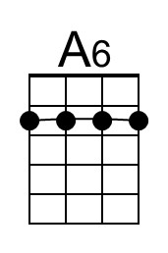 |  | 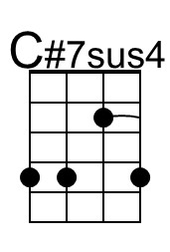 | 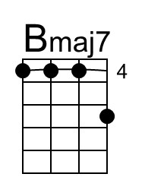

Minute by Minute (E) – Page 2

Amaj9
But... minute by minute by minute by minute,
Emaj7 D#m7 Bb7 C#m7
I keep holding on, now, I'll be holding on
Amaj9
Oh...minute by minute by minute by minute,
Emaj7 | Emaj7 | D#m7 Bb7 C#m7
I keep holding on I keep holding on.

Optional Interlude (4 Measures)
F#m7 E A A#dim7 E Cdim7 |
C#m B C#m Fdim7 F#m E |
A A#dim7 E Cdim7 C#m B |
C#m Fdim7

Bridge
G#m7 Emaj9
N.C. ___ Call my name and I'll be gone _____ You'll reach out and I won't be there
C#7sus4 C#m7 C#7sus4 C#m7
_______ Just my luck you'll real – ize
Emaj7 E9 Emaj7
_____ You should spend your life with someone.
E9 Emaj7
__ You could spend your life with someone.

Outro(Repeat and Fade)
Emaj9 Bmaj7 | __ __ A#m7 A7 | G#m7
Minute by minute by minute by minute, I'll be holding on.

 | 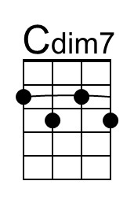 |  | 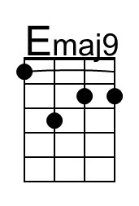 | 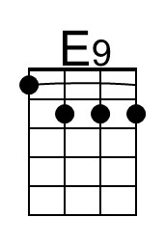
Bari |  | 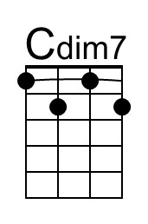 |  | 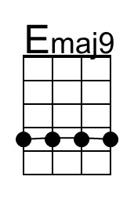 | 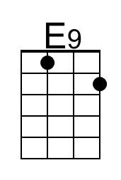

Minute By Minute (Michael McDonald & Lester Abrams, 1978) (G)
Minute By Minute by The Doobie Brothers (1979) (C @ 144)
Minute By Minute by The Doobie Brothers (Official Music Video)
12/8 Time

Intro (4 Measures)
Gmaj7

Optional Interlude
Am7 | Am7 | Am7 | Am7 | Gmaj7 | Gmaj7 | Gmaj7 | C9

Gmaj7
_____ Hey, don't worry, I've been lied to. __ I've been here many times before.
C6 Em7 C
Girl, don't you worry, I know where I stand, I don't need this love, I don't need your hand.
C#7 C6
I know I could turn, blink, and you'd be gone,
Em7 C
Then I must be pre-pared any time to carry on,
Cmaj9
But.__ minute by minute by minute by minute.
Gmaj7 F#m7 Bb7 Em7
I keep holding on, I'll be holding on
Cmaj9
Oh, minute by minute by minute by minute
Gmaj7 | Gmaj7 - C9
I keep holding on ah babe, now.

Gmaj7
_____ You will stay just to watch me, darlin', __ wilt away on lies from you.
C6 Em7 C
Can't stop the habit of livin' on the run. I take it all for granted like you're the only one.
C6
Livin' on my own, somehow that sounds nice.
Em7 C
You think I'm your fool, well, you may just be right.

 |  | 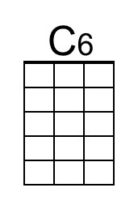 |  | 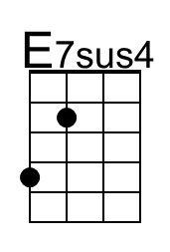
Bari |  |  | 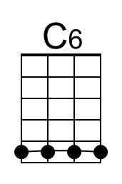 | 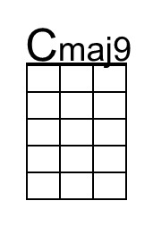 | 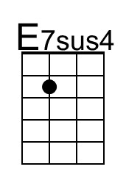

Minute by Minute (G) – Page 2

Cmaj9
But... minute by minute by minute by minute,
Gmaj7 F#m7 Bb7 Em7
I keep holding on, now, I'll be holding on
Cmaj9
Oh...minute by minute by minute by minute,
Gmaj7 | Gmaj7 | F#m7 Bb7 Em7
I keep holding on I keep holding on.

Optional Interlude (4 Measures)
Am7 G C C#dim7 G D#dim7 |
Em D Em G#dim7 Am G |
C C#dim7 G D#dim7 Em D |
Em G#dim7

Bridge
Bm7 Gmaj9
N.C. ___ Call my name and I'll be gone _____ You'll reach out and I won't be there
E7sus4 Em7 E7sus4 Em7
______ Just my luck you'll real – ize
Gmaj7 G9 Gmaj7
_____ You should spend your life with someone.
G9 Gmaj7
__ You could spend your life with someone.

Outro(Repeat and Fade)
Gmaj9 Dmaj7 | __ __ C#m7 C7 | Bm7
Minute by minute by minute by minute, I'll be holding on.

Bari

