Rockin’ Down The Highway (Tom Johnston, 1972) (A)
Rockin’ Down The Highway by The Doobie Brothers (A)
Rockin’ Down The Highway by The Doobie Brothers (A) (Live – The Wildlife Concert)
4/4 Time

Intro (Chords to Chorus)
A | _ G _ D | _ A | D _ A _ | A | _ G _ D | _ A |

A
Got those highway blues, can't you hear my motor runnin'
D A - D
Flyin' down the road with my foot on the floor,
A
All the way in town they can hear me comin'.
D A
Ford's about to drop, she won't do no more.
F↓↓
___ And I smell my motor burnin', underneath the hood is smoke.
E↓ ↓ G
Can't stop, and I can't stop, got to keep on movin' or I'll lose my mind.

Chorus
A G D A G D A
Oh, rockin' down the high-way. Oh, rockin' down the high-way.
G D A G D A
Oh, rockin' down the high-way. Oh, rockin' down the high-way. (You gotta)

Optional Instrumental (4 Measures of “A” & Variations)

A D A
The highway patrol got his eyes on me, I know what he's thinkin' and it ain't good.
A D A
I'm movin' so fast he can barely see me. Gonna lose that man, I know I should.
F↓↓
___ I gotta kick in my pedal, make my Ford move a little bit faster,
E ↓ ↓ E ↓ ↓ G
Can't stop, and I can't stop, got to keep on movin' or I'll lose my mind.

Chorus
A G D A G D A
Oh, rockin' down the high-way. Oh, rockin' down the high-way.
D A
( Good Lord, man )
G D A G D A
Oh, rockin' down the high-way. Oh, rockin' down the high-way.

Rockin’ Down The Highway (A) – Page 2

Bridge
| F#m7 C#m7 Bm7 | Bm7 |
| F#m7 C#m7 Bm7 | Bm7 |
| F#m7 C#m7 Bm7 | Bm7 | E6 | E6 |

Optional Solo (Chords for Verse)
A D A D A F E G

Outro
A G D A G D A
Oh, rockin' down the high-way. Oh, rockin' down the high-way.
G D A G D A | A F E C A | A↓
Oh, rockin' down the high-way. Oh, rockin' down the high-way. (Descending Run)

Bridge
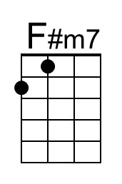 | 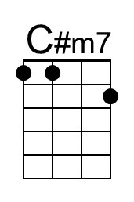 | 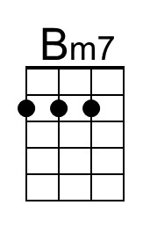 | 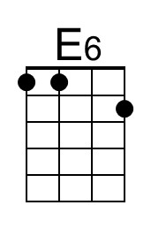 | Baritone | 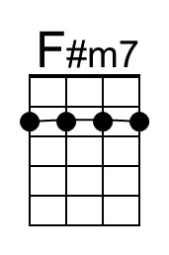 | 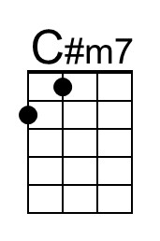 | 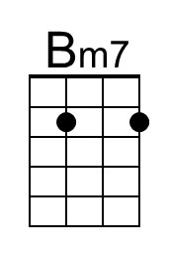 | 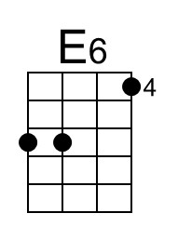
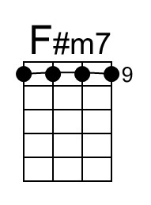 | 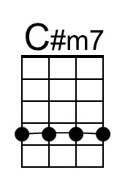 | 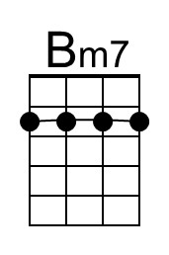 | 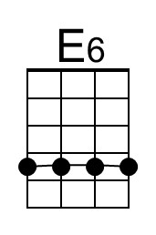 | Baritone |  | 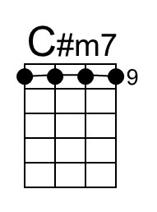 | 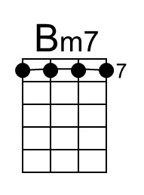 | 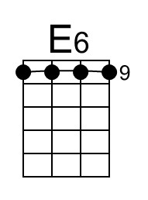

Introduction (One of many possible options)
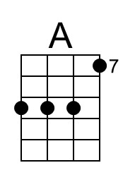 | 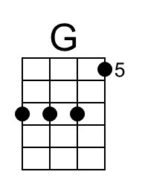 | 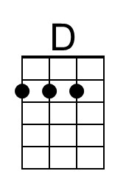 |  | Baritone | 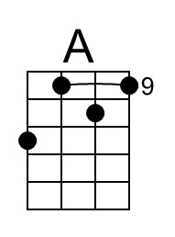 | 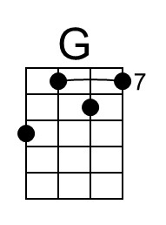 | 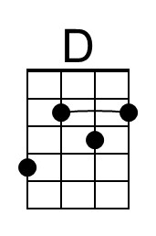

Rockin’ Down The Highway (Tom Johnston, 1972) (C)
Rockin’ Down The Highway by The Doobie Brothers (A)
Rockin’ Down The Highway by The Doobie Brothers (A) (Live – The Wildlife Concert)
4/4 Time

Intro (Chords to Chorus)
C | _ Bb _ F | _ C | F _ C _ | C | _ Bb _ F | _ C |

C
Got those highway blues, can't you hear my motor runnin'
F C - F
Flyin' down the road with my foot on the floor,
C
All the way in town they can hear me comin'.
F C
Ford's about to drop, she won't do no more.
Ab↓↓
___ And I smell my motor burnin', underneath the hood is smoke.
G↓ ↓ Bb
Can't stop, and I can't stop, got to keep on movin' or I'll lose my mind.

Chorus
C Bb F C Bb F C
Oh, rockin' down the high-way. Oh, rockin' down the high-way.
Bb F C Bb F C
Oh, rockin' down the high-way. Oh, rockin' down the high-way. (You gotta)

Optional Instrumental (4 Measures of “C” & Variations)

C F C
The highway patrol got his eyes on me, I know what he's thinkin' and it ain't good.
C F C
I'm movin' so fast he can barely see me. Gonna lose that man, I know I should.
Ab↓↓
___ I gotta kick in my pedal, make my Ford move a little bit faster,
G ↓ ↓ G ↓ ↓ Bb
Can't stop, and I can't stop, got to keep on movin' or I'll lose my mind.

Chorus
C Bb F C Bb F C
Oh, rockin' down the high-way. Oh, rockin' down the high-way.
F C
( Good Lord, man )
C Bb F C Bb F C
Oh, rockin' down the high-way. Oh, rockin' down the high-way.

Rockin’ Down The Highway (C) – Page 2

Bridge
| Am7 Em7 Dm7 | Dm7 |
| Am7 Em7 Dm7 | Dm7 |
| Am7 Em7 Dm7 | Dm7 | G6 | G6 |

Optional Solo (Chords for Verse)
C F C F C G# G Bb

Outro
C Bb F C Bb F C
Oh, rockin' down the high-way. Oh, rockin' down the high-way.
C Bb F C Bb F C
Oh, rockin' down the high-way. Oh, rockin' down the high-way.
| C G# G D# C | C↓

Bridge
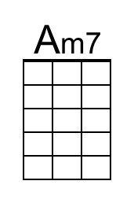 | 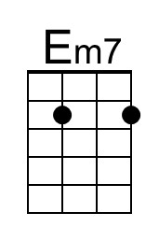 | 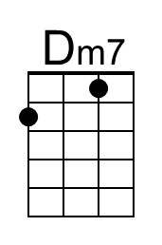 | 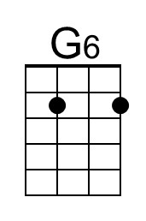 | Baritone | 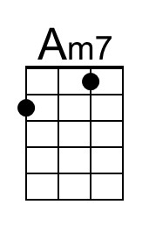 | 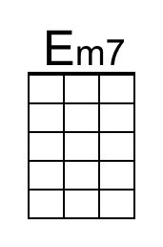 | 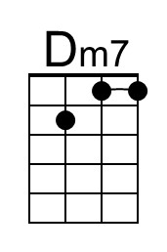 | 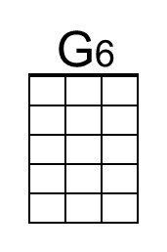

Rockin’ Down The Highway (Tom Johnston, 1972) (G)
Rockin’ Down The Highway by The Doobie Brothers (A)
Rockin’ Down The Highway by The Doobie Brothers (A) (Live – The Wildlife Concert)
4/4 Time

Intro (Chords to Chorus)
G | _ F _ C | _ G | C _ G _ | G | _ F _ C | _ G |

G
Got those highway blues, can't you hear my motor runnin'
C G - C
Flyin' down the road with my foot on the floor,
G
All the way in town they can hear me comin'.
C G
Ford's about to drop, she won't do no more.
Eb↓↓
___ And I smell my motor burnin', underneath the hood is smoke.
D↓ ↓ F
Can't stop, and I can't stop, got to keep on movin' or I'll lose my mind.

Chorus
G F C G F C G
Oh, rockin' down the high-way. Oh, rockin' down the high-way.
F C G F C G
Oh, rockin' down the high-way. Oh, rockin' down the high-way. (You gotta)

Optional Instrumental (4 Measures of “G” & Variations)

G C G
The highway patrol got his eyes on me, I know what he's thinkin' and it ain't good.
G C G
I'm movin' so fast he can barely see me. Gonna lose that man, I know I should.
Eb↓↓
___ I gotta kick in my pedal, make my Ford move a little bit faster,
D ↓ ↓ D ↓ ↓ F
Can't stop, and I can't stop, got to keep on movin' or I'll lose my mind.

Chorus
G F C G F C G
Oh, rockin' down the high-way. Oh, rockin' down the high-way.
C G
( Good Lord, man )
F C G F C G
Oh, rockin' down the high-way. Oh, rockin' down the high-way.

Rockin’ Down The Highway (G) – Page 2

Bridge
| Em7 Bm7 Am7 | Am7 |
| Em7 Bm7 Am7 | Am7 |
| Em7 Bm7 Am7 | Am7 | D6 | D6 |

Optional Solo (Chords for Verse)
G C G C G Eb D F

Outro
G F C G F C G
Oh, rockin' down the high-way. Oh, rockin' down the high-way.
F C G F C G
Oh, rockin' down the high-way. Oh, rockin' down the high-way.
| G Eb D Bb G | G↓

Bridge
 |  |  | 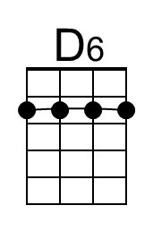 | Baritone

