South City Midnight Lady (Patrick Simmons, ca. 1972-73) (A)
South City Midnight Lady by The Doobie Brothers (1973) (G @ 113)
South City Midnight Lady by The Doobie Brothers (Live, 1996)
4/4 Time
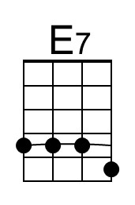
Intro (2x)
| A E | D | A E | D |

A E D A E D
Up all night I could not sleep, the whiskey that I drank was cheap,
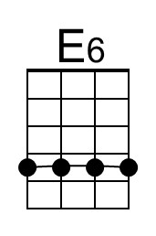
A D E E7 | E6 Bm
With shakin' hands I went and I lit up my last ciga-rette.
A E D A E D
Well the sun came, the night had fled, and sleepy-eyed, I reached my bed;
A D A | D - A
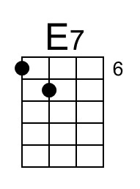
I saw you sleepy, dreaming there, all covered and warm.

Chorus
D C#m C - Bm
South city midnight lady, I'm much obliged in-deed;
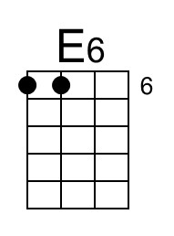
D C#m Bm A | D - A
You sure have saved this man who's soul was in need.
D C#m C Bm
I thought there was no reason, for all these things I do,
D C#m Bm A | A
But the smile that I sent out re-turned with you.

A E D A E D
When day has left the night be-hind, and shadows roll across my mind,
A D E - E7 | E6 Bm
I sometimes find myself a-lone and out walking the street.
A E D A E D
Yes and when I'm feelin' down and blue, then all I do is think of you,
A D A | D - A
And all my foolish problems seem to fade a-way. Chorus

Optional Guitar Solo
| C | C | C | D | C | C | C | D | C | C | C | D | C | C |
| A E7 | A E7 | A E7 | A E7 | E E7 | E6 Bm |
| A E7 | A E7 | A E7 | A | A |

Chorus

Outro (4X)
| D | A | D | Em | F | G | A | A |

South City Midnight Lady (Patrick Simmons, ca. 1972-73) (C)
South City Midnight Lady by The Doobie Brothers (1973) (G @ 113)
South City Midnight Lady by The Doobie Brothers (Live, 1996)
4/4 Time
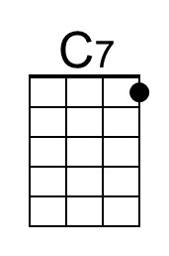
Intro (2x)
| C G | F | C G | F |

F C Bb F C Bb
Up all night I could not sleep, the whiskey that I drank was cheap,
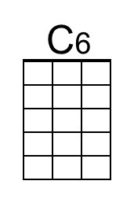
F Bb C C7 | C6 Gm
With shakin' hands I went and I lit up my last ciga-rette.
F C Bb F C Bb
Well the sun came, the night had fled, and sleepy-eyed, I reached my bed;
F Bb F | Bb - F
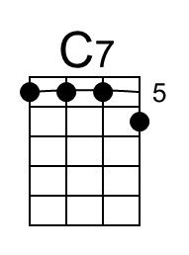
I saw you sleepy, dreaming there, all covered and warm.

Chorus
Bb Am Ab - Gm
South city midnight lady, I'm much obliged in-deed;
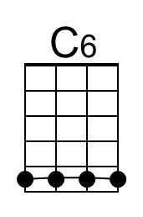
Bb Am Gm F | Bb - F
You sure have saved this man who's soul was in need.
Bb Am Ab Gm
I thought there was no reason, for all these things I do,
Bb Am Gm F | F
But the smile that I sent out re-turned with you.

F C Bb F C Bb
When day has left the night be-hind, and shadows roll across my mind,
F Bb C - C7 | C6 Gm
I sometimes find myself a-lone and out walking the street.
F C Bb F C Bb
Yes and when I'm feelin' down and blue, then all I do is think of you,
F Bb F | Bb - F
And all my foolish problems seem to fade a-way. Chorus

Optional Guitar Solo
| Ab | Ab | Ab | Bb | Ab | Ab | Ab | Bb | Ab | Ab | Ab | Bb | Ab | Ab |
| F C7 | F C7 | F C7 | F C7 | C C7 | C6 Gm |
| F C7 | F C7 | F C7 | F | F |

Chorus

Outro (4X)
| Bb | F | Bb | Cm | C# | Eb | F | F |

South City Midnight Lady (Patrick Simmons, ca. 1972-73) (D)
South City Midnight Lady by The Doobie Brothers (1973) (G @ 113)
South City Midnight Lady by The Doobie Brothers (Live, 1996)
4/4 Time
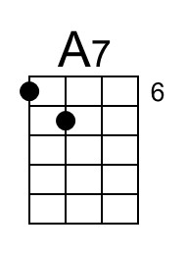
Intro (2x)
| D A | G | D A | G |

D A G D A G
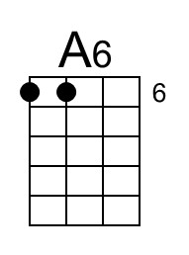
Up all night I could not sleep, the whiskey that I drank was cheap,
D G A A7 | A6 Em
With shakin' hands I went and I lit up my last ciga-rette.
D A G D A G
Well the sun came, the night had fled, and sleepy-eyed, I reached my bed;
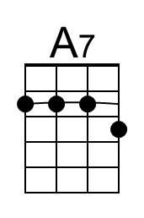
D G D | G - D
I saw you sleepy, dreaming there, all covered and warm.

Chorus
G F#m F - Em
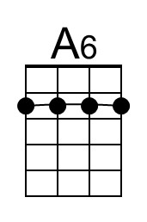
South city midnight lady, I'm much obliged in-deed;
G F#m Em D | G - D
You sure have saved this man who's soul was in need.
G F#m F Em
I thought there was no reason, for all these things I do,
G F#m Em D | D
But the smile that I sent out re-turned with you.

D A G D A G
When day has left the night be-hind, and shadows roll across my mind,
D G A - A7 | A6 Em
I sometimes find myself a-lone and out walking the street.
D A G D A G
Yes and when I'm feelin' down and blue, then all I do is think of you,
D G D | G - D
And all my foolish problems seem to fade a-way. Chorus

Optional Guitar Solo
| F | F | F | G | F | F | F | G | F | F | F | G | F | F |
| D A7 | D A7 | D A7 | D A7 | A A7 | A6 Em |
| D A7 | D A7 | D A7 | D | D |

Chorus

Outro (4X)
| G | D | G | Am | Bb | C | D | D |

South City Midnight Lady (Patrick Simmons, ca. 1972-73) (G)
South City Midnight Lady by The Doobie Brothers (1973) (G @ 113)
South City Midnight Lady by The Doobie Brothers (Live, 1996)
4/4 Time
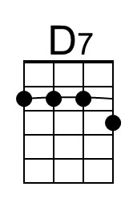
Intro (2x)
| G D | C | G D | C |
Note that the opening G is actually a D → G combination. An F# → G is pretty close.

G D C G D C
Up all night I could not sleep, the whiskey that I drank was cheap,
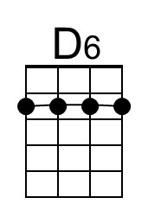
G C D D7 | D6 Am
With shakin' hands I went and I lit up my last ciga-rette.
G D C G D C
Well the sun came, the night had fled, and sleepy-eyed, I reached my bed;
G C G | C - G
I saw you sleepy, dreaming there, all covered and warm.

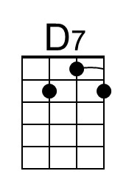
Chorus
C Bm Bb - Am
South city midnight lady, I'm much obliged in-deed;
C Bm Am G | C - G
You sure have saved this man who's soul was in need.
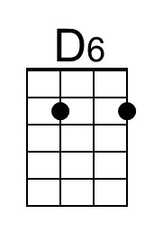
C Bm Bb Am
I thought there was no reason, for all these things I do,
C Bm Am G | G
But the smile that I sent out re-turned with you.

G D C G D C
When day has left the night be-hind, and shadows roll across my mind,
G C D - D7 | D6 Am
I sometimes find myself a-lone and out walking the street.
G D C G D C
Yes and when I'm feelin' down and blue, then all I do is think of you,
G C G | C - G
And all my foolish problems seem to fade a-way. Chorus

Optional Guitar Solo
| Bb | Bb | Bb | C | Bb | Bb | Bb | C | Bb | Bb | Bb | C | Bb | Bb |
| G D7 | G D7 | G D7 | G D7 | D D7 | D6 Am |
| G D7 | G D7 | G D7 | G | G |

Chorus

Outro (4X)
| C | G | C | Dm | Eb | F | G | G |

