South City Midnight Lady (Patrick Simmons, ca. 1972-73) (G)
South City Midnight Lady by The Doobie Brothers (1973) (G @ 113)
South City Midnight Lady by The Doobie Brothers (Live, 1996)
4/4 Time
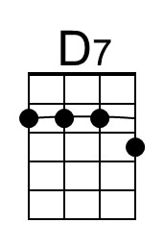
Intro (2x)
| G D | C | G D | C |
Note that the opening G is actually a D → G combination. An F# → G is pretty close.

G D C G D C
Up all night I could not sleep, the whiskey that I drank was cheap,
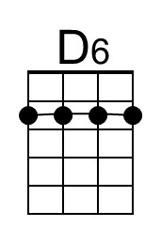
G C D D7 | D6 Am
With shakin' hands I went and I lit up my last ciga-rette.
G D C G D C
Well the sun came, the night had fled, and sleepy-eyed, I reached my bed;
G C G | C - G
I saw you sleepy, dreaming there, all covered and warm.

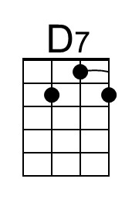
Chorus
C Bm Bb - Am
South city midnight lady, I'm much obliged in-deed;
C Bm Am G | C - G
You sure have saved this man who's soul was in need.
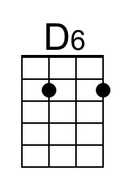
C Bm Bb Am
I thought there was no reason, for all these things I do,
C Bm Am G | G
But the smile that I sent out re-turned with you.

G D C G D C
When day has left the night be-hind, and shadows roll across my mind,
G C D - D7 | D6 Am
I sometimes find myself a-lone and out walking the street.
G D C G D C
Yes and when I'm feelin' down and blue, then all I do is think of you,
G C G | C - G
And all my foolish problems seem to fade a-way. Chorus

Optional Guitar Solo
| Bb | Bb | Bb | C | Bb | Bb | Bb | C | Bb | Bb | Bb | C | Bb | Bb |
| G D7 | G D7 | G D7 | G D7 | D D7 | D6 Am |
| G D7 | G D7 | G D7 | G | G |

Chorus

Outro (4X)
| C | G | C | Dm | Eb | F | G | G |

