Takin' It To The Streets (Michael McDonald, 1975) (C)
Takin' It To The Streets by The Doobie Brothers (1976) (C @ 147)
Takin' It To The Streets by The Doobie Brothers (Live)
4/4 Time
Intro (First two lines)
Fm6 F | C | D7 G7sus4 | Fm6 F | C | D7 G7sus4

Fm6 F C D7 G7sus4 Fm6 F C D7 G7sus4
____ You don't know me but I'm your bro – ther. ___ I was raised here in this living hell
Fm6 F C D7 G7sus4 Fm6 F C D7 - G7sus4
____ You don't know my kind in __ your world ___ Fairly soon, _ the time will tell.

Chorus 1
C - C7 F Fm G7sus4 - C C7 | C7
You telling me the things you're gonna do for me
F Fm G7sus4
I ain't blind and I don't like what I think I see
C7 F6 C . . F6 C7 F6 C . . F6
Takin' it to the streets (Takin' it to the streets) Takin' it to the streets (No more need for...)
C7 F6 C . . F6
Takin' it to the streets (Oh, na, na)

Fm6 F C D7 G7sus4 Fm6 F C D7 - G7sus4
____ Take this mes-sage to my __ bro-ther ___ You will find him everywhere.
Fm6 F C D7 G7sus4 Fm6 F C - D7 G7sus4
____ Wherever peo-ple live to – ge – ther. ___ Tied in pov-erty's despair.

Chorus 2
C - C9 F Fm G7sus4 C - C9 | C9
Oh, you Telling me the things you're gonna do for me
F Fm G7sus4
I ain't blind and I don't like what I think I see
C7 F6 D7b5 C | _ _ F  Takin' it to the streets. (Takin' it to the streets) | C7 F6 D7b5 C | _ _ F  Takin' it to the streets (No more need for...)
C7 F6 D7b5 C | _ _ F  Takin' it to the streets. (Oh, yeah) | C7 F6 D7b5 C | _ _ F  Takin' it to the streets. (Takin' it, takin' it)
C7 F6 D7b5 C | _ _ F  Takin' it to the streets. (No more need for hiding) | C7 F6 D7b5 C | _ _ F  Takin' it to the streets. (Oh, Lord)
C7 F6 D7b5 C | _ _ F  Takin' it to the streets. (Takin' it to the streets) | C7 F6 D7b5 C  Takin' it to the

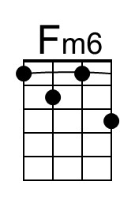 | 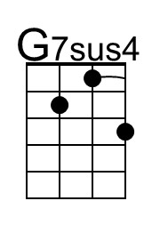 | 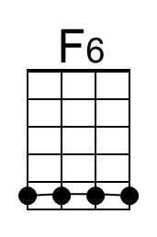 | 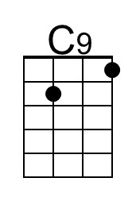 | 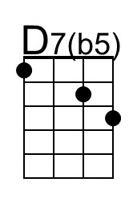
Baritone | 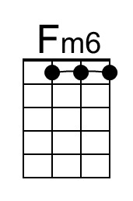 | 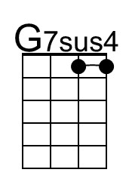 | 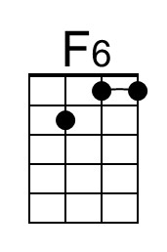 | 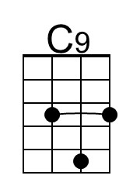 | 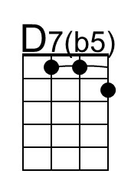

Takin’ It To The Streets (C) – Page 2

Optional Solo
Fm6 F C D7 G7sus4 Fm6 F C D7 G7sus4
____ You don't know me but I'm your bro – ther. ___ I was raised here in this living hell
Fm6 F C D7 G7sus4 Fm6 F C D7 - G7sus4
____ You don't know my kind in __ your world ___ Fairly soon, _ the time will tell.

Chorus 3
C - Bb Am Ab F - C Bb
Oh, you Telling me the things you're gonna do for me (Yeah, na)
Am Ab F
I ain't blind and I don't like what I think I see
C7 F6 D7b5 C | _ _ F  Takin' it to the streets. (Takin' it to the streets) | C7 F6 D7b5 C | _ _ F  Takin' it to the streets. (No more need for...)
C7 F6 D7b5 C | _ _ F  Takin' it to the streets. (Oh, yeah) | C7 F6 D7b5 C | _ _ F  Takin' it to the streets. (Takin' it to the streets)
C7 F6 D7b5 C | _ _ F  Takin' it to the streets. (Before it steps farther) | C7 F6 D7b5 C | _ _ F  Takin' it to the streets. (Oh, Lord)
C7 F6 D7b5 C | _ _ F  Takin' it to the streets. (Takin' it, takin' it) | C7 F6 D7b5 C | _ _ F  Takin' it to the streets. (Hey, yeah, ha)

Outro
C7 F6 D7b5 C | _ _ F  Takin' it to the streets. (Takin' it to the streets) | C7 F6 D7b5 C | _ _ F  Takin' it to the streets. (No more need for...)
C7 F6 D7b5 C | _ _ F  Takin' it to the streets. (No more need for...) | C7 F6 D7b5 C | _ _ F  Takin' it to the streets. (Hey, yeah, yeah)
Fade Out
C7 F6 D7b5 C | _ _ F  Takin' it to the streets. (No more) | C7 F6 D7b5 C | _ _ F  Takin' it to the streets. (Yeah, yeah)
C7 F6 D7b5 C | _ _ F  Takin' it to the streets. (Takin' it, takin' it) | C7 F6 D7b5 C | _ _ F  Takin' it to the streets.
C7 F6 D7b5 C | _ _ F  Takin' it to the streets. | C7 F6 D7b5 C | _ _ F  Takin' it to the streets.

Takin' It To The Streets (Michael McDonald, 1975) (G)
Takin' It To The Streets by The Doobie Brothers (1976) (C @ 147)
Takin' It To The Streets by The Doobie Brothers (Live)
4/4 Time
Intro (First two lines)
Cm6 G | D | E7 A7sus4 | Gm6 G | D | E7 A7sus4

Gm6 G D E7 A7sus4 Gm6 G D E7 A7sus4
____ You don't know me but I'm your bro – ther. ___ I was raised here in this living hell
Gm6 G D E7 A7sus4 Gm6 G D E7 - A7sus4
____ You don't know my kind in __ your world ___ Fairly soon, _ the time will tell.

Chorus 1
G - G7 C Cm D7sus4 - G G7 | G7
You telling me the things you're gonna do for me
C Cm D7sus4
I ain't blind and I don't like what I think I see
G7 C6 G . . C6 G7 C6 G . . C6
Takin' it to the streets (Takin' it to the streets) Takin' it to the streets (No more need for...)
G7 C6 G . . C6
Takin' it to the streets (Oh, na, na)

Cm6 C G A7 D7sus4 Cm6 C G A7 - D7sus4
____ Take this mes-sage to my __ bro-ther ___ You will find him everywhere.
Cm6 C G A7 D7sus4 Cm6 C G - A7 D7sus4
____ Wherever peo-ple live to – ge – ther. ___ Tied in pov-erty's despair.

Chorus 2
G - G9 C Cm D7sus4 G - G9 | G9
Oh, you Telling me the things you're gonna do for me
C Cm D7sus4
I ain't blind and I don't like what I think I see
G7 C6 A7b5 G | _ _ C  Takin' it to the streets. (Takin' it to the streets) | G7 C6 A7b5 G | _ _ C  Takin' it to the streets. (Takin' it to the streets)
G7 C6 A7b5 G | _ _ C  Takin' it to the streets. (Oh, yeah) | G7 C6 A7b5 G | _ _ C  Takin' it to the streets. (Oh, yeah)
G7 C6 A7b5 G | _ _ C  Takin' it to the streets. (No more need for hiding) | G7 C6 A7b5 G | _ _ C  Takin' it to the streets. (No more need for hiding)
G7 C6 A7b5 G | _ _ C  Takin' it to the streets. (Takin' it to the streets) | G7 C6 A7b5 G | _ _ C  Takin' it to the streets. (Takin' it to the streets)

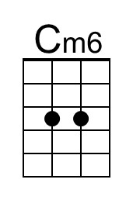 | 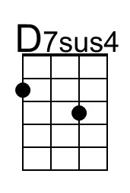 | 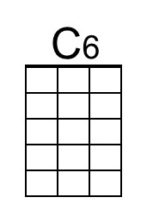 | 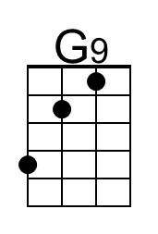 | 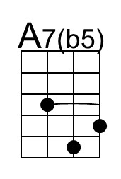
Baritone | 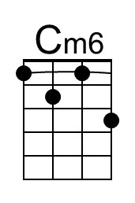 | 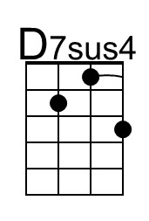 | 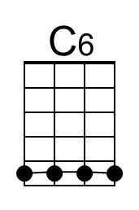 | 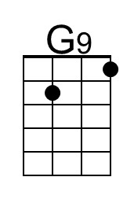 | 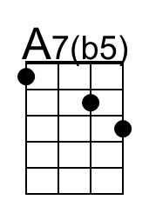

Takin’ It To The Streets (G) – Page 2

Optional Solo
Cm6 C G A7 D7sus4 Cm6 C G A7 D7sus4
____ You don't know me but I'm your bro – ther. ___ I was raised here in this living hell
Cm6 C G A7 D7sus4 Cm6 C G A7 - D7sus4
____ You don't know my kind in __ your world ___ Fairly soon, _ the time will tell.

Chorus 3
G - G9 C Cm D7sus4 G - G9 | G9
Oh, you Telling me the things you're gonna do for me
C Cm D7sus4
I ain't blind and I don't like what I think I see
G7 C6 A7b5 G | _ _ C  Takin' it to the streets. (Takin' it to the streets) | G7 C6 A7b5 G | _ _ C  Takin' it to the streets. (No more need for...)
G7 C6 A7b5 G | _ _ C  Takin' it to the streets. (Oh, yeah) | G7 C6 A7b5 G | _ _ C  Takin' it to the streets. (Takin' it to the streets)
G7 C6 A7b5 G | _ _ C  Takin' it to the streets. (Before it steps farther) | G7 C6 A7b5 G | _ _ C  Takin' it to the streets. (Oh, Lord)
G7 C6 A7b5 G | _ _ C  Takin' it to the streets. (Takin' it, takin' it) | G7 C6 A7b5 G | _ _ C  Takin' it to the streets. (Hey, yeah, ha)

Outro
G7 C6 A7b5 G | _ _ C  Takin' it to the streets. (Takin' it to the streets) | G7 C6 A7b5 G | _ _ C  Takin' it to the streets. (No more need for...)
G7 C6 A7b5 G | _ _ C  Takin' it to the streets. (No more need for...) | G7 C6 A7b5 G | _ _ C  Takin' it to the streets. (Hey, yeah, yeah)
Fade Out
G7 C6 A7b5 G | _ _ C  Takin' it to the streets. (No more) | G7 C6 A7b5 G | _ _ C  Takin' it to the streets. (Yeah, yeah)
G7 C6 A7b5 G | _ _ C  Takin' it to the streets. (Takin' it, takin' it) | G7 C6 A7b5 G | _ _ C  Takin' it to the streets.
G7 C6 A7b5 G | _ _ C  Takin' it to the streets. | G7 C6 A7b5 G | _ _ C  Takin' it to the streets.

