What A Fool Believes (A → C)
Michael McDonald & Kenny Loggins, 1978
What A Fool Believes by The Doobie Brothers (Db @ 120) [Capo 4]
What A Fool Believes by The Doobie Brothers (Official Music Video)
Second #1 hit in the US
4/4 Time
Intro  E7 Dadd2 A | A | Bm9 C#m7 Dadd2 Fdim F#m7 |  Fadd2 E7 Dadd2 A  _____ He came from somewhere back in her long ago  Bm9 C#m7 Dadd2 Fdim F#m7 Fadd2 E7 Dadd2  ____ _____ The sen - ti - men - tal fool don't see, tryin' hard to recre-ate  A Bm9 C#m7 Dadd2 Fdim F#m7  What had yet to be created ___ ____ once in her life.  Fadd2 E7 Dadd2 A  She musters a smile _____ for his nostalgic tale,  Bm9 C#m7 Dadd2 Fdim F#m7 Fadd2 E7 - Dadd2  ____ ____ Never com - in’ near what he wanted to say  A Bm9 C#m7 Dadd2 Fdim F#m7  Only to realize ___ ____ it never real - ly was.  F#m7 | E7 | E7 | F#m7 | E7  She had a place in his life. He never made her think twice.  Bm7 Dmaj7 Amaj7 - G7  As he rises to her a-pology,  F#7 Bm7 Dmaj7 F#m7 D#m7b5  An- y -body else would surely know . . . he's watching her go.  Dm7 | % | Fadd2  But what a fool be-lieves, he sees,  C | C Am7 | F  No wise man has the power . . . to reason a - way.  C Dm7 Fadd2 C | C  What seems . . . to be . . . is always better than nothing.  Am7  And nothing at all keeps sending him |  |  |  |  |  |  |  | 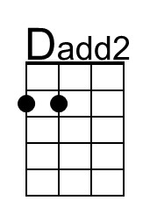
 |  |  |  |  |  |  |  | 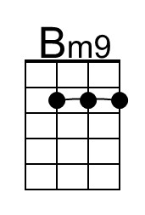
 |  |  |  |  |  |  |  | 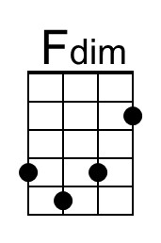
 |  |  |  |  |  |  |  | 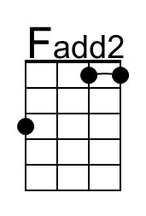
 |  |  |  |  |  |  |  | 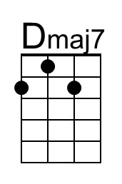
 |  |  |  |  |  |  |  | 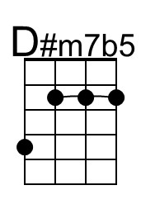
Baritone | 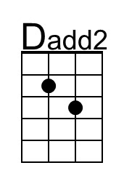 | 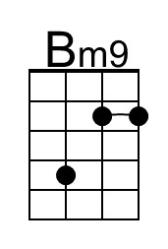 | 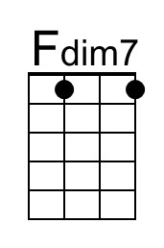 |  | 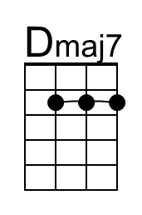

What A Fool Believes (A → C) – Page 2

E7 Dadd2 A
Somewhere back in her long ago,
Bm9 C#m7 Dadd2 Fdim F#m7 Fadd2 E7 - Dadd2
____ ____ Where he can still be-lieve there's a place in her life
A Bm9 C#m7 Dadd2 Fdim F#m7 | F#m7 |
Some-day, somewhere ___ ____ she will re - turn.

F#m7 | E7 | E7 | F#m7 | E7
She had a place in his life. He never made her think twice.
Bm7 Dmaj7 Amaj7 - G7
As he rises to her a-pology,
F#7 Bm7 Dmaj7 F#m7 D#m7b5
An- y -body else would surely know . . . he's watching her go.
Dm7 | % | Fadd2
But what a fool be-lieves, he sees,
C | C Am7 | F
No wise man has the power . . . to reason a-way.
C Dm7 Fadd2 C | C
What seems . . . to be . . . is always better than nothing.
Am7
And nothing at all.

Outro (2x then ‘Instrumental Close’)
||: F Dm7 | Dm7 | Fadd9 | Fadd9
__ What a fool be-lieves, he sees
C | C Am7 | F
No wise man has the power to reason a-way.
F↓↓ C Dm7 | Dm7 Fadd9 | C
___ __ What seems . . . to be is always better than nothing.
Am7
And nothing at all. :||

Instrumental Close
| F F C Dm7 | Dm7 | C G F C

What A Fool Believes (C → Eb)
Michael McDonald & Kenny Loggins, 1978
What A Fool Believes by The Doobie Brothers (Db @ 120)
What A Fool Believes by The Doobie Brothers (Official Music Video)
Second #1 hit in the US
4/4 Time
Intro
G7 Fadd2 C | C | Dm9 Em7 Fadd2 G#dim Am7 |

Ab9 G7 Fadd2 C
___ He came from somewhere back in her long ago
Dm9 Em7 Fadd2 G#dim Am7 Ab9 G7 Fadd2
____ ____ The sen - ti – men - tal fool don't see, tryin' hard to recre-ate
C Dm9 Em7 Fadd2 G#dim Am7
What had yet to be created ___ ___ once in her life.

Ab9 G7 Fadd2 C
She musters a smile _____ for his nostalgic tale,
Dm9 Em7 Fadd2 G#dim Am7 Ab9 G7 - Fadd2
___ ___ Never com - in’ near what he wanted to say
C Dm9 Em7 Fadd2 G#dim Am7
Only to realize ___ ___ it never real - ly was.

Am7 | G7 | G7 | Am7 | G7
She had a place in his life. He never made her think twice.
Dm7 Fmaj7 Cmaj7 - Bb7
As he rises to her apology,
A7 Dm7 Fmaj7 Am7 F#m7b5
An- y -body else would surely know . . . he's watching her go.
Fm7 | % | Abadd9
But what a fool be-lieves, he sees,
Eb | Eb Cm7 | Ab
No wise man has the power . . . to reason a-way.
Eb Fm7 Abadd9 Eb | Eb
What seems . . . to be . . . is always better than nothing.
Cm7
And nothing at all keeps sending him

 |  |  |  |  |  |  |  | 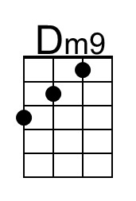
 |  |  |  |  |  |  |  | 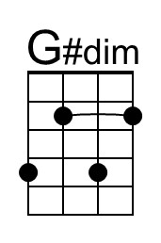
 |  |  |  |  |  |  |  | 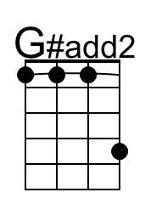
 |  |  |  |  |  |  |  | 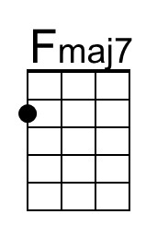
 |  |  |  |  |  |  |  | 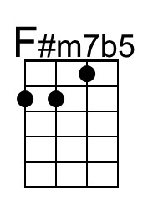
Baritone |  | 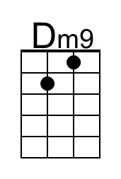 | 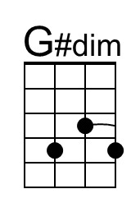 | 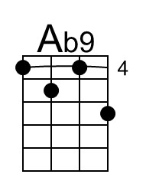 |  | 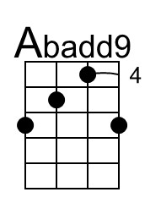

What A Fool Believes (C → Eb) – Page 2

G7 Fadd2 C
Somewhere back in her long ago,
Dm9 Em7 Fadd2 G#dim Am7 Ab9 G7 - Fadd2
____ ___ Where he can still be-lieve there's a place in her life
C Dm9 Em7 Fadd2 G#dim Am7 | Am7 |
Some-day, somewhere ___ ___ she will re - turn.

Am7 | G7 | G7 | Am7 | G7
She had a place in his life. He never made her think twice.
Dm7 Fmaj7 Cmaj7 - Bb7
As he rises to her apology,
A7 Dm7 Fmaj7 Am7 F#m7b5
An- y -body else would surely know . . . he's watching her go.
Fm7 | % | Abadd9
But what a fool be-lieves, he sees,
Eb | Eb Cm7 | Ab
No wise man has the power . . . to reason a-way.
Eb Fm7 Abadd9 Eb | Eb
What seems . . . to be . . . is always better than nothing.
Cm7
And nothing at all.

Outro (2x then ‘Instrumental Close’)
||: Eb Cm7 | Cm7 | Ebadd9 | Ebadd9
__ What a fool be-lieves, he sees
Bb | Bb Gm7 | Eb
No wise man has the power to reason a-way.
Eb↓↓ Bb Cm7 | Cm7 Ebadd9 | Bb
___ __ What seems . . . to be is always better than nothing.
Gm7
And nothing at all. :||

Instrumental Close
| Eb Eb Bb Cm7 | Cm7 | Bb F Eb Bb

What A Fool Believes (Db → E)
Michael McDonald & Kenny Loggins, 1978
What A Fool Believes by The Doobie Brothers (Db @ 120) – Second #1 US hit
What A Fool Believes by The Doobie Brothers (Official Music Video)
4/4 Time
Intro
Ab7 F#add2 Db | Db | Ebm9 Fm7 F#add2 Adim Bbm7 |

A9 Ab7 F#add2 Db
__ He came from somewhere back in her long ago
Ebm9 Fm7 F#add2 Adim Bbm7 A9 Ab7 F#add2
____ ____ The sen - ti - men - tal fool don't see, tryin' hard to recre-ate
Db Ebm9 Fm7 F#add2 Adim Bbm7
What had yet to be created ____ ___ once in her life.

A9 Ab7 F#add2 Db
She musters a smile _____ for his nostalgic tale,
Ebm9 Fm7 F#add2 Adim Bbm7 A9 Ab7 - F#add2
____ ___ Never com - in’ near what he wanted to say
Db Ebm9 Fm7 F#add2 Adim Bbm7
Only to realize _____ ___ it never real - ly was.

Bbm7 | - Ab7 | Ab7 | Bbm7 | Ab7
She had a place in his life. He never made her think twice.
Ebm7 F#maj7 Dbmaj7 - B7
As he rises to her a-pology,
Bb7 Ebm7 F#maj7 Bbm7 Gm7b5
An- y -body else would surely know . . . he's watching her go.

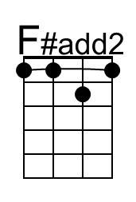 | 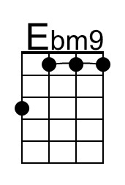 | 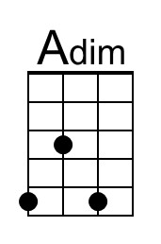 | 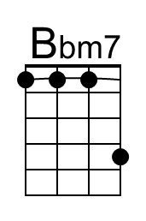 | 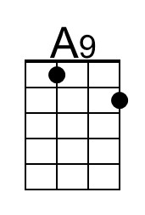 | 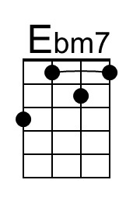
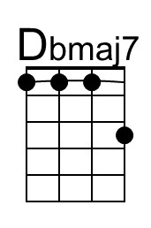 | 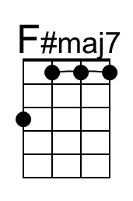 | 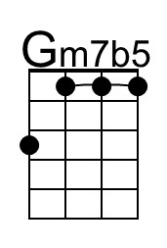 | 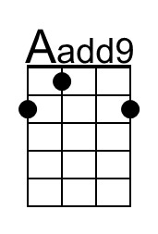 | 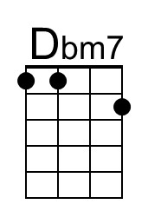
Baritone | 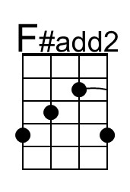 | 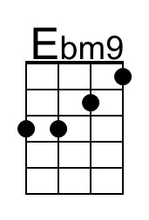 | 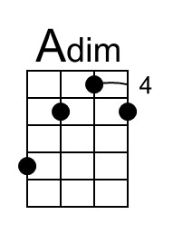 | 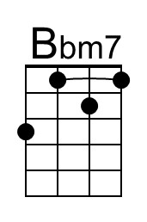 | 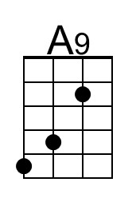 | 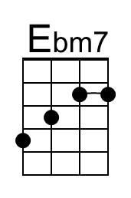
 | 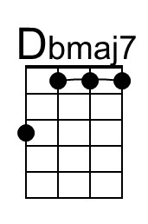 | 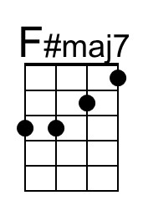 | 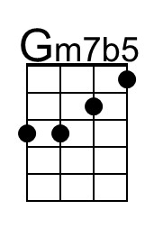 | 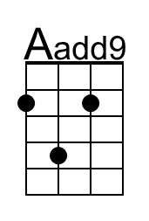 | 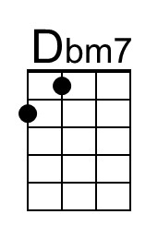

What A Fool Believes (Db → E) – Page 2

F#m7 | % | Aadd9
But what a fool be-lieves, he sees,
E | E Dbm7 | A
No wise man has the power . . . to reason a-way.
E F#m7 Aadd9 E | E
What seems . . . to be . . . is always better than nothing.
Dbm7
And nothing at all keeps sending him

Ab7 F#add2 Db
Somewhere back in her long ago,
Ebm9 Fm7 F#add2 Adim Bbm7 A9 Ab7 - F#add2
____ ___ Where he can still be-lieve there's a place in her life
Db Ebm9 Fm7 F#add2 Adim Bbm7 | Bbm7 |
Some-day, somewhere ___ ___ she will re - turn.

Bbm7 | Ab7 | Ab7 | Bbm7 | Ab7
She had a place in his life. He never made her think twice.
Ebm7 F#maj7 Dbmaj7 - B7
As he rises to her a-pology,
Bb7 Ebm7 F#maj7 Bbm7 Gm7b5
An- y -body else would surely know . . . he's watching her go.
F#m7 | % | Aadd9
But what a fool be-lieves, he sees,
E | E Dbm7 | A
No wise man has the power . . . to reason a-way.
E F#m7 Aadd9 E | E
What seems . . . to be . . . is always better than nothing.
Dbm7
And nothing at all.

Outro (2x then ‘Instrumental Close’)
||: A F#m7 | F#m7 | Aadd9 | Aadd9
__ What a fool be-lieves, he sees
E | E Dbm7 | A
No wise man has the power to reason a-way.
A↓↓ E F#m7 | F#m7 Aadd9 | E
___ __ What seems . . . to be is always better than nothing.
Dbm7
And nothing at all. :||

Instrumental Close
| A A E F#m7 | F#m7 | E B A E

What A Fool Believes (E → G)
Michael McDonald & Kenny Loggins, 1978
What A Fool Believes by The Doobie Brothers (Db @ 120) [Capo 4]
What A Fool Believes by The Doobie Brothers (Official Music Video)
Second #1 hit in the US
4/4 Time
Intro  B7 Aadd2 E | E | F#m9 G#m7 Aadd2 Cdim C#m7 |  Cadd2 B7 Aadd2 E  _____ He came from somewhere back in her long ago  F#m9 G#m7 Aadd2 Cdim C#m7 Cadd2 B7 Aadd2  ____ _____ The sen - ti - men - tal fool don't see, tryin' hard to recre-ate  E F#m9 G#m7 Aadd2 Cdim C#m7  What had yet to be created ___ ____ once in her life.  Cadd2 B7 Aadd2 E  She musters a smile _____ for his nostalgic tale,  F#m9 G#m7 Aadd2 Cdim C#m7 Cadd2 B7 - Aadd2  ____ ____ Never com - in’ near what he wanted to say  E F#m9 G#m7 Aadd2 Cdim C#m7  Only to realize ___ ____ it never real - ly was.  C#m7 | B7 | B7 | C#m7 | B7  She had a place in his life. He never made her think twice.  F#m7 Amaj7 Emaj7 - D7  As he rises to her a-pology,  C#7 F#m7 Amaj7 C#m7 A#m7b5  An- y -body else would surely know . . . he's watching her go.  Am7 | % | Cadd2  But what a fool be-lieves, he sees,  G | G Em7 | C  No wise man has the power . . . to reason a - way.  G Am7 Cadd2 G | G  What seems . . . to be . . . is always better than nothing.  Em7  And nothing at all keeps sending him |  |  |  |  |  |  |  | 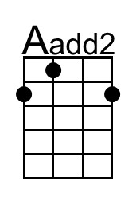
 |  |  |  |  |  |  |  | 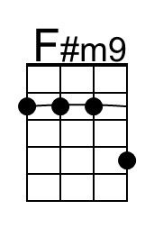
 |  |  |  |  |  |  |  | 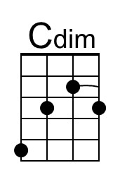
 |  |  |  |  |  |  |  | 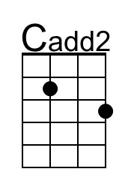
 |  |  |  |  |  |  |  | 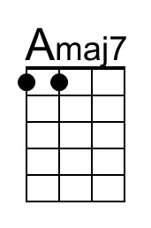
 |  |  |  |  |  |  |  | 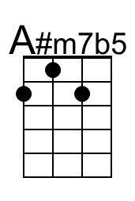
Baritone | 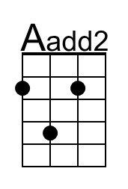 |  | 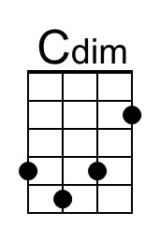 | 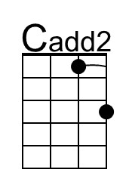 | 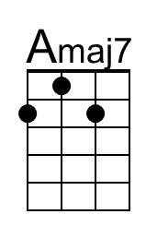 | 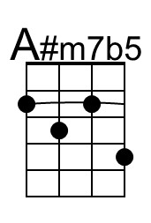

What A Fool Believes (E → G) – Page 2

B7 Aadd2 E
Somewhere back in her long ago,
F#m9 C#m7 Aadd2 Cdim C#m7 Cadd2 B7 - Aadd2
____ ____ Where he can still be-lieve there's a place in her life
E F#m9 G#m7 Aadd2 Cdim C#m7 | C#m7 |
Some-day, somewhere ___ ____ she will re - turn.

C#m7 | B7 | B7 | C#m7 | B7
She had a place in his life. He never made her think twice.
F#m7 Amaj7 Emaj7 - D7
As he rises to her a-pology,
C#7 F#m7 Amaj7 C#m7 A#m7b5
An- y -body else would surely know . . . he's watching her go.
Am7 | % | Cadd2
But what a fool be-lieves, he sees,
G | G Em7 | C
No wise man has the power . . . to reason a-way.
G Am7 Cadd2 G | G
What seems . . . to be . . . is always better than nothing.
Em7
And nothing at all.

Outro (2x then ‘Instrumental Close’)
||: C Am7 | Am7 | Cadd9 | Cadd9
__ What a fool be-lieves, he sees
G | G Em7 | C
No wise man has the power to reason a-way.
C↓↓ G Am7 | Am7 Cadd9 | G
___ __ What seems . . . to be is always better than nothing.
Em7
And nothing at all. :||

Instrumental Close
| C C G Am7 | Am7 | G D C G

