Hallelujah (Leonard Cohen) (C) (12/8 Time)
Version 1 – 4 Verses
Hallelujah by Leonard Cohen (Official Audio)
Hallelujah by Leonard Cohen (Live in London) (Official Video)

Intro: C Am C Am  C Am  Well I've heard there was a secret chord,  C Am  That David played and it pleased the Lord,  F G C G  But you don't really care for music, do you?  C F G  It goes like this, the fourth, the fifth,  Am F  The minor fall and the major lift,  G E7 Am  The baffled king com - posing Halle - lujah,  Chorus  F Am  Halle - lujah, Halle - lujah,  F C G C G  Halle - lujah, Halle-lu--- --- jah.  C Am  Your faith was strong but you needed proof,  C Am  You saw her bathing on the roof,  F G C G  Her beauty and the moonlight over-threw you,  C F G  She tied you to her kitchen chair,  Am F  She broke your throne and she cut your hair,  G E7 Am  And from your lips she drew the Halle – lujah, Chorus |  |  | C Am  You say I took the name in vain.  C Am  I don't even know the name.  F G C G  But if I did, well really, what's it to you?  C F G  There's a blaze of light in every word.  Am F  It doesn't matter which you heard.  G E7 Am  The holy or the broken Halle – lujah. Chorus  C Am  I did my best, it wasn't much,  C Am  I couldn't feel so I tried to touch,  F G C G  I've told the truth, I didn't come to fool you.  C F G  And even though it all went wrong,  Am F  I'll stand before the Lord of Song,  G E7 Am  With nothing on my tongue but Halle - lujah,  Chorus (2x)  Note: Some performers substitute Em for E7 in the last line of the verses.  The verses and their order follow the version recorded for the 1984 album, “Various Positions” (The Official Audio) |  |  | 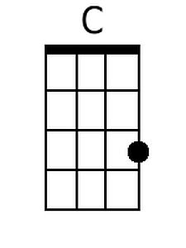
 |  |  |  |  |  | 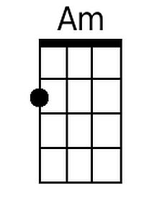
 |  |  |  |  |  | 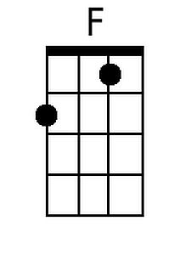
 |  |  |  |  |  | 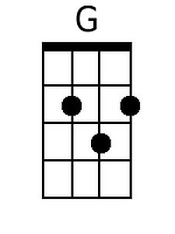
 |  |  |  |  |  | 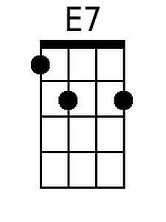
 |  |  |  |  |  | 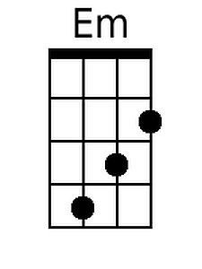
Bari
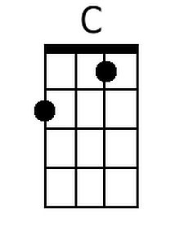 | 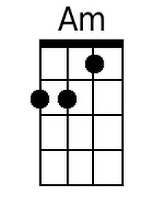 | 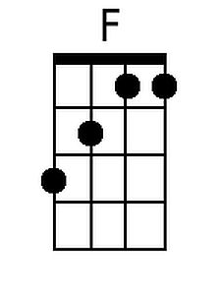 | 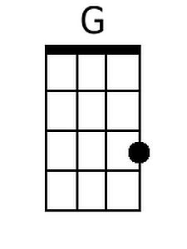 | 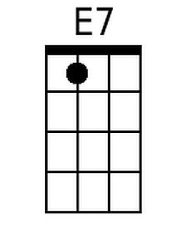 | 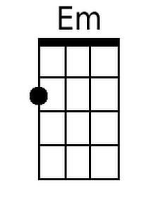

Hallelujah (Leonard Cohen) (G) (12/8 Time)
Version 1 – 4 Verses
Hallelujah by Leonard Cohen (Official Audio)
Hallelujah by Leonard Cohen (Live in London) (Official Video)

Intro: G Em G Em  G Em  Well I've heard there was a secret chord,  G Em  That David played and it pleased the Lord,  C D G D  But you don't really care for music, do you?  G C D  It goes like this, the fourth, the fifth,  Em C  The minor fall and the major lift,  D B7 Em  The baffled king com - posing Halle - lujah,  Chorus  C Em  Halle - lujah, Halle - lujah,  C G D G D  Halle - lujah, Halle lu--- --- jah  G Em  Your faith was strong but you needed proof,  G Em  You saw her bathing on the roof,  C D G D  Her beauty and the moonlight over-threw you,  G C D  She tied you to her kitchen chair,  Em C  She broke your throne and she cut your hair,  D B7 Em  And from your lips she drew the Halle - lujah, Chorus |  |  | G Em  You say I took the name in vain  G Em  I don't even know the name  C D G D  But if I did, well really, what's it to ya?  G C D  There's a blaze of light in every word  Em C  It doesn't matter which you heard  D B7 Em  The holy or the broken Halle – lujah. Chorus  G Em  I did my best, it wasn't much,  G Em  I couldn't feel so I tried to touch,  C D G D  I've told the truth, I didn't come to fool you.  G C D  And even though it all went wrong,  Em C  I'll stand before the Lord of Song,  D B7 Em  With nothing on my tongue but Halle – lujah, Chorus (2x)  Note: Some performers substitute Bm for B7 in the last line of the verses.  The verses and their order follow the version recorded for the 1984 album, “Various Positions” (The Official Audio)
 |  |  |  |  |  | 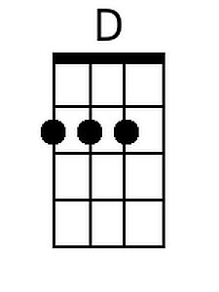
 |  |  |  |  |  | 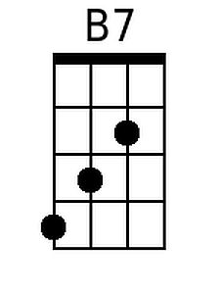
 |  |  |  |  |  | 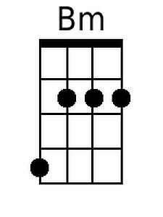
Bari
 |  |  | 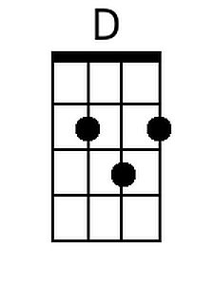 | 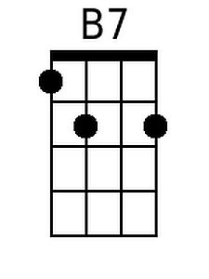 | 