Hallelujah (Leonard Cohen) (G) (12/8 Time)
Version 4 – The 7 Verses from the YouTube “Official Audio” page
Hallelujah by Leonard Cohen (Official Audio)

Intro: C Am C Am  C Am C Am  Well I've heard there was a secret chord, that David played and it pleased the Lord,  F G C G  But you don't really care for music, do you?  C F G Am F  It goes like this, the fourth, the fifth, the minor fall and the major lift,  G E7 Am  The baffled king com - posing Halle - lujah,  Chorus  F Am  Halle - lujah, Halle - lujah,  F C G C G  Halle - lujah, Halle-lu--- --- jah.  C Am C Am  Your faith was strong but you needed proof, you saw her bathing on the roof,  F G C G  Her beauty and the moonlight over-threw you,  C F G Am F  She tied you to her kitchen chair, she broke your throne and she cut your hair,  G E7 Am  And from your lips she drew the Halle – lujah, Chorus  C Am C Am  Baby I have been here before. I know this room, I've walked this floor.  F G C G  I used to live a-lone before I knew you.  C F G Am F  I've seen your flag on the marble arch. Love is not a victory march.  G E7 Am  It's a cold and it's a broken Halle – lujah. Chorus |  |  |  |  |  | 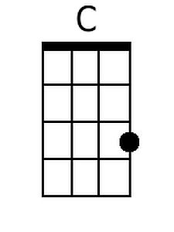
 |  |  |  |  |  | 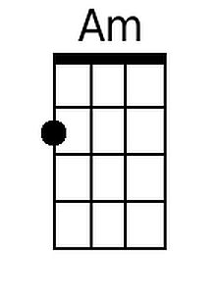
 |  |  |  |  |  | 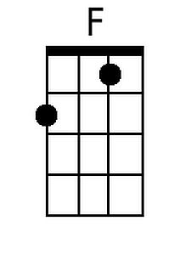
 |  |  |  |  |  | 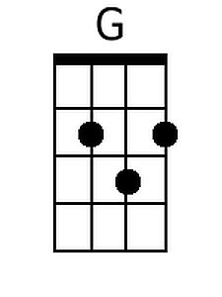
 |  |  |  |  |  | 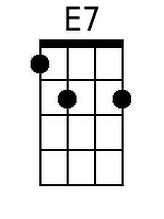
 |  |  |  |  |  | 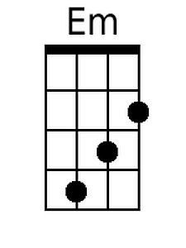
Bari
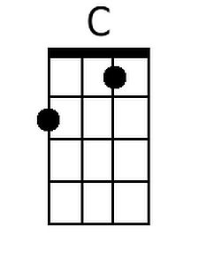 | 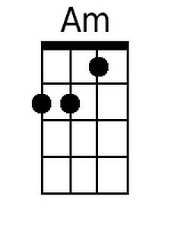 | 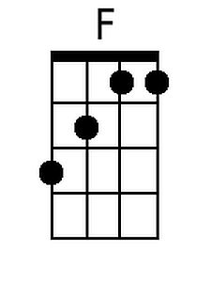 | 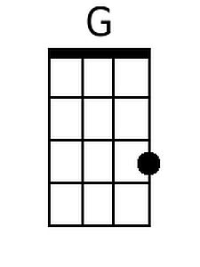 | 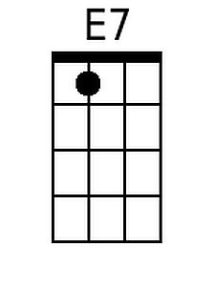 | 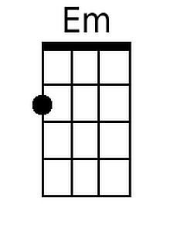

Hallelujah (Version 4) (C) – Page 2
C Am
There was a time when you let me know,
C Am
What's really going on below,
F G C G
But now you never show it to me do you.
C F G
Well re-member when I moved in with you,
Am F
And the holy dove was moving too,
G E7 Am
And every breath we drew was Halle - lujah. Chorus

C Am
You say I took the name in vain.
C Am
I don't even know the name.
F G C G
But if I did, well really, what's it to you?
C F G
There's a blaze of light in every word.
Am F
It doesn't matter which you heard.
G E7 Am
The holy or the broken Halle – lujah. Chorus

C Am
May-be there is a God above,
C Am
But all I ever learned from love,
F G C G
Was how to shoot at someone who out-drew you.
C F G
And it's not a cry you can hear at night,
Am F
It's not somebody who's seen the light,
G E7 Am
It's a cold and it's a broken Halle – lujah, Chorus

C Am
I did my best, it wasn't much,
C Am
I couldn't feel so I tried to touch,
F G C G
I've told the truth, I didn't come to fool you.
C F G
And even though it all went wrong,
Am F
I'll stand before the Lord of Song,
G E7 Am
With nothing on my tongue but Halle – lujah, Chorus (2x)

Note: Some performers substitute Em for E7 in the last line of the verses.
Hallelujah (Leonard Cohen) (G) (12/8 Time)
Version 4 – The 7 Verses from the YouTube “Official Audio” page
Hallelujah by Leonard Cohen (Official Audio)

Intro: G Em G Em

G Em G Em
Well I've heard there was a secret chord, that David played and it pleased the Lord,
C D G D
But you don't really care for music, do you?
G C D Em C
It goes like this, the fourth, the fifth, the minor fall and the major lift,
D B7 Em
The baffled king com - posing Halle - lujah,

Chorus
C Em
Halle - lujah, Halle - lujah,
C G D G D
Halle - lujah, Halle lu--- --- jah

G Em G Em
Your faith was strong but you needed proof, you saw her bathing on the roof,
C D G D
Her beauty and the moonlight over-threw you,
G C D Em C
She tied you to her kitchen chair, she broke your throne and she cut your hair,
D B7 Em
And from your lips she drew the Halle - lujah, Chorus

G Em G Em
Baby I have been here before. I know this room, I've walked this floor.
C D G D
I used to live a-lone before I knew you.
G C D Em C
I've seen your flag on the marble arch. Love is not a victory march.
D B7 Em
It's a cold and it's a broken Halle - lujah. Chorus.

 |  |  |  |  |  | 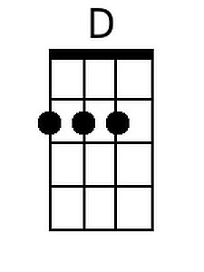
 |  |  |  |  |  | 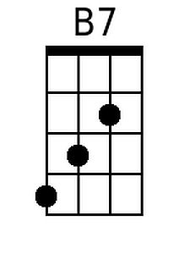
 |  |  |  |  |  | 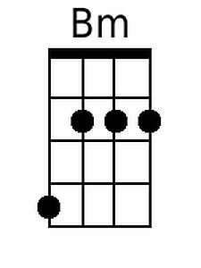
Bari
 |  |  | 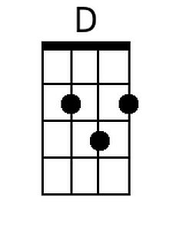 | 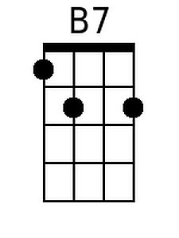 | 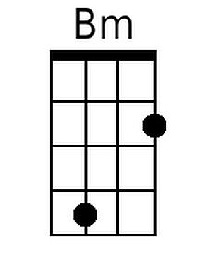

Hallelujah (Version 4) (G) – Page 2
G Em
There was a time when you let me know,
G Em
What's really going on below,
C D G D
But now you never show it to me do you.
G C D
Well re-member when I moved in with you,
Em C
And the holy dove was moving too,
D B7 Em
And every breath we drew was Halle - lujah. Chorus

G Em
You say I took the name in vain
G Em
I don't even know the name
C D G D
But if I did, well really, what's it to you?
G C D
There's a blaze of light in every word
Em C
It doesn't matter which you heard
D B7 Em
The holy or the broken Halle – lujah. Chorus

G Em
May-be there is a God above,
G Em
But all I ever learned from love,
C D G D
Was how to shoot at someone who out-drew you.
G C D
And it's not a cry you can hear at night,
Em C
It's not somebody who's seen the light,
D B7 Em
It's a cold and it's a broken Halle - lujah, Chorus

G Em
I did my best, it wasn't much,
G Em
I couldn't feel so I tried to touch,
C D G D
I've told the truth, I didn't come to fool you.
G C D
And even though it all went wrong,
Em C
I'll stand before the Lord of Song,
D B7 Em
With nothing on my tongue but Halle - lujah, Chorus (2x)

Note: Some performers substitute Bm for B7 in the last line of the verses.

