Being A Pirate (Don Freed, 1985; alt. Tom Lewis, 2003) (C)
Being A Pirate by Fisherman’s Friends

Intro C C C F F F C

C G
Being a pirate is all fun and games, ‘til somebody loses an ear.
G
It drips down your neck then it falls on the deck,
C
‘til someone shouts out: "Oy, what's this 'ere?"

You can't wear your glasses, you can’t ‘pull’ the lasses,
C7 F
and folks have to shout so you'll hear.
C G C
Being a pirate is all fun and games, ‘til somebody loses an ear.

Chorus
F C
It’s all part of being a pirate. (A pirate! A pirate!)
G C F C
You can't be a pirate, with all of your p-a-r-ts;
F C
It’s all part of being a pirate. (A pirate! A pirate!)
G C F C
You can't be a pirate, with all of your p-a-r-ts.

C G
Being a pirate is all fun and games, 'til somebody loses an eye.
G C
It stings like the blazes, it makes you make faces, you can't let your mates see you cry.
C7 F
A dashing black patch will cover the hatch, and make sure your socket stays dry.
C G C
Being a pirate is all fun and games, ‘til somebody loses an eye. Chorus

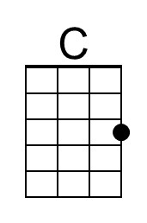 | 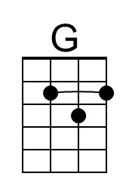 | 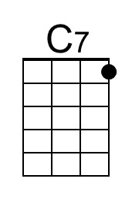 | 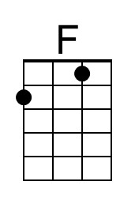 | 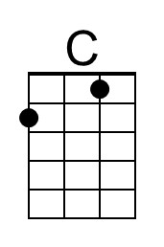 | 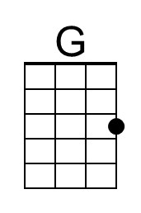 | 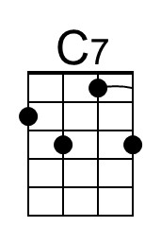 | 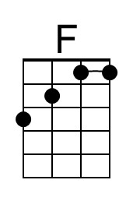

Being A Pirate (C) – Page 2

C G
Being a pirate is all fun and games, 'til somebody loses a hand.
G C
It spurts and it squirts and it jolly well hurts, pain only a pirate can stand.
C7 F
The fashionable look is a nice metal hook, but then you can't play in the band.
C G C
Being a pirate is all fun and games, ‘til somebody loses a hand. Chorus

C G
Being a pirate is all fun and games, 'til somebody loses a leg.
G C
It hurts like the dickens, your pace never quickens, hopping around on a peg.

Ask your sweetheart to marry, but too long you've tarried,
C7 F
‘cos now you can't kneel down and beg.
C G C
Being a pirate is all fun and games, ‘til somebody loses a leg. Chorus

C G
Being a pirate is all fun and games, 'til somebody loses a ‘wotsit.’
G C
Though you didn't choose it, you don't want to lose it, you're hoping that somebody spots it.
C7 F
Then the ‘Doc’ comes along and he sews it back on, or he ties it up tight – then he knots it!
C G C
Being a pirate is all fun and games, 'til somebody loses a ‘wotsit.’

Outro
F C G C F C
But it’s all part of being a pirate! You can't be a pirate, with all of your p-a-r-ts;
F C G C F C
It’s all part of being a pirate! You can't be a pirate, with all of your p-a-r-ts.
F C G C F C | F C| F G | C
It’s all part of being a pirate! You can't be a pirate, with all of your p-a-r-ts.

Lewis’ original ending:
F C G C F C
It makes me quite i-rate - You can't be a pirate - With all of your parts!

Original and modified lyrics were posted at mudcat.cafe:
Lyr Req/Add: You Can't Be a Pirate (Don Freed)

Numerous alternate lyrics have been created.
Being A Pirate (Don Freed, 1985; alt. Tom Lewis, 2003)
Being A Pirate by Fisherman’s Friends

Intro G G G D D D G

G D
Being a pirate is all fun and games, ‘til somebody loses an ear.
D
It drips down your neck then it falls on the deck,
G
‘til someone shouts out: "Oy, what's this 'ere?"

You can't wear your glasses, you can’t ‘pull’ the lasses,
G7 C
and folks have to shout so you'll hear.
G D G
Being a pirate is all fun and games, ‘til somebody loses an ear.

Chorus
C G
It’s all part of being a pirate. (A pirate! A pirate!)
D G C G
You can't be a pirate, with all of your p-a-r-ts;
C G
It’s all part of being a pirate. (A pirate! A pirate!)
D G C G
You can't be a pirate, with all of your p-a-r-ts.

G D
Being a pirate is all fun and games, 'til somebody loses an eye.
D G
It stings like the blazes, it makes you make faces, you can't let your mates see you cry.
G7 C
A dashing black patch will cover the hatch, and make sure your socket stays dry.
G D G
Being a pirate is all fun and games, ‘til somebody loses an eye. Chorus

 | 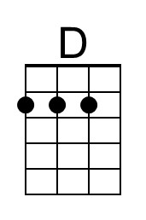 | 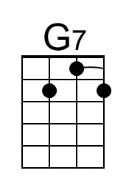 |  |  | 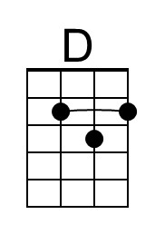 | 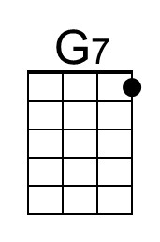

Being A Pirate (G) – Page 2

G D
Being a pirate is all fun and games, 'til somebody loses a hand.
D G
It spurts and it squirts and it jolly well hurts, pain only a pirate can stand.
G7 C
The fashionable look is a nice metal hook, but then you can't play in the band.
G D G
Being a pirate is all fun and games, ‘til somebody loses a hand. Chorus

G D
Being a pirate is all fun and games, 'til somebody loses a leg.
D G
It hurts like the dickens, your pace never quickens, hopping around on a peg.
G
Ask your sweetheart to marry, but too long you've tarried,
G7 C
‘cos now you can't kneel down and beg.
G D G
Being a pirate is all fun and games, ‘til somebody loses a leg. Chorus

G D
Being a pirate is all fun and games, 'til somebody loses a ‘wotsit.’
D G
Though you didn't choose it, you don't want to lose it, you're hoping that somebody spots it.
G7 C
Then the ‘Doc’ comes along and he sews it back on, or he ties it up tight – then he knots it!
G D G
Being a pirate is all fun and games, 'til somebody loses a ‘wotsit.’

Outro
C G D G C G
But it’s all part of being a pirate! You can't be a pirate, with all of your p-a-r-ts;
C G D G C G
It’s all part of being a pirate! You can't be a pirate, with all of your p-a-r-ts.
C G D G C G | C G | C D | G
It’s all part of being a pirate! You can't be a pirate, with all of your p-a-r-ts.

Lewis’ original ending:
C G D G C G
It makes me quite i-rate - You can't be a pirate - With all of your parts!

Original and modified lyrics were posted at mudcat.cafe:
Lyr Req/Add: You Can't Be a Pirate (Don Freed)

Numerous alternate lyrics have been created.

