Love Potion No. 9 (Jerry Leiber & Mike Stoller, 1959) (Am)
Love Potion No. 9 by The Clovers – Version 2 (LP Version, 1959)

Am↓↓ D7  I took my troubles down to Madam Ruth,  Am↓↓ D7  You know that gypsy with the gold-capped tooth.  C  She's got a pad on 34th and Vine,  D7 E7↓ Am | D7 E7 |  Sellin' little bottles of __ Love Potion Number Nine.  Am D7 Am D7  I told her that I was a flop with chicks; I've been this way since 19-56.  C  She looked at my palm and she made a magic sign  D7 E7↓ Am  She said, "What you need is __ Love Potion Number Nine.”  Chorus  D7  She bent down and turned around and gave me a wink  Bm  She said, "I'm gonna make it up right here in the sink"  D7  It smelled like turpentine and looked like Indian ink  E7↓ E7↓↓ (bass voice)  I held my nose, I closed my eyes, ___ I took a drink.  Am D7 Am D7  I didn't know it was a day or night. I started kissin' ev'ry thing in sight.  C  But when I kissed a cop at 34th and Vine,  D7 E7↓ Am | D7 E7 |  He broke my little bottle of ___ Love Potion Number Nine. Chorus.  Am D7 Am D7  I didn't know if it was day or night. I started kissin' ev'ry thing in sight.  C  I had so much fun that I'm going back again  D7 E7↓ Am  I wonder what happen with ___ Love Potion Number Ten?  E7 Am  Love Potion Number Nine (2x) |  |  |  |  |  |  | 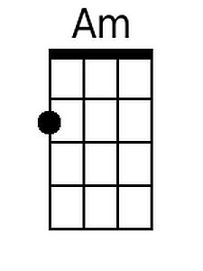
 |  |  |  |  |  |  | 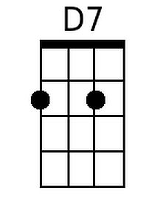
 |  |  |  |  |  |  | 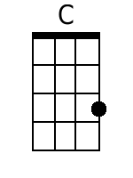
 |  |  |  |  |  |  | 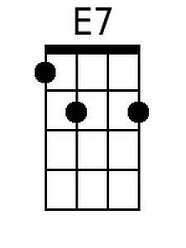
 |  |  |  |  |  |  | 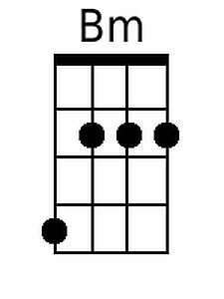
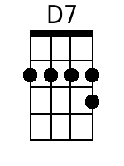
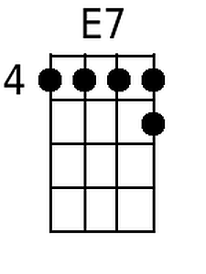
Baritone
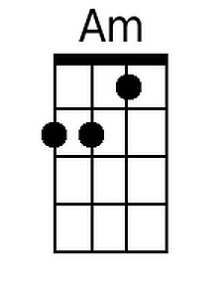 | 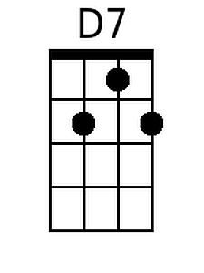 | 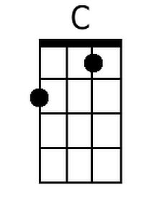 | 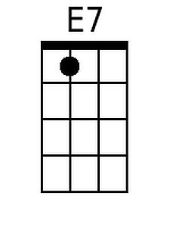 | 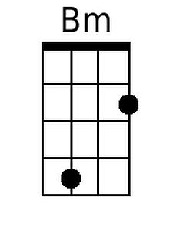

Love Potion No. 9 (Jerry Leiber & Mike Stoller, 1959) (Dm)
Love Potion No. 9 by The Clovers – Version 2 (LP Version, 1959)

Dm↓↓ G7  I took my troubles down to Madam Ruth,  Dm↓↓ G7  You know that gypsy with the gold-capped tooth.  F  She's got a pad on 34th and Vine,  G7 A7↓ Dm | G7 A7 |  Sellin' little bottles of __ Love Potion Number Nine.  Dm G7 Dm G7  I told her that I was a flop with chicks; I've been this way since 19-56.  F  She looked at my palm and she made a magic sign  G7 A7↓ Dm  She said, "What you need is __ Love Potion Number Nine."  Chorus  G7  She bent down and turned around and gave me a wink  Em  She said, "I'm gonna make it up right here in the sink"  G7  It smelled like turpentine and looked like Indian ink  A7↓ A7↓↓ (bass voice)  I held my nose, I closed my eyes, ___ I took a drink.  Dm G7 Dm G7  I didn't know it was a day or night. I started kissin' ev'ry thing in sight.  F  But when I kissed a cop at 34th and Vine,  G7 A7↓ Dm | G7 A7 |  He broke my little bottle of ___ Love Potion Number Nine. Chorus.  Dm G7 Dm G7  I didn't know if it was day or night. I started kissin' ev'ry thing in sight.  F  I had so much fun that I'm going back again  G7 A7↓ Dm  I wonder what happen with ___ Love Potion Number Ten?  A7 Dm  Love Potion Number Nine (2x) |  |  |  |  |  |  | 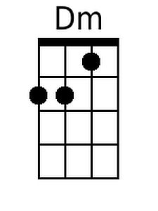
 |  |  |  |  |  |  | 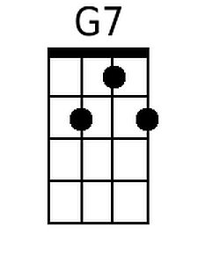
 |  |  |  |  |  |  | 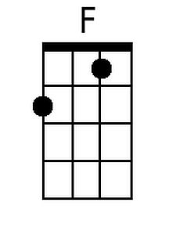
 |  |  |  |  |  |  | 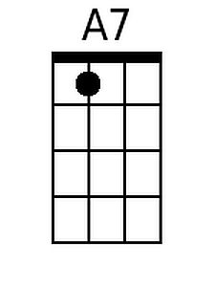
 |  |  |  |  |  |  | 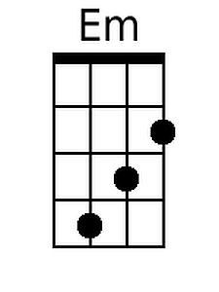
Baritone
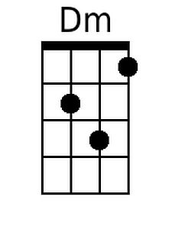 | 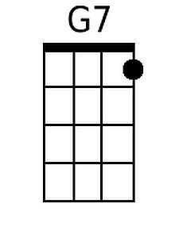 | 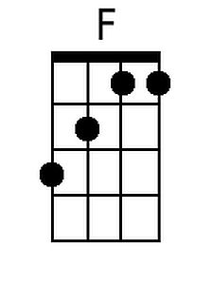 | 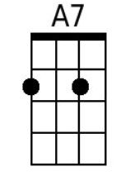 | 