I’m Looking Over a Four Leaf Clover (C)
Mort Dixon & Harry Woods, 1927
I’m Looking Over A Four Leaf Clover by Nick Lucas (1927)
I'm Looking Over a Four Leaf Clover by The Andrews Sisters (1948)

Start note C

Intro D7 G7 C G7
Last line: that I over-looked be-fore

C D7
I’m looking over a four leaf clover that I overlooked before
G7 Am
One leaf is sunshine, the second is rain,
D7 G7
The third is the roses, that grow in the lane.
C D7
No need explaining, the one remaining, is somebody I adore
F Dm7 Em A7 D7 G7 C G7
I’m looking over a four- leaf clover that I over-looked be-fore

C D7
I’m looking over a four leaf clover that I overlooked before
G7 Am
One leaf is sunshine, the second is rain,
D7 G7
The third is the roses, that grow in the lane.
C D7
No need explaining, the one remaining, is somebody I adore
F Dm7 Em A7 D7 G7
I’m looking over a four- leaf clover that I over-looked,
D7 G7 D7 G7 C G7 C
that I over-looked, that I over-looked be-fore. ↑↓ ↓ (up down DOWN)

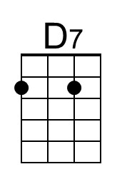 | 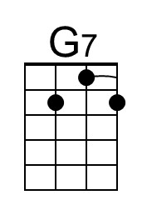 | 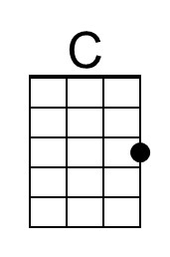 | 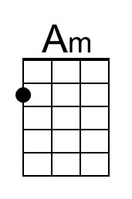 | 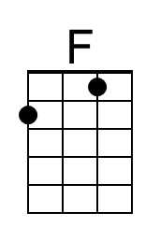 | 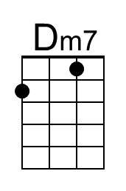 | 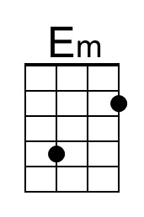 | 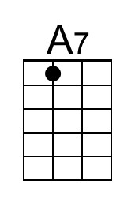
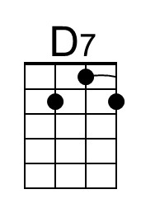 | 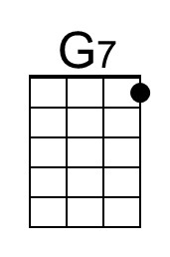 | 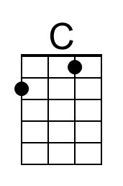 | 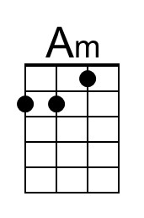 | 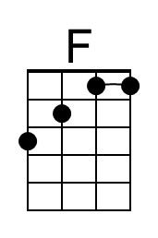 | 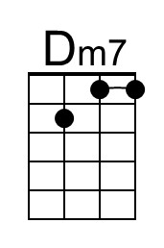 | 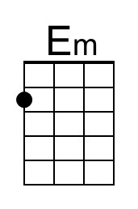 | 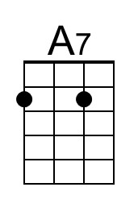


I’m Looking Over a Four Leaf Clover (G)
Mort Dixon & Harry Woods, 1927
I’m Looking Over A Four Leaf Clover by Nick Lucas (1927)
I'm Looking Over a Four Leaf Clover by The Andrews Sisters (1948)

Start note G

Intro A7 D7 G D7
Last line: that I over-looked be-fore

G A7
I’m looking over a four leaf clover that I overlooked before
D7 Em
One leaf is sunshine, the second is rain,
A7 D7
The third is the roses, that grow in the lane.
G A7
No need explaining, the one remaining, is somebody I adore
C Am7 Bm E7 A7 D7 G D7
I’m looking over a four- leaf clover that I over-looked be-fore

G A7
I’m looking over a four leaf clover that I overlooked before
D7 Em
One leaf is sunshine, the second is rain,
A7 D7
The third is the roses, that grow in the lane.
G A7
No need explaining, the one remaining, is somebody I adore
C Am7 Bm E7 A7 D7
I’m looking over a four- leaf clover that I over-looked,
A7 D7 A7 D7 G D7 G
that I over-looked, that I over-looked be-fore. ↑↓ ↓ (up down DOWN)

 |  | 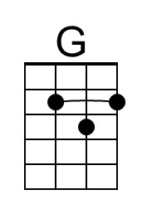 |  |  | 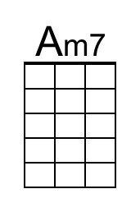 | 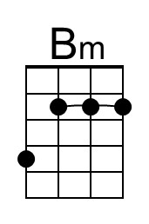 | 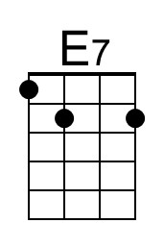
 |  | 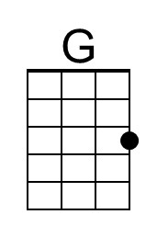 |  |  | 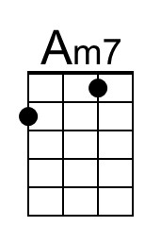 | 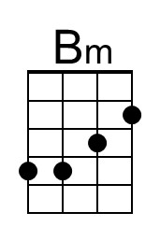 | 