
A Celtic Songbook

As of Feb. 23, 2023

Contents

Title | Key | Page
Galway Bay | C | 2
I’ll Tell Me Ma (Belle of Belfast City) | G | 3
I’m looking Over a 4 Leaf Clover | G | 4
The Leprechaun | Dm | 5
Maira's Wedding | D | 6
Molly Malone | C | 7
Pretty Irish Girl | G | 8
Nancy Mulligan | Am | 9
The Skye Boat Song (Version 1) | C | 10
Toora Loora (That’s An Irish Lullaby) | G | 11
When Irish Eyes Are Smiling | C | 12
The Parting Song | C | 13

Galway Bay (Dr. Arthur Colahan, c. 1927) (C)
Galway Bay by John McDermott from "Songs of the Isles" (2004)

Intro G G7 C G7  ( light a penny candle from a star)  C G G7 C  If you ever go across the sea to Ireland, then maybe at the closing of your day,  C C7 F Cdim7  You can sit and watch the moon rise over Claddagh, (area where the River  G G7 C G7 Corrib meets Falway Day)  And see the sun go down on Galway Bay.  C G  Just to hear again the ripple of the trout stream,  G7 C  The women in the meadow making hay,  C C7 F Cdim7  Just to sit beside the turf fire in a cabin,  G G7 C G7  And watch the barefoot gosoons as they play. (boys or lads)  C G  For the breezes blowing o'er the seas from Ireland  G7 C  Are perfumed by the heather as they blow,  C C7 F Cdim7  And the women in the uplands digging praties (Irish potatoes)  G G7 C G7  Speak a language that the strangers do not know.  C G  Yet the strangers came and tried to teach us their ways  G7 C  And they scorned us just for being what we are  C C7 F Cdim7  But they might as well go chasin' after moonbeams  G G7 C G7  Or light a penny candle from a star. (A small, inexpensive candle)  C G G7 C  And if there's gonna be a life here after, and somehow I feel sure there's gonna be,  C F Cdim7 G G7 C  I will ask my God to let me make my Heaven, in that dear land a-cross the Irish sea.  C F Cdim7 G G7 F - C  I will ask my God to let me make my Heaven, in that dear land a-cross the Irish sea. |  |  |  |  |  |  |  | 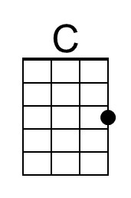
 |  |  |  |  |  |  |  | 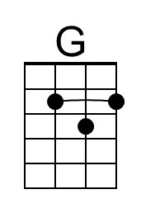
 |  |  |  |  |  |  |  | 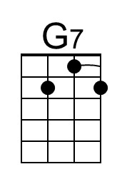
 |  |  |  |  |  |  |  | 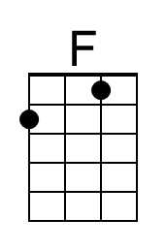
 |  |  |  |  |  |  |  | 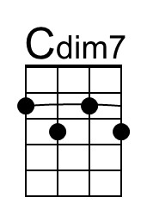
 |  | Bari | 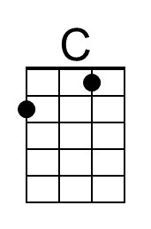 | 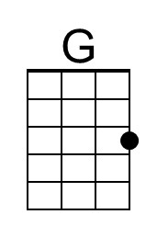 | 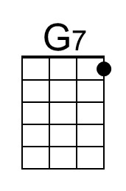 | 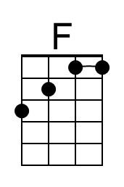 | 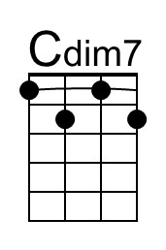
I'll Tell Me Ma (aka “Belle of Belfast City”) (G)
I’ll Tell Me Ma / Belle of Belfast City by The Irish Rovers

Intro (4 measures) G D D7 G

Chorus
G D D7 G
I'll tell me ma when I go home, the boys won't leave the girls alone.
G D D7 G
They pull my hair, they stole my comb, but that's all right 'til I go home.
G C G D7
She is handsome, she is pretty, she's the belle of Belfast City.
G C G D D7 G
She is courtin', one, two, three. Please won't you tell me who is she?

G D D7 G
Now Albert Mooney says he loves her, an' all the boys are fighting for her.
G D
Knocking on the door and they're ringing on the bell,
D7 G
Saying, "Oh my true love, are you well?"
G C G D7
Out she comes as white as snow, with rings on her fingers and bells on her toes.
G C
Old Jenny Murphy says she'll die,
G D D7 G
If she doesn't get the fellow with the roving eye. Chorus

G D
Let the wind and the rain and the hail come high,
D7 G
And the snow come shoveling from the sky.
G D7 D G
She's as nice as apple pie, she'll get her own lad by and by!
G C G D7
An' when she gets a lad of her own, she won't tell her ma when she comes home.
G C G D D7 G
Let them all come as they will, but it's Albert Mooney she loves still! Chorus (2x)

 |  |  |  |  |  |  | 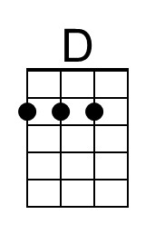
 |  |  |  |  |  |  | 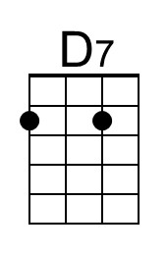
 |  |  | Bari |  | 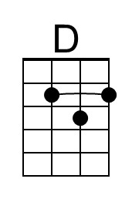 | 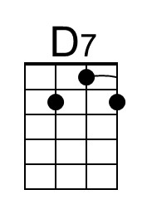

I’m Looking Over a Four Leaf Clover (G)
Mort Dixon & Harry Woods, 1927
I’m Looking Over A Four Leaf Clover by Nick Lucas (1927)
I'm Looking Over a Four Leaf Clover by The Andrews Sisters (1948)

Start note G

Intro A7 D7 G D7
Last line: that I over-looked be-fore

G A7
I’m looking over a four leaf clover that I overlooked before
D7 Em
One leaf is sunshine, the second is rain,
A7 D7
The third is the roses, that grow in the lane.
G A7
No need explaining, the one remaining, is somebody I adore
C Am7 Bm E7 A7 D7 G D7
I’m looking over a four- leaf clover that I over-looked be-fore

G A7
I’m looking over a four leaf clover that I overlooked before
D7 Em
One leaf is sunshine, the second is rain,
A7 D7
The third is the roses, that grow in the lane.
G A7
No need explaining, the one remaining, is somebody I adore
C Am7 Bm E7 A7 D7
I’m looking over a four- leaf clover that I over-looked,
A7 D7 A7 D7 G D7 G
that I over-looked, that I over-looked be-fore. ↑↓ ↓ (up down DOWN)

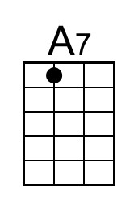 |  |  | 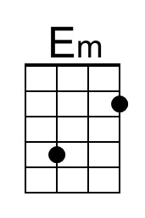 |  | 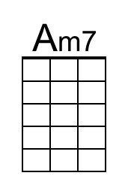 | 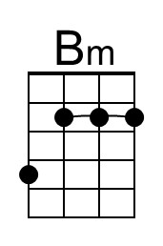 | 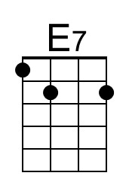
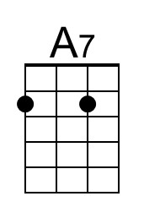 |  |  | 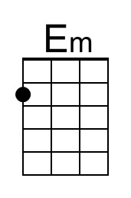 |  | 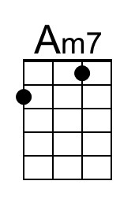 | 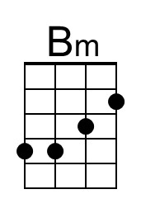 | 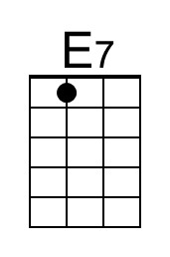

The Leprechaun (P. W. Joyce, 1853) (Dm)
The Leprechaun by Mary O'Hara – The Leprechaun by Margaret Barry

Intro (Drone like - down strum) Dm ↓ ↓ ↓ ↓  Dm Am Dm  In a shady nook one moonlit night, a leprechaun I spied  Am C Dm  In a scarlet cap and coat of green, A cruiskeen by his side ( croosh-kin )  C Dm  ‘Twas tick, tack, tick, his hammer went, u-pon a weeny shoe,  Dm C Dm Am  Oh, I laughed to think of his purse of gold,  Dm Am7 Dm  But the fairy was laughing too!  Dm Am Dm Am7 Dm  The fairy was laughin’, laughin’, laughin, the fairy was laugh-in’ too!  Dm Am Dm  With tip-toe step and beating heart, quite softly I drew nigh  Am C Dm  There was mischief in his merry face, a twinkle in his eye;  C Dm  He hammered and sang with a tiny voice, and drank his mountain dew;  Dm C Dm Am  Oh, I laughed to think he was caught at last,  Dm Am7 Dm  But the fairy was laughing too!  Dm Am Dm Am7 Dm  The fairy was laughin’, laughin’, laughin, the fairy was laugh-in’ too!  Dm Am Dm  As quick as thought I seized the elf, “Your fairy purse,” I cried,  Am C Dm  “The purse?” said he, “tis in her hand, that lady by your side.”  Am C Dm  I turned to look, the elf was off, and what was I to do?  Dm C Dm Am  Oh! I laughed to think what a fool I’d been,  Dm Am7 Dm  But the fairy was laughing too!  Dm Am Dm Am7 Dm  The fairy was laughin’, laughin’, laughin, the fairy was laugh-in’ too!  From a recording by harpist Mary O'Hara. The words and music are in P. W.. Joyce, Ancient Irish Music (1873), pp. 100-101, and Herbert Hughes, Irish Country Songs., Vol. 3 (1935), pp. 1-4. The tune, taken down by Joyce from Joseph Martin, Limerick ballad singer, 1853, and later from Jane Murphy (no date).  According to P. W. Joyce, a cruiskeen is a small jar; mountain dew is “potteen” or illicit whiskey.  Robert Dwyer Joyce was the younger brother of Patrick Weston (P.W.) Joyce. | 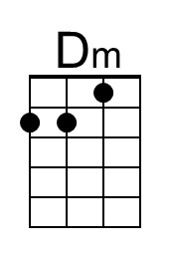
 | 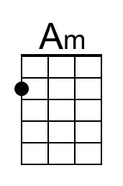
 | 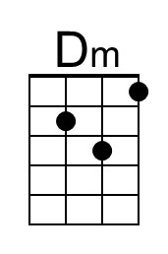
 | 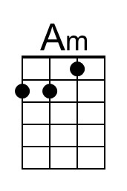

Mairi’s Wedding (D)
Also known as “Marie’s Wedding” and “The Lewis Bridal Song”
Words: John Bannerman in honor of Scottish singer Mary C MacNiven (1934)
Loose translation from Gaelic by Sir Hugh Robertson (1936)
Tune: Scottish Traditional collected by Dr. Peter A. MacLeod
Mairi’s Wedding by The Irish Rovers – Marie’s Wedding by The Clancy Brothers
Arrangement by Theresa Miller

Chorus
D G A7
Step we gaily, on we go, heel for heel, and toe for toe,
D G A
Arm in arm and row on row, all for Mairi’s wedding.

D G A7
Over hillways up and down, myrtle green and bracken brown,
D G A
Past the sheilings through the town, all for sake of Mairi. Chorus

D G A7
Red her cheeks as rowans are, bright her eyes as any star,
D G A
Fairest o’ them all by far, is our darlin’ Mairi. Chorus

D G A7
Plenty herring, plenty meal, plenty peat to fill her creel,
D G A
Plenty bonny bairns as well, that’s the toast for Mairi. Chorus
Molly Malone (“Cockles and Mussels”) (Traditional) (C)
Molly Malone by The Dubliners – Molly Malone by The Irish Rovers

C Am Dm G
In Dublin's fair city, where the girls are so pretty,
C Em Dm G
I first set my eyes on sweet Molly Malone,
C Am
As she wheeled her wheel-barrow,
Dm G
Through streets broad and narrow,
C Em G C
Crying, "Cockles and mussels, alive, alive, oh!"

Chorus
C Am Dm G
"Alive, alive, oh, alive, alive, oh",
C Em G C
Crying "Cockles and mussels, a-live, alive, oh".

C Am Dm G
She was a fishmonger, and sure 'twas no wonder,
C Em Dm G
For so were her father and mother before,
C Am
And they each wheeled their barrow,
Dm G
Through streets broad and narrow,
C Em G C
Crying, "Cockles and mussels, alive, alive, oh!" Chorus

C Am Dm G
She died of a fever, and no one could save her,
C Em Dm G
And that was the end of sweet Molly Malone.
C Am
Now her ghost wheels her barrow,
Dm G
Through streets broad and narrow,
C Em G C
Crying, "Cockles and mussels, alive, alive, oh!" Chorus

C Em G C
Crying, "Cockles and mussels, alive, alive, oh!"

Pretty Irish Girl (Lawrence Edward Watkin & Oliver Wallace, 1959) (G)
Pretty Irish Girl by Sean Connery & Janet Munro (G)
"Darby O'Gill And The Little People" (1959)

Intro Am C A7 G D7 G D7
I love the ground she walks upon - my pretty Irish girl

D7 G G7 C C7
Have you ever seen the seagulls, a-flyin' o'er the heather?
G Em A7 D7
Or the crimson sails on Galway Bay the fishermen un-furl?
G G7 C C7
Oh, the earth is filled with beauty, and it’s gathered all to-gether
G Em A7 D7
In the form and face and dainty grace of a pretty Irish girl

Chorus
G D7 C G
Oh, she's my dear, my darlin' one, her eyes so sparklin' full of fun
C G A7 D7
No other, no other, can match the likes of her
G D7 C G
She's my dear, my darlin' one, my smilin' and be-guilin' one
Am C A7 G (A7) D7 G D7
I love the ground she walks upon - my pretty I – r i s h girl

D7 G G7 C C7
Have you ever seen the morning, in Kerry and Kil-larney?
G Em A7 D7
When the dew is on the hayrick, and ev'ry drop a pearl ?
G G7 C C7
When the geese are full of blarney, and the thrush is singing Gaelic
G Em A7 D7
And standing in the doorway is a pretty Irish Girl? Chorus

D7 G G7 C C7
When I'm parted from my darlin', my sighs would sail a schooner
G Em A7 D7
And when I cannot reach her, sure my tears would turn a mill
G G7 C C7
Since she cannot be un-kind, to any helpless creature
G Em A7 D7
I think that I will marry me a pretty Irish girl!
 |  |  |  |  |  |  | 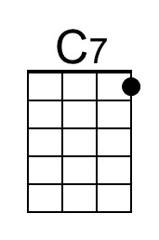
 |  |  | 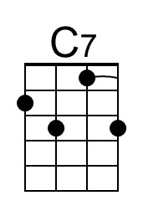 |  | 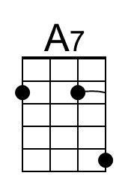
Nancy Mulligan (Ed Sheeran, 2017) (Am)
Nancy Mulligan by Ed Sheeran (Official Video)
Nancy Mulligan by Ed Sheeran (Music video of Irish Dancers)
Video of Nancy Mulligan hearing the song for the first time

Am F G Am
I was twenty-four years old when I met the woman I would call my own
Am F C F G Am
Twenty-two grand kids now growing old in that house that your brother bought ya
Am F G Am
On the summer day when I proposed, I made that wedding ring from dentist gold
Am F C F G Am
And I asked her father but her daddy said no, you can't marry my daughter

Chorus
C F C G F C
She and I went on the run, don't care about reli – gion
C F C F G Am
I'm gonna marry the woman I love, down by the Wexford border
C F C G F C
She was Nancy Mul-ligan, and I was William She-eran
C F C F G Am
She took my name and then we were one, down by the Wexford border

Am F G Am / Am F C F G Am

Am F G Am
Well I met her at Guy's in the Second World War and she was working on a soldier's ward
Am F C F G Am
Never had I seen such beauty before the moment that I saw her
Am F G Am
Nancy was my yellow rose and we got married wearing borrowed clothes
Am F C F G Am
We got eight children now growing old, five sons and three daughters. Chorus

Interlude (2x)
C F G
Di da-da-da-da-da di-da-di, di da-da-da-da-da di-da-di, da da
C F G C
Di da-da-da-da-da di-da-di, di da-da-da-da-da di

Am F G Am
From her snow white streak in her jet black hair, over sixty years I've been loving her
Am F C F G Am
Now we're sat by the fire in our old armchairs, you know Nancy I a-dore ya
Am F G Am
From a farm boy born near Belfast town, I never worried about the king and crown
Am F C F G Am
'Cause I found my heart upon the southern ground, there's no difference I assure ya. Chorus

Outro Interlude
The Skye Boat Song (C)
Version 1 – Lyrics by Sir Harold Boulder (1884) to a traditional air
collected by Anne Campbelle MacLeod (1870's)
The Skye Boat Song by Celtic Dreams (¾ Time)

Intro
C Am Dm7 G7 C F C | C
Speed bonnie boat like a bird on the wing, "Onward!" the sailors cry

Chorus
C Am Dm7 G7 C F C | G7
Speed bonnie boat like a bird on the wing "Onward!" the sailors cry
C Am Dm7 G7 C F C | C
Carry the lad that's born to be King, over the sea to Skye.

Am Dm Am F Am | Am
Loud the winds howl, loud the waves roar, thunderclaps rend the air.
Am Dm Am F Am | G7
Baffled our foes stand by the shore, Follow they will not dare. Chorus

Am Dm Am F Am | Am
Though the waves leap, soft shall ye sleep, Ocean's a royal bed.
Am Dm Am F Am | G7
Rocked in the deep, Flora will keep watch by your weary head. Chorus

Am Dm Am F Am | Am
Many's the lad fought on that day; well the clay-more could wield.
Am Dm Am F Am | G7
When the night came, silently lay, dead on Culloden's field. Chorus

Am Dm Am F Am | Am
Burned are our homes, exile and death, scatter the loyal men.
Am Dm Am F Am | G7
Yet e'er the sword cool in the sheath, Charlie will come a-gain. Chorus

Outro
C Am Dm7 G7 C F C
Carry the lad that's born to be King Over the sea to Skye.

Toora Loora Looral (That’s An Irish Lullaby) (G)
James Royce Shannon, 1913
Too-Ra-Loo-Ra-Loo-Ral by The Irish Tenors (1998) ( ¾ Time )

Chorus
G C G G7 C C#dim7
Too ra loo ra loo ral Too ra loo ra ly
G C G A7 D - D7
Too ra loo ra loo ral. Hush now don't you cry.
G C G G7 C C#dim7
Too ra loo ra loo ral Too ra loo ra ly
G C G A7 Cm G
Too ra loo ra loo ral. That's an Irish lul – la - by.

G C G Em G D7
Over in Killarney, many years a-go
G C G A7 Am D7
My mother sang a song to me in tones so sweet and low
G C G Em G
Just a simple little ditty in her good old Irish way
C G Em A7 Am D7
And I'd give the world if she could sing that song to me today . Chorus

G C G Em G D7
Oft' in dreams I wander to that cot again
G C G A7 Am D7
I feel her arms a-huggin' me as when she did back then
G C G Em G
I hear her softly hummin' to me as in days of yore
C G Em A7 Am D7
When she used to rock me fast asleep out-side that cottage door. Chorus

 |  |  | 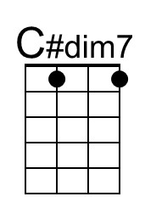 |  |  | 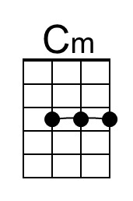
 |  |  | 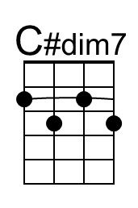 |  |  | 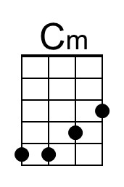

When Irish Eyes Are Smiling (C)
Lyrics by Chauncy Olcott & George Graff, Jr.; Music by Ernest R. Ball (1912)
When Irish Eyes Are Smiling by John McCormick (1917) (F) (¾ Time)

Intro F D7 C A7 D7 G7 C G7
And when Irish eyes are smiling, sure, they steal your heart a-way.

C G7
There's a tear in your eye, and I'm wondering why,
C G
For it never should be there at all.
F C A7
With such pow'r in your smile, sure a stone you'd be-guile,
D7 G7
So there's never a teardrop should fall.
C G7
When your sweet lilting laughter's like some fairy song,
C C7 F
And your eyes twinkle bright as can be;
D7 G G7
You should laugh all the while, and all other times smile,
D D7 G - G7
And now, smile a smile for me.

Chorus
C C7 F C
When Irish eyes are smiling, sure, 'tis like the morn in Spring.
F C D7 G G7
In the lilt of Irish laughter, you can hear the angels sing.
C C7 F C
When Irish hearts are happy, all the world seems bright and gay.
F D7 C A7 D7 G7 C
And when Irish eyes are smiling, sure, they steal your heart a-way.

C G7
For your smile is a part of the love in your heart,
C G
And it makes even sunshine more bright.
F C A7
Like the linnet's sweet song, crooning all the day long,
D7 G7
Comes your laughter so tender and light.
C G7
For the springtime of life, is the sweetest of all
C C7 F
There is ne'er a real care or re-gret;
D7 G G7
And while springtime is ours, throughout all of youth's hours,
D D7 G - G7
Let us smile each chance we get. Chorus

The Parting Glass (C)
Traditional Scots before 1605;
versions from Ireland and the United States have influenced contemporary variants
Tune: "The Peacock" from James Aird's A Selection of Scots, English, Irish and Foreign Airs (1782)
A version of The Parting Glass by The Clancy Brothers and Tommy Makem
(In Person at Carnegie Hall, 1963) (Eb)
The Parting Glass by The Clancy Brothers and Tommy Makem
from "Come Fill Your Glass With Us" (1959) (Eb)

C Am C G7 C G7
O, all the money that e'er I spent, I spent it in good compa-ny.
C Am C G7 C F C G7 Am
And all the harm that e’er I've done, a-las, it was to none but me.
C F G7 Am G7
And all I've done for want of wit to mem'ry, now, I can't re-call.
C Am C G7 C F C G7 Am
So fill to me the parting glass, good night and joy be with you all.

C Am C G7 C G7
O, all the comrades that e'er I had, They're sorry for my going a-way,
C Am C G7 C F C G7 Am
And all the sweethearts that e'er I had, would wish me one more day to stay.
C F G7 Am G7
But since it falls unto my lot, that I should rise and you should not
C Am C G7 C F C G7 Am
I’ll gently rise and softly call, Good night and joy be with you all.

