Halloween in Zoom's New Tavern (Am)
To the tune of ‘St. James Infirmary Blues’, more or less.
Adaptation by Doug Anderson – Based on events occurring on Oct. 30, 2021

Intro Am E7 | Am

Am E7 Am - E7
I was there in Zoom's new tavern,
Am F7 C - E7
singing songs and playing uke.
Am E7 Am - D
Ten good friends were gathered
F7 E7 Am - E7
on that sunny after-noon.

Am E7 Am - E7
Keith was singing St. James In-firm‘ry,
Am F7 C - E7
a song we all en-joy.
Am E7 Am - D
When six young trolls in-truded,
F7 E7 Am - E7
they were swearing up and down the aisle.

Am E7 Am - E7
One troll wrote this message
Am F7 C - E7
in language that I can't re-peat.
Am E7 Am - D
You can guess how low this troll was
F7 E7 Am - E7
by his use of nasty words.

Am E7 Am - E7
But John, he sprang to action
Am F7 C - E7
with Kirk, a plan to best the trolls.
Am E7 Am - D
They could not harm the uke group
F7 E7 Am - E7
so their plan was acted on.

Am E7 Am - E7
But the screen was badly damaged;
Am F7 C - E7
a burial was on the way.
Am E7 Am - D
The sopranos sang a dirge to its mem’ry
F7 E7 Am - E7
and the tenors sang the har-mony.

Am E7 Am - E7
Now the baris bore the coffin;
Am F7 C - E7
The concerts alight: St. Elmo's fire.
Am F7 C - E7
And the uke gods wept the whole way
F7 E7 Am - E7
Only carbon fiber sur-vived.

Am E7 Am - E7
So we all had the last laugh.
Am F7 C - E7
Those ugly trolls had lost the game.
Am F7 C - E7
Keep the faith, sing a song, and smile:
F7 E7 Am - E7
We'll beat those trolls every time.
F7 E7 Am - E7 | Am
We'll beat those trolls every time.

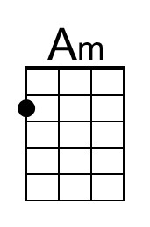 | 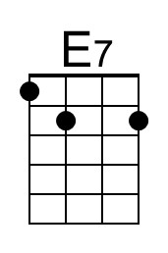 | 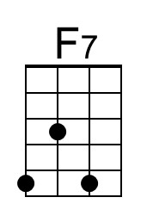 | 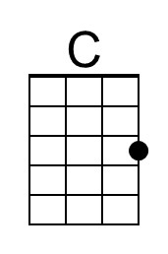 | 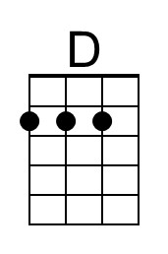
 |  |  | Bari | 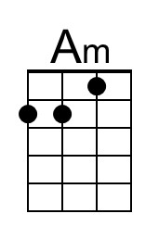 | 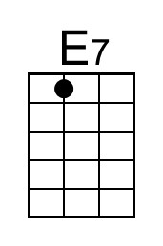 | 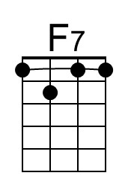 | 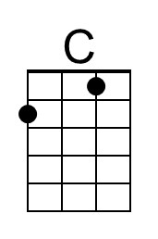 | 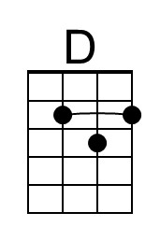

Halloween in Zoom's New Tavern (Dm)
To the tune of ‘St. James Infirmary Blues’, more or less.
Adaptation by Doug Anderson – Based on events occurring on Oct. 30, 2021

Intro Dm A7 | Dm

Dm A7 Dm - A7
I was there in Zoom's new tavern,
Dm Bb7 F - A7
singing songs and playing uke.
Dm A7 Dm - G
Ten good friends were gathered
Bb7 A7 Dm - A7
on that sunny after-noon.

Dm A7 Dm - A7
Keith was singing St. James In-firm‘ry,
Dm Bb7 F - A7
a song we all en-joy.
Dm A7 Dm - G
When six young trolls in-truded,
Bb7 A7 Dm - A7
they were swearing up and down the aisle.

Dm A7 Dm - A7
One troll wrote this message
Dm Bb7 F - A7
in language that I can't re-peat.
Dm A7 Dm - G
You can guess how low this troll was
Bb7 A7 Dm - A7
by his use of nasty words.

Dm A7 Dm - A7
But John, he sprang to action
Dm Bb7 F - A7
with Kirk, a plan to best the trolls.
Dm A7 Dm - G
They could not harm the uke group
Bb7 A7 Dm - A7
so their plan was acted on.

Dm A7 Dm - A7
But the screen was badly damaged;
Dm Bb7 F - A7
a burial was on the way.
Dm A7 Dm - G
The sopranos sang a dirge to its mem’ry
Bb7 A7 Dm - A7
and the tenors sang the har-mony.

Dm A7 Dm - A7
Now the baris bore the coffin;
Dm Bb7 F - A7
The concerts alight: St. Elmo's fire.
Dm Bb7 F - A7
And the uke gods wept the whole way
Bb7 A7 Dm - A7
Only carbon fiber sur-vived.

Dm A7 Dm - A7
So we all had the last laugh.
Dm Bb7 F - A7
Those ugly trolls had lost the game.
Dm Bb7 F - A7
Keep the faith, sing a song, and smile:
Bb7 A7 Dm - A7
We'll beat those trolls every time.
Bb7 A7 Dm - A7 | Dm
We'll beat those trolls every time.

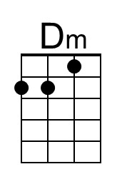 | 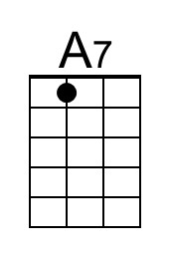 | 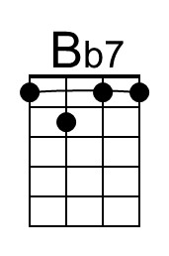 | 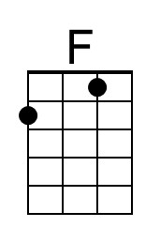 | 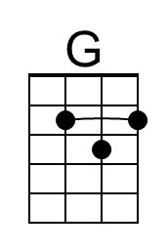
 |  |  | Bari | 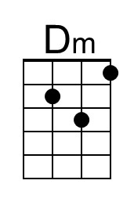 | 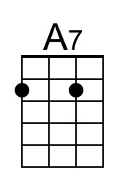 | 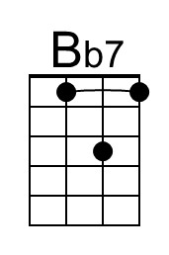 | 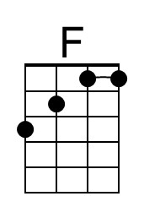 | 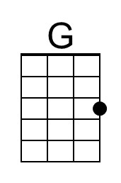

Halloween in Zoom's New Tavern (Em)
To the tune of ‘St. James Infirmary Blues’, more or less.
Adaptation by Doug Anderson – Based on events occurring on Oct. 30, 2021

Intro Em B7 | Em

Em B7 Em - B7
I was there in Zoom's new tavern,
Em C7 G - B7
singing songs and playing uke.
Em B7 Em - A
Ten good friends were gathered
C7 B7 Em - B7
on that sunny after-noon.

Em B7 Em - B7
Keith was singing St. James In-firm‘ry,
Em C7 G - B7
a song we all en-joy.
Em B7 Em - A
When six young trolls in-truded,
C7 B7 Em - B7
they were swearing up and down the aisle.

Em B7 Em - B7
One troll wrote this message
Em C7 G - B7
in language that I can't re-peat.
Em B7 Em - A
You can guess how low this troll was
C7 B7 Em - B7
by his use of nasty words.

Em B7 Em - B7
But John, he sprang to action
Em C7 G - B7
with Kirk, a plan to best the trolls.
Em B7 Em - A
They could not harm the uke group
C7 B7 Em - B7
so their plan was acted on.

Em B7 Em - B7
But the screen was badly damaged;
Em C7 G - B7
a burial was on the way.
Em B7 Em - A
The sopranos sang a dirge to its mem’ry
C7 B7 Em - B7
and the tenors sang the har-mony.

Em B7 Em - B7
Now the baris bore the coffin;
Em C7 G - B7
The concerts alight: St. Elmo's fire.
Em C7 G - B7
And the uke gods wept the whole way
C7 B7 Em - B7
Only carbon fiber sur-vived.

Em B7 Em - B7
So we all had the last laugh.
Em C7 G - B7
Those ugly trolls had lost the game.
Em C7 G - B7
Keep the faith, sing a song, and smile:
C7 B7 Em - B7
We'll beat those trolls every time.
C7 B7 Em - B7 | Em
We'll beat those trolls every time.

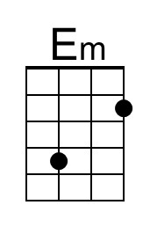 | 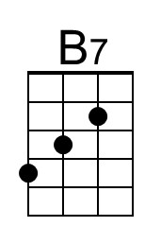 | 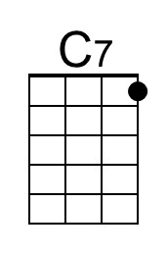 |  | 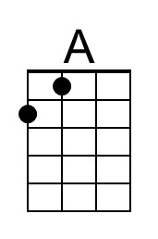
 |  |  | Bari | 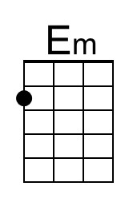 | 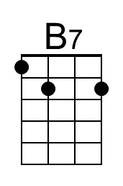 | 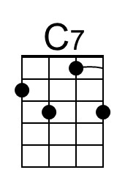 |  | 