Hallelujah (Leonard Cohen) (C)
Version 2 – 4 Verses (12/8 Time)
Hallelujah by Leonard Cohen (Official Audio)
Hallelujah by Leonard Cohen (Live in London) (Official Video)

Lyrics from "Cohen Live" (June 1994), a performance in Austin, 31 October 1988

Intro: C Am C Am  C Am  Baby I have been here before  C Am  I know this room, I've walked this floor  F G C G  I used to live a-lone before I knew you  C F G  I've seen your flag on the marble arch  Am F  Love is not a victory march  G E7 Am  It's a cold and it's a broken Halle – lujah. Chorus  Chorus  F Am  Halle - lujah, halle - lujah,  F C G C G  halle - lujah, halle lu--- --- jah.  C Am  There was a time when you let me know,  C Am  What's really going on below,  F G C G  But now you never show it to me do you.  C F G  Well re-member when I moved in with you,  Am F  And the holy dove was moving too,  G E7 Am  And every breath we drew was Halle - lujah. Chorus |  |  | C Am  May be there is a God above,  C Am  But all I ever learned from love,  F G  Was how to shoot at someone  C G  who out - drew you.  C F G  And it's not a cry you can hear at night,  Am F  It's not somebody who's seen the light,  G E7 Am  It's a cold and it's a broken halle – lujah, Chorus  C Am  I did my best, it wasn't much,  C Am  I couldn't feel so I tried to touch,  F G C G  I've told the truth, I didn't come to fool you.  C F G  And even though it all went wrong,  Am F  I'll stand before the Lord of Song,  G E7 Am  With nothing on my tongue but halle - lujah, Chorus |  |  | 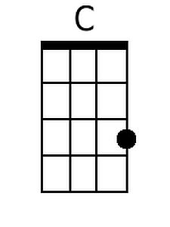
 |  |  |  |  |  | 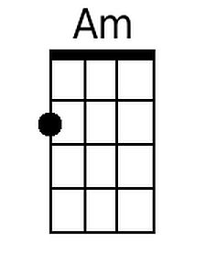
 |  |  |  |  |  | 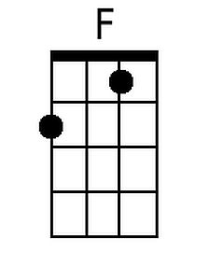
 |  |  |  |  |  | 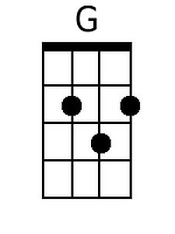
 |  |  |  |  |  | 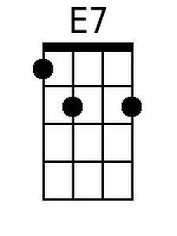
 |  |  |  |  |  | 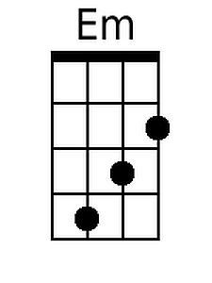
Bari
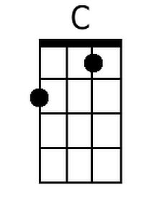 | 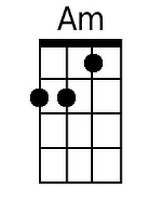 | 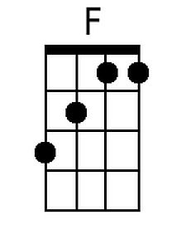 | 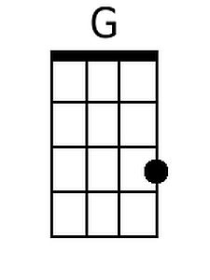 | 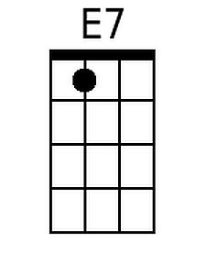 | 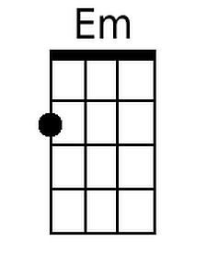

Note: Some performers substitute Em for E7 in the last line of the verses.
Hallelujah (Leonard Cohen) (G)
Version 2 – 4 Verses (12/8 Time)
Hallelujah by Leonard Cohen (Official Audio)
Hallelujah by Leonard Cohen (Live in London) (Official Video)

Lyrics from "Cohen Live" (June 1994), a performance in Austin, 31 October 1988

Intro: G Em G Em  G Em  Baby I have been here before  G Em  I know this room, I've walked this floor  C D G D  I used to live a-lone before I knew you.  G C D  I've seen your flag on the marble arch  Em C  Love is not a victory march  D B7 Em  It's a cold and it's a broken Halle - lujah. Chorus.  G Em  There was a time when you let me know,  G Em  What's really going on below,  C D G D  But now you never show it to me do you.  G C D  Well re-member when I moved in with you,  Em C  And the holy dove was moving too,  D B7 Em  And every breath we drew was Halle - lujah. Chorus  Chorus  C Em  Halle - lujah, Halle - lujah,  C G D G D  Halle - lujah, Halle lu--- --- jah |  |  | G Em  May be there is a God above,  G Em  But all I ever learned from love,  C D  Was how to shoot at someone  G D  who out - drew you.  G C D  And it's not a cry you can hear at night,  Em C  It's not somebody who's seen the light,  D B7 Em  It's a cold and it's a broken Halle - lujah, Chorus  G Em  I did my best, it wasn't much,  G Em  I couldn't feel so I tried to touch,  C D G D  I've told the truth, I didn't come to fool you.  G C D  And even though it all went wrong,  Em C  I'll stand before the Lord of Song,  D B7 Em  With nothing on my tongue but Halle - lujah, Chorus
 |  |  |  |  |  | 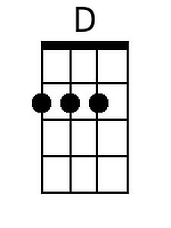
 |  |  |  |  |  | 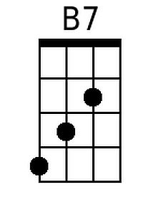
 |  |  |  |  |  | 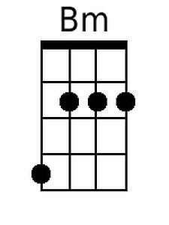
Bari
 |  |  | 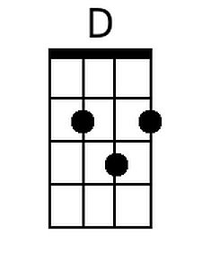 | 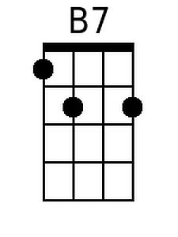 | 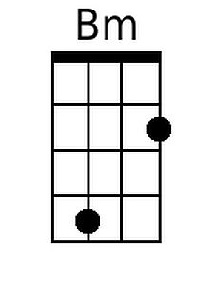

Note: Some performers substitute Bm for B7 in the last line of the verses.

