Hallelujah (Leonard Cohen) (C) (12/8 Time)
Version 3 – 6 Verses
Hallelujah by Leonard Cohen (Live in London) (Official Video)

Intro: C Am C Am  C Am  Well I've heard there was a secret chord,  C Am  That David played and it pleased the Lord,  F G C G  But you don't really care for music, do you?  C F G  It goes like this, the fourth, the fifth,  Am F  The minor fall and the major lift,  G E7 Am  The baffled king com - posing Halle - lujah,  Chorus  F Am  Halle - lujah, Halle - lujah,  F C G C G  Halle - lujah, Halle-lu--- --- jah.  C Am  Your faith was strong but you needed proof,  C Am  You saw her bathing on the roof,  F G C G  Her beauty and the moonlight over-threw you,  C F G  She tied you to her kitchen chair,  Am F  She broke your throne and she cut your hair,  G E7 Am  And from your lips she drew the Halle – lujah, Chorus  C Am  May-be there is a God above,  C Am  But all I ever learned from love,  F G C G  Was how to shoot at someone who out-drew you.  C F G  And it's not a cry you can hear at night,  Am F  It's not somebody who's seen the light,  G E7 Am  It's a cold and it's a broken Halle – lujah, Chorus |  |  |  | C Am  Baby I have been here before.  C Am  I know this room, I've walked this floor.  F G C G  I used to live a-lone before I knew you.  C F G  I've seen your flag on the marble arch.  Am F  Love is not a victory march.  G E7 Am  It's a cold and it's a broken Halle – lujah. Chorus  C Am  There was a time when you let me know,  C Am  What's really going on below,  F G C G  But now you never show it to me do you.  C F G  Well re-member when I moved in with you,  Am F  And the holy dove was moving too,  G E7 Am  And every breath we drew was Halle - lujah. Chorus  C Am  I did my best, it wasn't much,  C Am  I couldn't feel so I tried to touch,  F G C G  I've told the truth, I didn't come to fool you.  C F G  And even though it all went wrong,  Am F  I'll stand before the Lord of Song,  G E7 Am  With nothing on my tongue but Halle – lujah, Chorus (2x)  Note: Some performers substitute Em for E7 in the last line of the verses. |  |  | 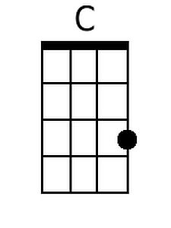
 |  |  |  |  |  |  | 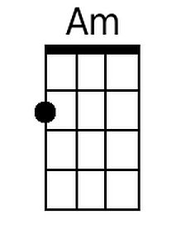
 |  |  |  |  |  |  | 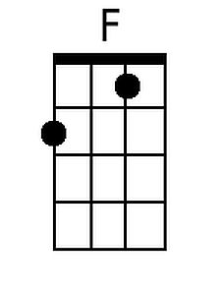
 |  |  |  |  |  |  | 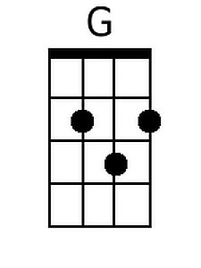
 |  |  |  |  |  |  | 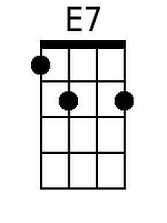
 |  |  |  |  |  |  | 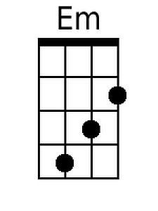
Bari
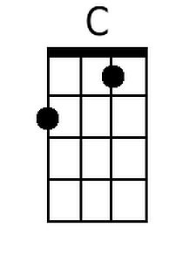 | 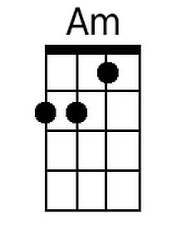 | 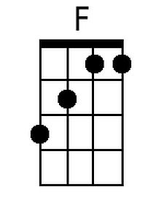 | 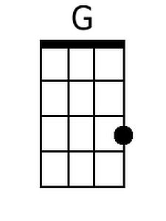 |  | 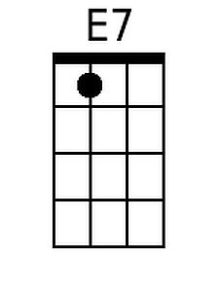 | 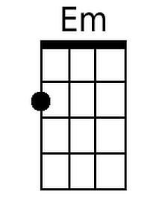

Hallelujah (Leonard Cohen) (G) (12/8 Time)
Version 3 – 6 Verses
Hallelujah by Leonard Cohen (Live in London) (Official Video)

Intro: G Em G Em  G Em  Well I've heard there was a secret chord,  G Em  That David played and it pleased the Lord,  C D G D  But you don't really care for music, do you?  G C D  It goes like this, the fourth, the fifth,  Em C  The minor fall and the major lift,  D B7 Em  The baffled king com - posing Halle - lujah,  Chorus  C Em  Halle - lujah, Halle - lujah,  C G D G D  Halle - lujah, Halle lu--- --- jah  G Em  Your faith was strong but you needed proof,  G Em  You saw her bathing on the roof,  C D G D  Her beauty and the moonlight over-threw you,  G C D  She tied you to her kitchen chair,  Em C  She broke your throne and she cut your hair,  D B7 Em  And from your lips she drew the Halle - lujah, Chorus  G Em  May-be there is a God above,  G Em  But all I ever learned from love,  C D G D  Was how to shoot at someone who out-drew you.  G C D  And it's not a cry you can hear at night,  Em C  It's not somebody who's seen the light,  D B7 Em  It's a cold and it's a broken Halle - lujah, Chorus |  |  |  | G Em  Baby I have been here before.  G Em  I know this room, I've walked this floor.  C D G D  I used to live a-lone before I knew you.  G C D  I've seen your flag on the marble arch.  Em C  Love is not a victory march.  D B7 Em  It's a cold and it's a broken Halle - lujah. Chorus.  G Em  There was a time when you let me know,  G Em  What's really going on below,  C D G D  But now you never show it to me do you.  G C D  Well re-member when I moved in with you,  Em C  And the holy dove was moving too,  D B7 Em  And every breath we drew was Halle - lujah. Chorus  G Em  I did my best, it wasn't much,  G Em  I couldn't feel so I tried to touch,  C D G D  I've told the truth, I didn't come to fool you.  G C D  And even though it all went wrong,  Em C  I'll stand before the Lord of Song,  D B7 Em  With nothing on my tongue but Halle - lujah, Chorus (2x)  Note: Some performers substitute Bm for B7 in the last line of the verses.
 |  |  |  |  |  |  | 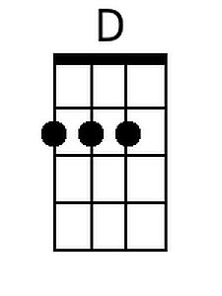
 |  |  |  |  |  |  | 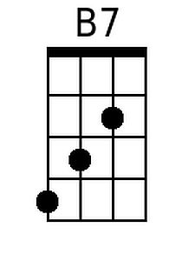
 |  |  |  |  |  |  | 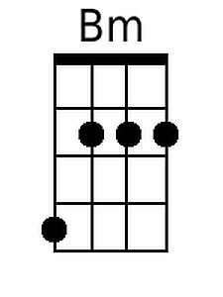
Bari
 |  |  | 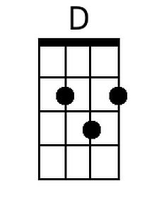 |  | 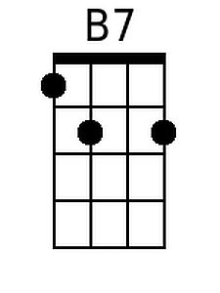 | 