**International Day**

|  |  |
| --- | --- |
| **Hawaii Calls** | **UF** |
| **Hukilau** | **H10** |
| **Island Style C** | **H12C** |
| **Little Grass Shack/Little Brown Gal** | **UF** |
| **Pearly Shells G** | **H22** |
| **Hawaiian Suppa’man** | **H52** |
|  |  |
|  |  |
|  |  |
|  |  |
|  |  |
|  |  |
|  |  |
|  |  |
|  |  |
|  |  |
|  |  |

**Hawaii Calls (Harry Owens)**

**Vamp: D7 G7 C (2x)**

**C Dm G7 C**

Hawai`i calls, with a melody of love, dear

**Dm G7 C C7**

Across the sea as evening falls

**F G7 C**

The surf is booming on the sand at Waikîkî tonight

**D7 G7**

And how I wish that you were strolling hand in hand with me tonight

**Dm G7 C**

Hawai`i calls, with a message of aloha

**Dm G7 C C7**

To you sweetheart where 'er you are

**F Fm C A7**

Reminding you to dream awhile of happy days we knew

**Dm G7 C**

Hawai`i calls and my heart's calling too

**(Repeat entire song)**

**BARITONE**



F

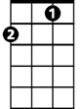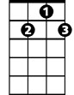

G7

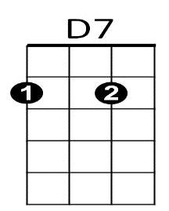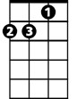

Dm

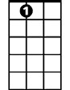

A7

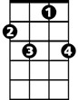

C7

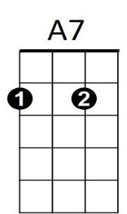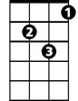

Dm

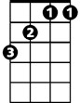

F

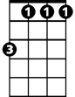

Fm

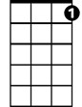

G7



D7



C



C7

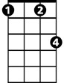

Fm

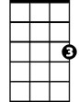

C

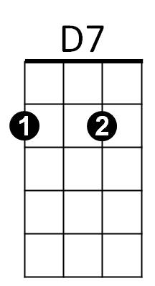**Hukilau**

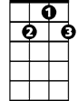

G7

F

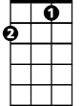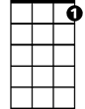

C7

H10

**VAMP: G7 C7 F (2x)**

**F**

Oh, we’re going to a hukilau

**C7**

A huki huki huki huki hukilau

Everybody loves the hukilau

Where the laulau is the kaukau

**F**

At the big luau

**D7**

We throw our nets out into the sea

**G7**

And all the ‘ama ‘ama come

A-swimming to me

**F D7**

Oh, we’re going to a hukilau

**C7 F**

A huki huki huki hukilau

*Hukilau: Community fishing event*

*Laulau: Hawaiian dish, pork and fish with taro or luau leaves (like spinach or turnip greens) wrapped in ti leaves and steamed*

*Kaukau: Generic term for food*

*Luau: Feast*

*‘Ama ‘ama: Striped mullet*

*La’ie Bay: Beach site on Northern Oahu near Mala’ekahana State Recreation Area*

**F**

What a beautiful day for fishing

**C7**

The old Hawaiian way

Where the hukilau nets are swishing

**G7 C7**

Down in old La’ie Bay

**F**

Oh, we’re going to a hukilau

**C7**

**BARITONE**

A huki huki huki huki hukilau

Everybody loves the hukilau

Where the laulau is the kaukau

**F**

At the big luau

**D7**

We throw our nets out into the sea

**G7**

And all the ‘ama ‘ama come

A-swimming to me

**F D7**

Oh, we’re going to a hukilau

**C7**

A huki huki huki huki

Huki huki huki huki

**F**

Huki huki huki hukilau

**VAMP: G7 C7 F (2x)**

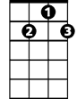

D7

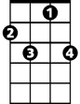

C7



F

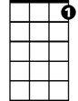

G7

**Island Style (John Cruz)**

H12C

**Intro: G D7 G G7 (Melody of second line of chorus)**

**Chorus:**

**C G**

On the island, we do it island style

**D7 G G7**

From the mountain to the ocean from the windward to the leeward side

**C G**

On the island, we do it island style

**D7 G**

From the mountain to the ocean from the windward to the leeward side





G

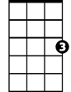

C



G7

**G C G**

Mama's in the kitchen cooking dinner real nice

**D7 G**

Beef stew on the stove, lomi salmon with the ice

**C G**

We eat and drink and we sing all day

**D7 G G7**

Kanikapila in the old Hawaiian way

**(Chorus)**

**BARITONE**

C



D7



G



G7

**G C G**

We go grandma's house on the weekend clean yard, ‘cause

**D7 G**

If we no go, grandma gotta work hard

**G C G**

You know my grandma, she like the poi real sour

**D7 G G7**

I love my grandma every minute, every hour

**(Chorus, First Verse and Chorus)**

**Ending:**

Revised 12 July 2016

**C G**

On the island, we do it island style

**D7 G**

**(repeat 2x)** From the mountain to the ocean from the windward to the leeward side

**Little Grass Shack / Little Brown Gal \***

**VAMP: G7 C7 F (2x)**

*Kay-ah-la-kay-koo-ah*

**F D7 G7**

I want to go back to my little grass shack in Kealakekua, Hawaii

*Kah-nays*

*Vah-hee-nays*

**C7 F**

I want to be with all the kanes and wahines that I used to know, long ago

*Ho-oh-now-now*

**A7 D7**

I can hear the old guitars playing on the beach at Ho’o-Nau-Nau

**G7 C7**

I can hear the old Hawaiians saying "Ko-Mo-Mai No Ka-ua Ika Hale Welakahao"

**F D7 G7**

It won't be long til my ship will be sailing back to Kona

**C7 A7**

A grand old place that's always fair to see, you're telling me

**D7**

I'm just a little Hawaiian, a homesick Island boy

**G7**

I want to go back to my fish and poi

**F D7 G7**

I want to go back to my little grass shack in Kealakekua, Hawaii



G7

**C7 F**

*Hoo-moo-hoo-moo-nu-ku-nu-ku-ah-poo-ah-ah*

Where the Humu humu nuku nuku a pua’a goes swimming by

**C7 F**

Where the Humu humu nuku nuku a pua’a goes swimming by

**VAMP: G7 C7 F (2x)**



C7

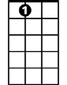

A7

F



**C7**

It’s not the Islands fair that are calling to me

**F**

It’s not the balmy air, not the tropical sea

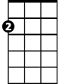

Am

E7

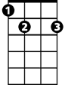

**D7 G7**

But it’s a little brown gal, in a little grass skirt

**C7 F**

In a little grass shack in Hawaii

**C7**

*Kah-meha-meha’s Pah-lee*

It isn’t Waikiki or Kamehameha’s Pali

*Ho-oh-mali-mali*

**F**

Not the beach boys free, with their ho’o mali mali

**D7 G7**

It’s a little brown gal, in a little grass skirt

**BARITONE**

**C7 F**



F



C7



G7

In a little grass shack in Hawaii

**Refrain:**

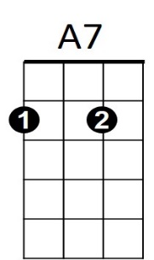**Am E7**

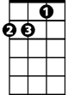

Am

Through that Island wonderland



D7

**Am E7**

She’s broken all the kane’s hearts

**Am E7**

It’s not hard to understand

**Am C7**



E7

For that wahine is a gal of parts

**C7**

I’ll be leaving soon, but the thrill I’ll enjoy

**F**

Is not the Island moon nor the fish and the poi

**D7 G7**

It’s just a little brown gal, in a little grass skirt

**C7 F**

In a little grass shack in Hawaii

**D7 G7**

It’s just a little brown gal, in a little grass skirt

**C7 F**

In a little grass shack in Hawaii

**VAMP: G7 C7 F**

**C7 F (2x)**

That’s where the Humu humu nuku nuku a pua’a goes swimming by

**VAMP: G7 C7 F**

**Pearly Shells (Ray Coniff) Key G**

H22G

**Chorus:**

** G**



G7



A7

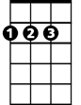

D



C



G

Pearly Shells *(pearly shells)*

From the ocean (*from the ocean*)

**C**

Shining in the sun (*shining in the sun*)

**D D7**

Covering the shore (*covering the shore*)

**G G7**

When I see them (*when I see them*)

**C**

My heart tells me that I love you

**G D7 G F G**

More than all those lit-tle pearly shells

**D7**

For every grain of sand upon the beach

**G**

**BARITONE**

I’ve got a kiss for you and



G

C



**D7**

I’ve got more left over for each star

**A7 D7**

That twinkles in the blue

**(Chorus)**



D



D7

**Ending:**

 **G D7 G C G**



G7

More than all those lit-tle pearly shells

**Hawaiian Sup'pa Man (Israel Kamakawiwo'ole)**

H52

**Intro: Last line of chorus melody: Am G F E7**

**Am**

Oh, tall is the tale of the mischievous one



G



Am

**G F E7 Am**

Who fished out all the islands and captured the sun

**Am**

His deeds and tasks I will unmask so that you'll understand

**G F E7 Am**

That before there was a Clark Kent there was a Hawaiian Superman

E7



F



**C G F**

He fished out all the islands with a magic hook

**C G Am**

There would've been more but somebody looked

**C G F**

He pulled morning sky, the sun he entwined

**C G Am E7**



C

To slow down his flight, so kapa could dry, yeah

**Chorus:**

**Am**

Mischievous, marvelous, magical Maui, Hero of this land

**G F E7 Am**

The one, the only, the ultimate Hawaiian Supa’man

**Am G F E7**

Maui, Maui, oh Maui, Hawaiian Supa’man

**Am G F E7**

**BARITONE**



Am



G

Maui, Maui, oh Maui, Hawaiian Supa’man

**Am**

The secret of fire was locked somewhere in time

**G F E7 Am**

So when the ahi died in the hale kuke, no way to re-ignite

**Am**

So off he goes in search of those who hold the informa-tion



E7



F

**G F E7 Am**

So that fire could be used by all the future generations

**C G F**

He found that Alae held the fire connection

**C G Am**

But his plan of deception fell short of perfection

C



**C G F**

With no other choice he had to get mean

**C G Am E7**

So he squeezed Alae's throat until she screamed the se-cret

**(Chorus)**

**Am G F E7 (2x end in Am)**

Maui, Maui, oh Maui, Hawaiian Supa’man